Meviy Technical Information

Table of Contents

**Sheet Metal** 2

Shapes Eligible for Quotation 2

Shapes 2

Shapes that are difficult to process (typical examples) 3

Material, Surface Treatment, Size 3

Metric Thickness Gauge Standard 3

Inch Gauge Standard 9

Material Standards and Materials Used 13

Types of Hole Machining 14

Shipping Days 15

Material, Surface Treatment, Shipping Day(s) 15

Delivery Options 19

List of delivery options 19

How to select the options 20

Material Properties 21

Surface Treatments 23

Color Samples 25

# **Sheet Metal**

## Shapes Eligible for Quotation

https://us.meviy.misumi-ec.com/help/en/technical_info-en-c/shm_shape-material-en-c/9656/

Depending on the shape and dimensions, we may not be able to provide a quotation even for the following shapes. For details, please refer to the size regulations and design guidelines in this manual.

### Shapes

1. Flat Plate

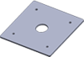

1. Round shape



1. L Bend

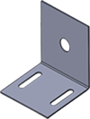

1. Z Bend

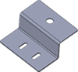

1. Convex Bend

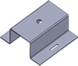

1. C Bend

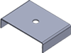

1. Angle Bend (L Bend)



1. Multiple Angle Bend

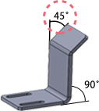

1. Tab Flange

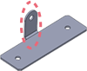

1. Cutout in Bend

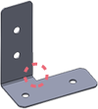

1. Partial Bend with Cutout

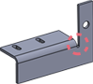

1. Rectangular Slot

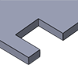

1. U-Shaped Slot



1. Rectangular Corner Notch



### Shapes that are difficult to process (typical examples)

There may be cases where we are unable to manufacture the following shapes or others due to the processing limitations of our equipment. In such cases, meviy support will contact you.

1. Connected parts



1. Punching out characters



1. Gear shape



1. Pointed shape



## Material, Surface Treatment, Size

### Metric Thickness Gauge Standard

|  |  |  |  |  |  |  |  |  |
| --- | --- | --- | --- | --- | --- | --- | --- | --- |
| Material: Ferrous Metals | Surface Treatment | | Sheet Thickness *1 | | | External Dimensions (Length, Width, Height) *2 | | |
| Sheet Thickness ≤2.0 mm | | Sheet Thickness >2.0 mm |
| Low Carbon Steel (Cold/Hot Rolled) | – | | 0.8, 1.0, 1.2, 1.6, 2.0, 2.3, 3.2, 4.5, 6.0, 9.0 | | | 5–1200 | | 10–1200 |
| Powder Coating *3 | | 0.8, 1.0, 1.2, 1.6, 2.0, 2.3, 3.2, 4.5, 6.0 | | |
| Wet Paint *3 | |
| Electroless Nickel Plating | | 0.8, 1.0, 1.2, 1.6, 2.0, 2.3, 3.2, 4.5, 6.0, 9.0 | | | 5–1200 *4 | | 10–1200*4 |
| Black Oxide | |
| Trivalent Chromate (Clear) | |
| Trivalent Chromate (Black) | | 0.8, 1.0, 1.2, 1.6, 2.0, 2.3, 3.2, 4.5, 6.0 | | | 5–300 | | 10–300 |
| 1018 Carbon Steel | – | | 10.0, 12.0, 16.0 | | | – | | 20-1200 |
| Low Carbon Steel (Cold Rolled) | Electrolytic Zinc Plating *5 | | 0.8, 1.0, 1.2, 1.6, 2.0, 2.3, 3.2 | | | 5–1200 | | 10–1200 |
| Hot Zinc Plating *5 | | 1.6, 2.3 | | |
| Cold Rolled Low Carbon Steel (for Shims) *6 | – | | 0.1, 0.2, 0.3, 0.5 | | | * Length 5-850 * Width 5-300 | | – |
| Material: Stainless Steel | | Finishing Method | | Sheet Thickness *1 | External Dimensions (Length, Width, Height) *2 | | | |
| Sheet Thickness ≤2.0 mm | | Sheet Thickness >2.0 mm | |
| * 304 Stainless Steel | | No.1 | | 9.0 | — | | 10-1200 | |
| 10.0, 12.0 | 20-1200 | |
| 2B | | 0.8, 1.0, 1.2, 1.5, 2.0, 2.5,  3.0, 4.0, 5.0, 6.0 | 5–1200 | | 10–1200 | |
| Single-Sided #400-Grit Polished *7 | | 0.8, 1.0, 1.2, 1.5, 2.0, 3.0 |
| Single-sided hairline finish *7 *8 | | 0.8, 1.0, 1.2, 1.5, 2.0, 3.0 |
| * 430 Stainless Steel | | 2B | | 0.8, 1.0, 1.2, 1.5, 2.0, 3.0 |
| * 304 Stainless Steel (for Shims) *6 | | — | | 0.05, 0.1, 0.2, 0.3, 0.5, 0.8, 1.0 | * Length 5-850 * Width 5-300 | | — | |

|  |  |  |  |  |  |  |  |  |
| --- | --- | --- | --- | --- | --- | --- | --- | --- |
| Material: Aluminum | | Surface Treatment | | Sheet Thickness *1 | | External Dimensions (Length, Width, Height) *2 | | |
| Sheet Thickness ≤2.0 mm | | Sheet Thickness >2.0 mm |
| * 5052 Aluminum Alloy | | — | | 0.8 1.0 1.2 1.5 2.0 2.5 3.0 4.0 5.0 6.0 | | 5～920 | | 10～920 |
| Clear Anodize | | 0.8 1.0 1.2 1.5 2.0 2.5 3.0 4.0 5.0 6.0 | | 5–920 *4 | | 10–920 *4 |
| Black Anodize | |
| Black Anodize (matte) *11 | | 0.8 1.0 1.2 1.5 2.0 2.5 3.0 （4.0 5.0 6.0） | | 5～920 *4 | | 10～920 *4 |
| 5052 AL Alloy Pre-Finish, Clear Anodize | | Clear Anodize | | 1.0 1.5 2.0 3.0 | | 5~1100 | | 10~1100 |
| 5052 AL Alloy Pre-Finish, Black Anodize | | Black Anodize | |
| Material: Perforated Metal | Hole Diameter × Hole Pitch *9 | | Open Area Ratio | | Sheet Thickness *1 | | External Dimensions (Length, Width, Height) *2 | |
| * Perforated Metal – 60° Staggered Round Hole Type – * (304 Stainless Steel-BA, Bright Annealed) | ø1 × 2p | | 22.6% | | 0.8 | | 30–900 | |
| ø2 × 3p | | 40.3% | | 1.0 | |
| ø3 × 5p | | 32.7% | | 1.0, 1.5 | |
| ø5 × 8p | | 35.4% | | 1.0, 1.5 | |
| ø8 × 12p | | 40.2% | | 1.5 | |

|  |  |  |  |  |  |
| --- | --- | --- | --- | --- | --- |
| Material: Clear Resin *10 | Grade | Color | Sheet Thickness *1 | External Dimensions | |
| Width | Length |
| PET (Polyethylene Terephthalate) | Standard | Transparent | 3.0  5.0  8.0 | 10～1000 | 10～2000 |
| Smoky Brown | 3.0  5.0 |
| Anti-Static | Transparent |
| Smoky Brown |
| Acrylic | Standard | Transparent | 3.0  5.0  8.0  10.0 | 10～1000 | 10～2000 |
| Smoky Brown | 3.0  5.0 |
| Anti-Static | Transparent |
| Smoky Brown |
| Polycarbonate | Standard | Transparent | 3.0  5.0 | 10～1000 | 10～2000 |
| Smoky Brown |
| Anti-Static | Transparent |
| Smoky Brown |
| PVC (polyvinyl chloride) | Standard | Transparent | 3.0  5.0 | 10～1000 | 10～2000 |
| Smoky brown |
| Anti-Static | Transparent |
| Smoky brown |

* *1 Reference value for tolerance is ±10％ excluding shim and transparent resin material.
* *2 The maximum and minimum dimensional values are limited by the shape of the model.
* *3 Please select the [paint color](https://us.meviy.misumi-ec.com/help/en/technical_info-en-c/shm_shape-material-en-c/9663/) from the Appendix table.
* *4 Maximum dimensions for length, width, and height (refer to the attached table) vary depending on the material, plate thickness, and surface treatment.
* *5 The machining surface will not be plated as it is a pre-treatment material.
* *6 Shim plate materials can only be used with flat plate parts. For more information, see “[Parts Eligible for Thin Shim Plates](https://us.meviy.misumi-ec.com/help/en/technical_info-en-c/shm_shape-material-en-c/9659/).”
* *7 Protective sheets (one-side only) affixed.
* *8 For more information about hairline direction, please see “[Hairline Direction](https://us.meviy.misumi-ec.com/help/en/technical_info-en-c/shm_conditions-en-c/16880/)“.
* *9 See figure below for hole diameter and hole pitch standards. However, the hole pitch orientation can be set to any value.

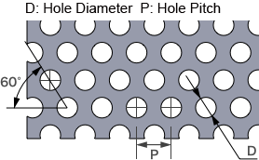

* *10 Can only be used with flat plate parts. For more information, see “[Parts Eligible for Clear Resin](https://us.meviy.misumi-ec.com/help/en/technical_info-en-c/shm_shape-material-en-c/9658/).”
* *11 Matt black anodize of 4.0 mm or more is only available for flat plate parts.
* *12 The upper limit was added in April 2023.

|  |  |  |  |
| --- | --- | --- | --- |
| (Appendix Table) Size limit including surface treatment | External Dimensions (Maximum) | | |
| Length | Width | Height |
| Electroless Nickel Plating | 1200 | 800 | 300 |
| Black Oxide |
| Trivalent Chromate (Clear) |
| 5052 Aluminum Alloy (No surface treatment) | 1200 | 920 | 920 |
| Clear Anodize | 600 | 400 |
| Black Anodize |
| Black Anodize (matte) | 1100 | 600 | 400 |

### Inch Gauge Standard

|  |  |  |  |  |  |  |  |  |  |  |  |  |
| --- | --- | --- | --- | --- | --- | --- | --- | --- | --- | --- | --- | --- |
| Ferrous Metals | | Surface Treatment | | Sheet Thickness (Inch) *1 | | (mm) | External Dimensions *2 *6 | | | | | |
| Length | | Width | | Height | |
| Low Carbon Steel (Cold/Hot Rolled) | | – | | 0.0179″ (#26), 0.0239″ (#24), 0.0299″ (#22), 0.0359″ (#20), 0.0418″ (#19), 0.0478″ (#18), 0.0538″ (#17), 0.0598″ (#16), 0.0747″ (#14), 0.0897″ (#13), 0.1046″ (#12), 0.1196″ (#11), 0.1345″ (#10), 0.1644″ (#8), 0.1793″ (#7), 0.1943″ (#6), 0.2500″ , 0.3750″ | | 0.454mm (#26), 0.607mm (#24), 0.759mm (#22), 0.912mm (#20), 1.062mm (#19), 1.214mm (#18), 1.367mm (#17), 1.519mm (#16), 1.897mm (#14), 2.278mm (#13), 2.657mm (#12), 3.038mm (#11), 3.416mm (#10), 4.175mm (#8), 4.554mm (#7), 4.935mm (#6), 6.350mm, 9.525mm | 5–1200mm (47.24″) | | | | | | |
| Paint *3 | | 5–609.6mm (24″) | | | | 5–304.8mm (12″) | | |
| Black Oxide | |
| Trivalent Chromate (Clear) | |
| Cold Rolled Low Carbon Steel | | Electrolytic Galvanized | | 0.0336″ (#22), 0.0396″ (#20), 0.0516 (#18), 0.0635″ (#16), 0.0785″ (#14) | | 0.701mm (#24), 1.006mm (#20), 1.311mm (#18), 1.613mm (#16), 1.994mm (#14) | 5–1200mm (47.24″) | | | | | | |
| Hot Galvanized | | 0.0276″ (#24), 0.0336″ (#22), 0.0516 (#18), 0.0635″ (#16), 0.0785″ (#14) | | 0.701mm (#24), 0.853mm (#22), 1.311mm (#18), 1.613mm (#16), 1.994mm (#14) | 5–1200mm (47.24″) | | | | | | |
| Stainless Steel | Surface Finish | | Sheet Thickness (inch) *1 | | (mm) | | | External Dimensions *2 *6 | | | | | |
| Length | | Width | | Height | |
| 304 Stainless Steel | 2B | | 0.0187″ (#26), 0.025″ (#24), 0.0312″ (#22), 0.0375″ (#20), 0.0437″ (#19), 0.0500″ (#18), 0.0625″ (#16), 0.0781″ (#14), 0.0937″ (#13), 0.1094″ (#12), 0.1250″ (#11), 0.1406″ (#10), 0.1719″ (#8), 0.1875″ (#7), 0.2500″ (#3) | | 0.476mm (#26), 0.635mm (#24), 0.792mm (#22), 0.953mm (#20), 1.110mm (#19), 1.270mm (#18), 1.588mm (#16), 1.984mm (#14), 2.380mm (#13), 2.779mm (#12), 3.175mm (#11), 3.571mm (#10), 4.366mm (#8), 4.762mm (#7), 6.350mm (#3), | | | 5–1200mm (47.24″) | | | | | |
| Single-sided #4 Brushed | | 0.0187″ (#26), 0.025″ (#24), 0.0312″ (#22), 0.0375″ (#20), 0.0437″ (#19), 0.0500″ (#18), 0.0562″ (#17), 0.0625″ (#16), 0.0781″ (#14), 0.1094″ (#12), 0.1250″ (#11), 0.1406″ (#10) | | 0.476mm (#26), 0.635mm (#24), 0.792mm (#22), 0.953mm (#20), 1.110mm (#19), 1.270mm (#18), 1.427mm (#17), 1.588mm (#16), 1.984mm (#14), 2.779mm (#12), 3.175mm (#11), 3.571mm (#10) | | |
| 316 Stainless Steel | 2B | | 0.0187″ (#26), 0.025″ (#24), 0.0312″ (#22), 0.0375″ (#20), 0.050″ (#18), 0.0625″ (#16), 0.0781″ (#14), 0.1094″ (#12), 0.1250″ (#11), 0.1406″ (#10), 0.1875″ (#7) | | 0.476mm (#26), 0.635mm (#24), 0.792mm (#22), 0.953mm (#20), 1.270mm (#18), 1.588mm (#16), 1.984mm (#14), 2.779mm (#12), 3.175mm (#11), 3.571mm (#10), 4.762mm (#7) | | |

|  |  |  |  |  |  |  |
| --- | --- | --- | --- | --- | --- | --- |
| Aluminum Alloy | Surface Treatment | Sheet Thickness (inch) *1 | (mm) | External Dimensions *2 *6 | | |
| Length | Width | Height |
| * 5052 Aluminum Alloy * 6061 Aluminum Alloy | – | 0.020″ ,*5 0.025″ , 0.032″ , 0.040″ , 0.050″ , 0.063″ , 0.080″ , 0.090″ , 0.100″ , 0.125″, 0.160″, 0.190″, 0.250″ | 0.508mm , *5 0.635mm, 0.813mm, 1.016mm, 1.270mm, 1.600mm, 2.032mm, 2.286mm, 2.540mm, 3.175mm, 4.064mm, 4.826mm, 6.35mm | 5–1200mm (47.24″) | | | |
| Anodized (Clear) | 5–609.6mm (24″) | | 5–304.8mm (12″) |  |
| Anodized (Black) |  |
| Anodized (Matte Black) |  |

* *1 Excluding shim material and transparent resin. The plate thickness tolerance is ±10% (reference value).
* *2 The maximum and minimum dimensional values are limited by the shape of the bend.
* [*3 Select a paint color from the table (Appendix Table).](https://us.meviy.misumi-ec.com/help/en/technical_info-en-c/shm_shape-material-en-c/9663/)
* *4 Protective sheets (one-side only) affixed.
* *5 Only available for 5052 Aluminum Alloy
* *6 Maximum dimention of flat pattern can’t exceed 1,200mm (47.24″)
* *7 only available for Low Carbon Steel (Hot rolled)
* *8 0.2500″/6.350mm and 0.3750″/9.525mm can only be quoted as flat parts

## Material Standards and Materials Used

The table below lists the JIS standard materials used for each selectable equivalent AISI material. The materials used are equivalent to JIS standards and do not fully comply with AISI・SAE・ANSI standards.

|  |  |  |  |  |
| --- | --- | --- | --- | --- |
| No | Material | JIS | GB | Notes |
| 1 | Low Carbon Steel (Cold/Hot Rolled) | SPCC | SPCC | – |
| 2 | Low Carbon Steel (Cold Rolled) (Hot Zinc Plating) | SPCC（Hot Zinc Plating） | – | – |
| 3 | Low Carbon Steel (Cold/Hot Rolled) | SPHC | Q235 | – |
| 4 | Low Carbon Steel (Cold Rolled) (Electrolytic Zinc Plating) | SECC（Electrolytic Zinc Plating） | – | – |
| 5 | 1018 Carbon Steel | SS400 | – | Uses materials that are equivalent to JIS G 3101 standards. |
| 6 | Cold Rolled Low Carbon Steel (for Shims) *6 | SPCC（for SHIM） | – | – |
| 7 | 5052 Aluminum Alloy | A5052 | 5052 H32 | Uses materials that are equivalent to JIS H 4000 standards. |
| 8 | 304 Stainless Steel | SUS304 | 06Cr19Ni10 | Uses materials that are equivalent to JIS G 4305 standards. |
| 9 | 304 Stainless Steel (for Shims) *6 | SUS304(H)（for SHIM） | – | Uses materials that are equivalent to JIS G 4313 standards. |
| 10 | 430 Stainless Steel | SUS430 | – | Uses materials that are equivalent to JIS G 4305 standards. |

Caution

1. Steel types that are not included in the JIS standard, or for which there is no comparable steel even if a JIS standard exists, are not listed.
2. The steel types and standards listed are for comparison and are for reference only.
3. Please note that the chemical composition may vary.

## Types of Hole Machining

1. Through hole



1. Slotted hole

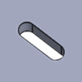

1. Rectangular hole

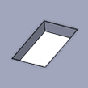

1. Tapped hole



1. Friction/Flow-Drilled & Tapped hole

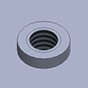

1. Countersunk hole



1. Press-fit nut (coarse), Weld nut (coarse)

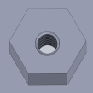

## Shipping Days

### Material, Surface Treatment, Shipping Day(s)

|  |  |  |  |  |  |  |  |
| --- | --- | --- | --- | --- | --- | --- | --- |
| Material: Ferrous Metals | | Surface Treatment | | Standard Shipping | | Expedite Shipping | Economy Shipping (For mm sheetmetal) |
| * Low Carbon Steel (Cold/Hot Rolled) * 1018 Carbon Steel | | — | | 4 days~ | | 2 days~ | 22 days~ |
| Powder Coating | | 7 days~ | | – |
| Wet Paint | | 8 days~ | |
| Electroless Nickel Plating | | 7 days~ | |
| Black Oxide | |
| Trivalent Chromate (Clear) | |
| Trivalent Chromate (Black) | |
| Low Carbon Steel (Cold Rolled) | | Electrolytic Zinc Plating | | 5 days~ | |
| Hot Zinc Plating | |
| Cold Rolled Low Carbon Steel (for Shims) | | — | | 5 days~ | |
| Material: Stainless Steel | Finishing Method | | Standard Shipping | | Expedite Shipping | | Economy Shipping (For mm sheetmetal) |
| 304 Stainless Steel | No.1 | | 4 days~ | | – | | – |
| 2B | | 22 days~ |
| Single-sided #400-Grit Polished | |
| Single-sided hairline finish | |
| 430 Stainless Steel | 2B | |
| 304 Stainless Steel (for SHIM) | — | | 5 days~ | |

|  |  |  |  |  |  |  |  |  |  |
| --- | --- | --- | --- | --- | --- | --- | --- | --- | --- |
| Material: Aluminum | | Surface Treatment | | Standard Shipping | | Expedite Shipping | | Economy Shipping (For mm sheetmetal) | |
| 5052 Aluminum Alloy | | — | | 5 days~ | | – | | 22 days~ | |
| Clear Anodize | | 11 days~ | |
| Black Anodize | |
| Black Anodize (matte) | | 12 days~ | |
| 5052 AL Alloy Pre-Finish, Clear Anodize | | Clear Anodize | | 5 days~ | | – | |
| 5052 AL Alloy Pre-Finish, Black Anodize | | Black Anodize | |
| Material: Perforated Metal | Hole Diameter × Hole Pitch | | Open Area Ratio | | Standard Shipping | | Expedite Shipping | | Economy Shipping |
| Perforated Metal – 60° Staggered Round Hole Type – (304 Stainless Steel-BA, Bright Annealed) | ø1 × 2p | | 22.6% | | 5 days~ | | – | | – |
| ø2 × 3p | | 40.3% | |
| ø3 × 5p | | 32.7% | |
| ø5 × 8p | | 35.4% | |
| ø8 × 12p | | 40.2% | |

|  |  |  |  |  |  |
| --- | --- | --- | --- | --- | --- |
| Material: Clear Resin | Grade | Color | Standard Shipping | Expedite Shipping | Economy Shipping |
| PET (Polyethylene Terephthalate) | Standard | Clear | 5 days~ | – | 22 days~ |
| Smoky Brown |
| Anti-Static | Clear | – |
| Smoky Brown |
| Acrylic | Standard | Clear | 22 days~ |
| Smoky Brown |
| Anti-Static | Clear | – |
| Smoky Brown |
| Polycarbonate | Standard | Clear | 22 days~ |
| Smoky Brown |
| Anti-Static | Clear | – |
| Smoky Brown |
| PVC (polyvinyl chloride) | Standard | Clear | 22 days~ |
| Smoky brown |
| Anti-Static | Clear | – |
| Smoky brown |

*For R-bend shapes, 1 to 2 days shipping will be added to normal bend products. In addition, express shipping cannot be selected.

*Nut installation will add 1 to 2 days delivery time to the normal shipping date. Delivery options are not available.

*Economy shipping option is not available for the product over 9mm thickness.

*The Expedite Service is currently available for a limited range of Cold Rolled Low Carbon Steel Inch gauges. Metric thickness is not currently supported.

*There are 4 colors available for the economy shipping option(RAL color value:9005, 9016, 7032, 1021).

For more information about paint color, please check [“Types of Paint Color“](https://us.meviy.misumi-ec.com/help/en/technical_info-en-c/shm_shape-material-en-c/9663/).

*There may be a slight color difference for pre-finished products depending on the delivery option selected. Performance is equivalent.

*Two days will be added to standard and expedite delivery when transparent resin tapping is specified. No additional days will be added for long delivery options.

*Two days will be added to the standard shipping date for transparent resin threaded inserts. There is no additional lead time for Economy Shipping.

## Delivery Options

Three delivery options are available to prioritize delivery time and price. Standard delivery optimizes fast delivery and price. Economy shipping prioritizes price with a 30% discount and extended (20 day) shipping. Expedite shipping provides the fastest delivery with shipping in as little as 2 days!

### List of delivery options

|  |  |  |  |  |  |
| --- | --- | --- | --- | --- | --- |
| Options | Shipping days | Merit | Quality | End of part number | Order closing time(EST) |
| Expedite Shipping | 2days~ | Peace of mind for urgent situations with minimum 2-days shipping | Same quality | -E | 15:00 |
| Standard Shipping | 4days~ | Minimum 4-days for standard shipping | ー | ー | 20:00 |
| Economy Shipping | 20days~ | Same quality with 30% discount, minimun 20-days for shipping | Same quality | -L |

Notes

* Please refer to the following for detailed shipping dates by material and surface treatment
* →Sheet metal＞Applicable parts/Materials＞[Shipping Days](https://us.meviy.misumi-ec.com/help/en/technical_info-en-c/shm_shape-material-en-c/9654/)

### How to select the options

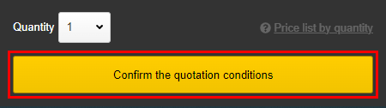

**STEP1**

Click “Confirm the quotation conditions” button.



**STEP2**

A list of delivery dates is displayed to select from.

Notes

* Default setting is standard shipping

**Part Number**

* Part numbers with Economy or Expedite option availablilty are designated with the suffix “-L” for Economy/Long ship time and “-E” for Expedited Shipping.
* These characters can be added to previously issued standard meviy part numbers if Long or Expedite options are available.

## Material Properties

|  |  |  |
| --- | --- | --- |
| Low Carbon Steel | **Low Carbon Steel (Cold Rolled)** | |
| Cold-rolled steel sheet for use in general type pressing. Characterized by its high dimensional accuracy and attractive surface finish. The standard plate thickness is generally between 0.2 mm and 3.2 mm. | |
|  | | **1018 Carbon Steel (Hot Rolled)** | |
| This is a typical rolled steel for general structural use. It has high strength and is used in a wide range of applications such as construction and machinery. The surface is covered with a black oxide film and is also called black film material. | |

|  |  |  |
| --- | --- | --- |
|  | **Cold Rolled Low Carbon Steel (Galvanized)** | |
| Also used in building materials and has high corrosion resistance. Because this material has been pre-machined with a surface treatment, the cut surfaces will not be plated. However, this does afford faster delivery times. The surface is the color of silver. | |
| SUS304(2B) | **304 Stainless Steel (2B)** |
| The most common type of stainless steel. Provides excellent corrosion resistance, toughness, ductility, machinability and weldability. Used in a wide range of applications. The surface has a slightly glossed finish. |

|  |  |
| --- | --- |
| SUS304(Single-sided hairline finish) | **304 Stainless Steel (Single-sided hairline finish)** |
| This is a surface finishing material characterized by long, continuous, hair-like polished grains. The surface is low-gloss to create a relaxed atmosphere. When shipped, a protective sheet (one side only) is attached. |
| SUS430(2B) | **430 Stainless Steel (2B)** |
| A common type of ferritic stainless steel. Has a glossier surface finish than 304 Stainless Steel and is characterized by its magnetic properties. |

|  |  |
| --- | --- |
| NO IMAGE | **6061 Aluminum Alloy** |
| Popular aluminum alloy with excellent corrosion resistance, used in many industries and applications. |
| 5052 AL Alloy Pre-Finish, Clear Anodize | **5052 AL Alloy Pre-Finish, Clear Anodize** | |
| 5052 AL alloy pre-finished anodized sheet. Cut surfaces are not anodized.Due to the characteristics of the material, there is a possibility the surface treatment may peel at bends.The surface is silver. | |
| Low Carbon Steel | **Low Carbon Steel (Hot Rolled)** |
| Hot-rolled soft steel sheet for general use and deep drawing. The standard plate thickness is generally 1.2 mm or more. The material is commonly used in products with medium plate thicknesses. |

|  |  |
| --- | --- |
|  | **Cold Rolled Low Carbon Steel (Electrolytic Zinc Plating)** |
| A plated steel sheet with good corrosion resistance. The cut surfaces will not be plated. Because of the properties of the material, there may be some marks on the surface. The surface is gray. |
| 304 Stainless Steel（No.1） | **304 Stainless Steel（No.1）** | |
| * After hot rolling and heat treatment, it is acid washed to remove black film and dirt from the surface. * It features a matte, satin-finish surface. | |

|  |  |
| --- | --- |
| 304 Stainless Steel (Single-Sided #400-Grit Polished) | **304 Stainless Steel (Single-Sided #400-Grit Polished)** |
| A material with a highly attractive surface finish commonly used for exterior covers. The surface has a mirror-like glossed finish onto which a small amount of polishing marks may remain. Protective sheets (one-side only) are affixed prior to shipment. |
| NO IMAGE | **304 Stainless Steel (Single-sided #4 Brushed)** | |
| Common among polished stainless steels.  Used in a wide range of applications. | |

|  |  |  |
| --- | --- | --- |
| Perforated Metal (304 Stainless Steel-BA); —60° Staggered Round Hole Type— | **Perforated Metal – 60° Staggered Round Hole Type –**  **(304 Stainless Steel-BA, Bright Annealed)** | |
| Perforated steel plates used in a wide range of applications, including in ventilation covers and filters. The material is straightened prior to shipment, but some warping may remain due to the properties of the material. | |
| 5052 Aluminum Alloy | **5052 Aluminum Alloy** |
| The most versatile aluminum alloy. Offers excellent corrosion resistance and weldability and is used in a wide range of applications. |

|  |  |
| --- | --- |
| 5052 AL Alloy Pre-Finish, Black Anodize | **5052 AL Alloy Pre-Finish, Black Anodize** |
| 5052 AL alloy pre-finished anodized sheet. Cut surfaces are not anodized.Due to the characteristics of the material, there is a possibility the surface treatment may peel at bends.The surface is black. |

Please [click here](https://us.meviy.misumi-ec.com/help/en/technical_info-en-c/shm_conditions-en-c/30527/) for more information about pre-finished sheets.

## Surface Treatments

|  |  |
| --- | --- |
| Electroless nickel plating | **Electroless Nickel Plating** |
| A plating finish widely used in industrial applications. Highly corrosion and abrasion resistant. Often used for precision equipment parts as the film thickness tends to be uniform. The color of the surface is white silver. |
| Black oxide | **Black Oxide** |
| A plating finish commonly known as "blackening."  Often used for precision equipment parts as the film is thin and dimensional changes are minimal. However, care must be taken as parts will rust quickly if the oil runs out. |
| Trivalent chromate (white) | **Trivalent Chromate (Clear)** | |
| An environmentally friendly trivalent chromate plating finish. Provides excellent corrosion resistance and an attractive finish with a pale appearance. | |

|  |  |  |
| --- | --- | --- |
| Trivalent chromate (black) | **Trivalent Chromate (Black)** | |
| An environmentally friendly trivalent chromate plating finish.  Gives a black surface finish and good corrosion resistance. | |
| Anodized (white) | **Clear Anodize** |
| A plating finish with good corrosion and abrasion resistance. The surface will have the color of aluminum. |

|  |  |
| --- | --- |
| Anodized (black) | **Black Anodize** |
| A plating finish with good corrosion and abrasion resistance. Gives a black surface finish. |

|  |  |
| --- | --- |
| Electroless nickel plating  NEW | **Black Anodize (matte)** |
| A surface-plating treatment commonly used in optical devices and decorative goods. It is black in color with a subdued, low-gloss effect. The base material has been chemically treated. |

## Color Samples

### Ferrous Metals

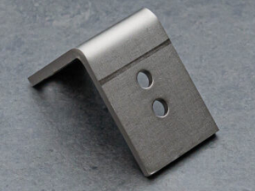

**Electroless Nickel Plating**

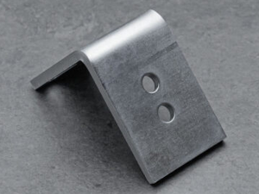

**Trivalent Chromate (Clear)**

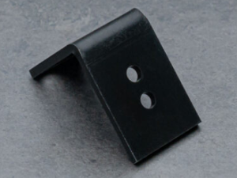

**Trivalent Chromate (Black)**

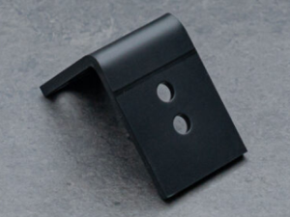

**Black Oxide**

### Aluminum

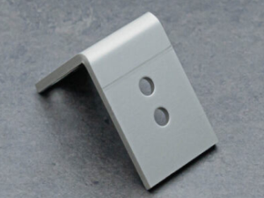

**Clear Anodize**

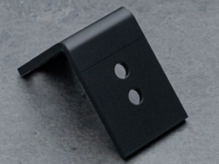

**Black Anodize**

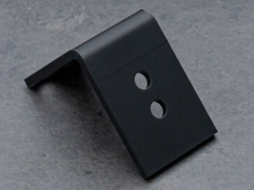

**Black Anodize (matte)**

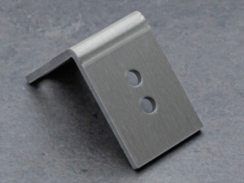

**Anodized Aluminum Sheet, Clear**

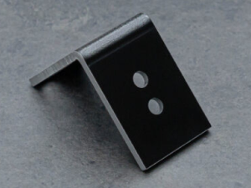

**Anodized Aluminum Sheet, Black**

*There may be color differences depending on the part shape and surfaces to be cut. Film thickness cannot be specified.

*There may be slight color differences for pre-finished products depending on the delivery option selected. Performance is equivalent.

## Types of Paint Color

### Inch Thickness Sheetmetal

**▼**Powder Coating

**Trailer Black**

|  |  |
| --- | --- |
| Trailer Black | * PCTT99259 (Product#) * Manufactured by PPG * RAL9005 |

**Anthracite Grey**

|  |  |
| --- | --- |
| Anthrocite Gray | * PCTA79109 (Product#) * Manufactured by PPG * RAL7016 |

**Oyster White**

|  |  |
| --- | --- |
| Oyster White | * PCTA89102 (Product#) * Manufactured by PPG * RAL1013 |

**Pastel Green**

|  |  |
| --- | --- |
| Pastel Green | * PCTA49120 (Product#) * Manufactured by PPG * FRAL6019 |

**Sulfur Yellow**

|  |  |
| --- | --- |
| Sulfur Yellow | * PCTA39108 (Product#) * Manufactured by PPG * RAL1016 |

**Cream**

|  |  |
| --- | --- |
| Cream | * PCTA89103 (Product#) * Manufactured by PPG * RAL9001 |

**Light Ivory**

|  |  |
| --- | --- |
| Light Ivory | * PCTA29104 (Product#) * Manufactured by PPG * RAL1015 |

**Silver Gray**

|  |  |
| --- | --- |
| Silver Gray | * PCTA79104 (Product#) * Manufactured by PPG * RAL7001 |

**Tele Gray**

|  |  |
| --- | --- |
| Tele Gray | * PCTA79127 (Product#) * Manufactured by PPG * RAL7047 |

**Signal White**

|  |  |
| --- | --- |
| Signal White | * PCTA89104 (Product#) * Manufactured by PPG * RAL9003 |

**Traffic Red**

|  |  |
| --- | --- |
| Signal White | * PCTA69115 (Product#) * Manufactured by PPG * RAL3020 |

### Metric Thickness Sheetmetal

#### ▼Wet Paint/Powder Coating

**Flame Red**

|  |  |
| --- | --- |
|  | * RAL 3000 equiv., * (CMYK 0 81 84 28) |

**Black**

|  |  |
| --- | --- |
|  | * RAL 9005, * (95% match) |

**Dark grey**

|  |  |
| --- | --- |
|  | * RAL 7016, * (97% match) |

**White**

|  |  |
| --- | --- |
|  | * RAL 9016, * (97% match) |

**Deep Orange**

|  |  |
| --- | --- |
|  | * RAL 2011 equiv., * (CMYK 0 50 83 12) |

**Off-white**

|  |  |
| --- | --- |
|  | * RAL 9003, * (96% match), * Full Gloss |

**Off-white**

|  |  |
| --- | --- |
|  | * RAL 9003, * (95% match), * Semi-Gloss |

**Cream**

|  |  |
| --- | --- |
|  | * RAL 1015, * (94% match) |

**Pebble Grey**

|  |  |
| --- | --- |
|  | * RAL 7032 equiv., * (CMYK 0 6 17 19) |

**Yellow**

|  |  |
| --- | --- |
|  | * RAL 1021, * (94% match) |

**Light cream**

|  |  |
| --- | --- |
|  | * RAL 9001, * (97% match) |

**Light Ivory**

|  |  |
| --- | --- |
|  | * RAL 1015, * (97% match) |

**Pastel Blue**

|  |  |
| --- | --- |
|  | * RAL 5024 equiv., * (CMYK 52 16 0 31) |

**Light green**

|  |  |
| --- | --- |
|  | * RAL 9012, * (90% match) |

**Oyster White**

|  |  |
| --- | --- |
|  | * RAL 1013, * (97% match) |

**Grey**

|  |  |
| --- | --- |
|  | * RAL 7032, * (97% match) |

**Green Beige**

|  |  |
| --- | --- |
|  | * RAL 1000 equiv., * (CMYK 0 6 17 19) |

**Cream Gray**

|  |  |
| --- | --- |
|  | * RAL 7032, * (98% match) |

**Light Gray**

|  |  |
| --- | --- |
|  | * RAL 9002, * (95% match) |

**Off-pale gray**

|  |  |
| --- | --- |
|  | * RAL 9001, * (97% match) |

## Specifications for Edge Breaking

* For sheet metal parts, a double-sided deburring machine is used to break the edges.
* There is a possibility of minor scratches on appearance surfaces from this process.
* Please see “[About Edge breaking](https://us.meviy.misumi-ec.com/help/en/technical_info-en-c/shm_conditions-en-c/29955/)” for more information.

### Materials Available for Edge Breaking and Corresponding Edge Break Sizes

|  |  |  |  |  |  |
| --- | --- | --- | --- | --- | --- |
| Material | Surface treatment | | Sheet Thickness | | |
| * Low Carbon Steel (Cold/Hot Rolled) * Low Carbon Steel (Hot Rolled) | ー | | 0.8  1.0  1.2  1.6  2.0  2.3  3.2  4.5  6.0  9.0  10.0  12.0  16.0 | | |
| Powder Coating * | | 0.8  1.0  1.2  1.6  2.0  2.3  3.2  4.5  6.0 | | |
| Wet Paint | |
| Electroless Nickel Plating | | 0.8  1.0  1.2  1.6  2.0  2.3  3.2  4.5  6.0  9.0 | | |
| Black Oxide | |
| Trivalent Chromate (Clear) | |
| Trivalent Chromate (Black) | | 0.8  1.0  1.2  1.6  2.0  2.3  3.2  4.5  6.0 | | |
| Low Carbon Steel (electrolytic zinc plating) | Electrolytic Zinc Plating | | 0.8  1.0  1.2  1.6  2.0  2.3  3.2 | | |
| Material | | Finishing Method | | Sheet Thickness |
| SUS304 | | 2B | | 0.8  1.0  1.2  1.5  2.0  2.5  3.0  4.0  5.0  6.0 |
| No.1 | | 9.0  10.0  12.0 |
| SUS430 | | 2B | | 0.8  1.0  1.2  1.5  2.0  3.0 |

*The following painted finishes are available: Black (RAL 9005, (95% match)), Grey (RAL 7032, (97% match)), Off-white (RAL 9003, (95% match), Semi-Gloss), Off-white (RAL 9003, (96% match), Full Gloss), Cream Gray (RAL 7032, (98% match))

## Target Range for R-Bending (Large Radius)

* The R-bend shape is subject to FR bending (feed bending), which will result in die marks. Please refer to “[Bending Specifications](https://us.meviy.misumi-ec.com/help/en/technical_info-en-c/shm_conditions-en-c/9703/)” for details.
* *If you would like to request R-bending processing without leaving die marks, please write it in the comment column for manual quotation.

### Metric Thickness Gauge Standard

|  |  |  |  |  |  |  |
| --- | --- | --- | --- | --- | --- | --- |
| Material: Ferrous Metals | | Surface Treatment | Sheet Thickness *1 | | External Dimensions (Length, Width, Height) *2 | |
| Sheet Thickness ≤2.0 mm | Sheet Thickness >2.0 mm |
| Low Carbon Steel (Cold/Hot Rolled) | | – | 0.8, 1.0, 1.2, 1.6, 2.0, 2.3, 3.2 | | 5–1200 | 10–1200 |
| Powder Coating *3 | 0.8, 1.0, 1.2, 1.6, 2.0, 2.3, 3.2 | |
| Wet Paint *3 |
| Electroless Nickel Plating | 0.8, 1.0, 1.2, 1.6, 2.0, 2.3, 3.2 | | 5–1200 *4 | 10–1200 *4 |
| Black Oxide |
| Trivalent Chromate (Clear) |
| Trivalent Chromate (Black) | 0.8, 1.0, 1.2, 1.6, 2.0, 2.3, 3.2 | | 5–300 | 10–300 |
| Low Carbon Steel (Cold Rolled) | | Electrolytic Zinc Plating *5 | 0.8, 1.0, 1.2, 1.6, 2.0, 2.3, 3.2 | | 5–1200 | 10–1200 |
| Hot Zinc Plating *5 | 1.6, 2.3 | |
| Material: Stainless Steel | Finishing Method | | | Sheet Thickness *1 | External Dimensions (Length, Width, Height) *2 | |
| Sheet Thickness ≤2.0 mm | Sheet Thickness >2.0 mm |
| * 304 Stainless Steel | 2B | | | 0.8, 1.0, 1.2, 1.5, 2.0, 2.5, 3.0 | 5–1200 | 10–1200 |
| Single-Sided #400-Grit Polished *6 | | | 0.8, 1.0, 1.2, 1.5, 2.0, 3.0 |
| * 430 Stainless Steel | 2B | | | 0.8, 1.0, 1.2, 1.5, 2.0, 3.0 |

|  |  |  |  |  |  |  |  |  |
| --- | --- | --- | --- | --- | --- | --- | --- | --- |
| Material: Aluminum | Surface Treatment | | Sheet Thickness *1 | | | External Dimensions (Length, Width, Height) *2 | | |
| Sheet Thickness ≤2.0 mm | | Sheet Thickness >2.0 mm |
| 5052 Aluminum Alloy | — | | 0.8, 1.0, 1.2, 1.5, 1.6, 2.0, 2.5, 3.0 | | | 5–920 | | 10–920 |
| Clear Anodize | | 5–920 *4 | | 10–920 *4 |
| Black Anodize | |
| 5052 AL Alloy Pre-Finish, Clear Anodize | Clear Anodize | | 1.0 1.5 2.0 3.0 | | | 5~1100 | | 10~1100 |
| 5052 AL Alloy Pre-Finish, Black Anodize | Black Anodize | |
| Material: Perforated Metal | | Hole Diameter × Hole Pitch *7 | | Open Area Ratio | Sheet Thickness *1 | | External Dimensions (Length, Width, Height) *2 | |
| * Perforated Metal – 60° Staggered Round Hole Type – * (304 Stainless Steel-BA, Bright Annealed) | | ø1 × 2p | | 22.60% | 0.8 | | 30–900 | |
| ø2 × 3p | | 40.30% | 1.0 | |
| ø3 × 5p | | 32.70% | 1.0, 1.5 | |
| ø5 × 8p | | 35.40% | 1.0, 1.5 | |
| ø8 × 12p | | 40.20% | 1.5 | |

* *1 The plate thickness tolerance is ±10% (reference value).
* *2 The maximum and minimum dimensional values are limited by the shape of the bend.
* *3　Select a [paint color](https://us.meviy.misumi-ec.com/help/en/technical_info-en-c/shm_shape-material-en-c/9663/) from the table (Appendix Table).
* *4　The maximum length and width dimensions (Appendix Table) may vary depending on the surface treatment.
* *5　The machining surface will not be plated as it is a pre-treatment material.
* *6　Protective sheets (one-side only) affixed.
* *7　See figure below for hole diameter and hole pitch standards.
* However, the hole pitch orientation can be set to any value.



**■Inner R range**

|  |  |  |
| --- | --- | --- |
| Plate thickness | Minimum inner R | Maximum inner R |
| 0.8 | 10 | 150 |
| 1.0 | 10 | 150 |
| 1.2 | 10 | 150 |
| 1.5 | 10 | 150 |
| 1.6 | 10 | 150 |
| 2.0 | 10 *8 | 150 |
| 2.3 | 15 | 150 |
| 2.5 | 10 | 150 |
| 3.0 | 30 | 150 |
| 3.2 | 30 | 150 |

* *8 Steel material is R15 as minimum inner R.

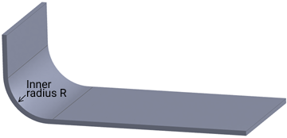

|  |  |  |  |
| --- | --- | --- | --- |
| (Appendix Table) Maximum Sizes for Each Surface Treatment | External Dimensions (Maximum) | | |
| Length | Width | Height |
| Electroless Nickel Plating | 1200mm | 800mm | 300mm |
| Black Oxide |
| Trivalent Chromate (White) |
| 5052 Aluminum Alloy(Without surface treatment) | 1200mm | 920mm | 920mm |
| Anodized (White) | 600mm | 400mm |
| Anodized (Black) |

### Inch Gauge Standard

|  |  |  |  |  |  |  |  |  |  |  |  |  |
| --- | --- | --- | --- | --- | --- | --- | --- | --- | --- | --- | --- | --- |
| Material: Ferrous Metals | Surface Treatment | | Sheet Thickness (Inch) *1 | | (mm) | | External Dimensions *2 *4 | | | | | |
| Length | | Width | | Height | |
| Low Carbon Steel (Cold/Hot Rolled) | – | | 0.0299″ (#22), 0.0359″ (#20), 0.0418″ (#19), 0.0478″ (#18), 0.0538″ (#17), 0.0598″ (#16), 0.0747″ (#14), 0.0897″ (#13), 0.1046″ (#12), 0.1196″ (#11) | | 0.759mm (#22), 0.912mm (#20), 1.062mm (#19), 1.214mm (#18), 1.367mm (#17), 1.519mm (#16), 1.897mm (#14), 2.278mm (#13), 2.657mm (#12), 3.038mm (#11) | | 5–1200mm (47.24″) | | | | | |
| Paint *3 | |
| 5–609.6mm (24″) | | | | 5–304.8mm (12″) | |
| Black Oxide | |
| Trivalent Chromate (Clear) | |
| Trivalent Chromate (Black) | |
| Low Carbon Steel (Cold Rolled) | Electrolytic Galvanized *5 | | 0.0336″ (#22), 0.0396″ (#20), 0.0516″ (#18), 0.0635″ (#16), 0.0785″ (#14) | | 0.701mm (#24), 1.006mm (#20), 1.311mm (#18), 1.613mm (#16), 1.994mm (#14) | | 5–1200mm (47.24″) | | | | | |
| Hot Galvanized *5 | | 0.0276″ (#24), 0.0336″ (#22), 0.0516″ (#18), 0.0635″ (#16), 0.0785″ (#14) | | 0.701mm (#24), 0.853mm (#22), 1.311mm (#18), 1.613mm (#16), 1.994mm (#14) | | 5–1200mm (47.24″) | | | | | |
| Material: Stainless Steel | | Surface Finish | | Sheet Thickness (Inch) *1 | | (mm) | | External Dimensions *2 *4 | | | | |
| Length | | Width | | Height |
| * 304 Stainless Steel | | 2B | | 0.0312″ (#22), 0.0375″ (#20), 0.0437″ (#19), 0.0500″ (#18), 0.0625″ (#16), 0.0781″ (#14), 0.0937″ (#13), 0.1094″ (#12), 0.1250″ (#11) | | 0.792mm (#22), 0.953mm (#20), 1.110mm (#19), 1.270mm (#18), 1.588mm (#16), 1.984mm (#14), 2.380mm (#13), 2.779mm (#12), 3.175mm (#11) | | 5–1200mm (47.24″) | | | | |
| Single Sided #4 Brushed *6 | | 0.0312″ (#22), 0.0375″ (#20), 0.0437″ (#19), 0.0500″ (#18), 0.0625″ (#16), 0.0781″ (#14), 0.0937″ (#13) | | 0.792mm (#22), 0.953mm (#20), 1.110mm (#19), 1.270mm (#18), 1.588mm (#16), 1.984mm (#14), 2.380mm (#13) | |

|  |  |  |  |  |  |  |
| --- | --- | --- | --- | --- | --- | --- |
| Material: Aluminum Alloy | Surface Treatment | Sheet Thickness (Inch) *1 | (mm) | External Dimensions *2 *4 | | |
| Length | Width | Height |
| 5052 Aluminum AlloyClear | — | 0.025″, 0.032″, 0.040″, 0.050″, 0.063″, 0.080″, 0.090″, 0.100″, 0.125″ | 0.635mm, 0.813mm, 1.016mm, 1.270mm, 1.600mm, 2.032mm, 2.286mm, 2.540mm, 3.175mm | 5–1200mm (47.24″) | | |
| Anodize (Clear) | 5–609.6mm (24″) | | 5–304.8mm (12″) |
| Anodize (Black) |

* *1 The plate thickness tolerance is ±10% (reference value).
* *2 The maximum and minimum dimensional values are limited by the shape of the bend.
* *3 Select a paint color from the table (Appendix Table).
* *4 The maximum length and width dimensions (Appendix Table) may vary depending on the surface treatment.
* *5 The machining surface will not be plated as it is a pre-treatment material.
* *6 Protective sheets (one-side only) affixed.

**■Inner R range**

|  |  |  |
| --- | --- | --- |
| Plate thickness | Minimum inner R | Maximum inner R |
| #24 | 0.394″ | 5.905″ |
| #22 | 0.394″ | 5.905″ |
| #20 | 0.394″ | 5.905″ |
| #19 | 0.394″ | 5.905″ |
| #18 | 0.394″ | 5.905″ |
| #16 | 0.394″ | 5.905″ |
| #14 | 0.394″ | 5.905″ |
| #13 | 0.394″ | 5.905″ |
| #12 | 0.394″ | 5.905″ |
| #11 | 0.181″ | 5.905″ |

## Scope of Engraving

For sheet metal engraving services, only the appearance is supported. The finish may vary depending on the material and processing machine conditions. For details, please refer to “[Engraving](https://us-stg.meviy.misumi-ec.com/help/en/technical_info-en-c/shm_conditions-en-c/25033/)“.

### Inch Gauge Standard

|  |  |  |
| --- | --- | --- |
| Material: Steel | Surface Treatment | Sheet Thickness (Inch)*1 |
| Low Carbon Steel (Cold/Hot Rolled) | – | 0.0299″ (#22), 0.0359″ (#20), 0.0418″ (#19), 0.0478″ (#18), 0.0538″ (#17), 0.0598″ (#16), 0.0747″ (#14), 0.0897″ (#13), 0.1046″ (#12), 0.1196″ (#11), 0.1345″ (#10), 0.1943″ (#6), 0.2500″ , 0.3750″ |
| Cold Rolled Low Carbon Steel | Electrolytic Galvanized | 0.0336″ (#22), 0.0396″ (#20), 0.0516″ (#18), 0.0635″ (#16), 0.0785″ (#14) |
| Hot Galvanized | 0.0276″ (#24), 0.0336″ (#22), 0.0516″ (#18), 0.0635″ (#16), 0.0785″ (#14) |
| Material: Stainless Steel | Surface Treatment | Sheet Thickness (Inch)*1 |
| 304 Stainless Steel | 2B | 0.0312″ (#22), 0.0375″ (#20), 0.0437″ (#19), 0.0500″ (#18), 0.0625″ (#16), 0.0781″ (#14), 0.0937″ (#13), 0.1094″ (#12), 0.1250″ (#11), 0.1406″ (#10), 0.1719″ (#8), 0.1875″ (#7), 0.2500″ (#3) |
| #4 | 0.0312″ (#22), 0.0375″ (#20), 0.0437″ (#19), 0.0500″ (#18), 0.0562″ (#17), 0.0625″ (#16), 0.0781″ (#14), 0.0937″ (#13) |

|  |  |  |
| --- | --- | --- |
| Material: Aluminum | Surface Treatment | Sheet Thickness (Inch)*1 |
| 5052 Aluminum Alloy | – | 0.020″, 0.025″, 0.032″, 0.040″, 0.050″, 0.063″, 0.080″, 0.090″, 0.100″, 0.125″ |
| 6061 Aluminum Alloy | – | 0.025″, 0.032″, 0.040″, 0.050″, 0.063″, 0.080″, 0.090″, 0.100″, 0.125″ |

*1 The plate thickness tolerance is ±10% (reference value).

### Metric Thickness Gauge Standard

For sheet metal engraving services, only the appearance is supported. The finish may vary depending on the material and processing machine conditions. For details, please refer to “[Engraving](https://us.meviy.misumi-ec.com/help/en/technical_info-en-c/shm_conditions-en-c/25033/)“.

|  |  |  |
| --- | --- | --- |
| Material: Steel | Surface Treatment | Plate thickness |
| Low Carbon Steel（Cold/Hot） | – | 0.8  1.0  1.2  1.6  2.0  2.3  3.2  4.5  6.0 |
| 1018 Carbon Steel | – | 9.0  10.0  12.0  16.0 |
| Material: Stainless Steel | Finish | Plate thickness |
| 304 Stainless Steel | 2B | 0.8  1.0  1.2  1.5  2.0  2.5  3.0  4.0  5.0  6.0 |
| 430 Stainless Steel | 2B | 0.8  1.0  1.2  1.5  2.0  3.0 |
| 304 Stainless Steel | No.1 | 9.0　10.0  12.0 |

*1 The plate thickness tolerance is ±10% (reference value).

### Character Size

* Half-width alphanumeric characters and some symbols (+-. #$%&()=*:? /_~) can be freely entered.
* Line feed and space input are also supported.
* Font (font, spacing) and line spacing cannot be specified.

**Character Size**

Due to the definition of font size, there may be deviations from the specified size depending on the content.

**Font Size Definition**

i.e., If you specify a default character size of 5.0 mm

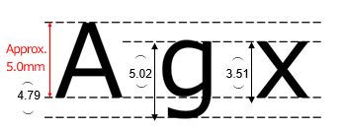

|  |  |  |  |  |  |  |  |  |  |  |  |  |  |  |  |  |  |  |  |
| --- | --- | --- | --- | --- | --- | --- | --- | --- | --- | --- | --- | --- | --- | --- | --- | --- | --- | --- | --- |
|  |  | Initial value  (＊) | | |  |  |  |  |  |  |  |  |  |  |  |  |  |  |  |
| Specified size | 3.0 | 4.0 | 5.0 | 6.0 | 7.0 | 8.0 | 9.0 | 10.0 | 11.0 | 12.0 | 13.0 | 14.0 | 15.0 | 17.5 | 20.0 | 22.5 | 25.0 | 27.5 | 30.0 |
| Measured value A | 2.80 | 3.74 | 4.79 | 5.60 | 6.54 | 7.47 | 8.41 | 9.34 | 10.27 | 11.2 | 12.14 | 13.08 | 14.01 | 16.34 | 18.68 | 21.01 | 23.37 | 25.68 | 28.01 |
| Measured value g | 3.01 | 4.02 | 5.02 | 6.26 | 7.03 | 8.03 | 9.04 | 10.04 | 11.05 | 12.52 | 13.05 | 14.06 | 15.07 | 17.39 | 20.08 | 22.36 | 25.11 | 27.62 | 30.13 |
| Measured value x | 2.10 | 2.80 | 3.51 | 4.21 | 4.91 | 5.61 | 6.31 | 7.01 | 7.71 | 8.42 | 9.11 | 9.81 | 10.52 | 12.27 | 14.02 | 15.77 | 17.53 | 19.28 | 21.03 |

* *Depending on the material and characters, 3-5.0mm may cause character blurring.
* *Size is only a reference value. Dimensional accuracy is not guaranteed. Depending on the text content, there may be cases where the size differs from the specified size.

### Angle of the engraving

* Rotate counterclockwise at 45 degree intervals.
* These are reference values only and accuracy is not guaranteed by quality assurance.

|  |  |
| --- | --- |
| Initial value | 0 degree (end-face reference) |
| Angular pitch (standard value) | 0 to 360 degrees (45 degree intervals) |

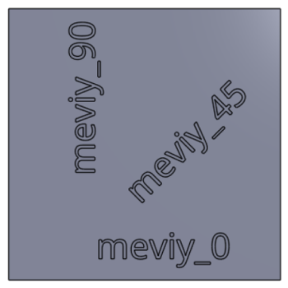

## Shapes to be Available Soon

### Shapes

|  |  |  |  |
| --- | --- | --- | --- |
| **1** | | Hemming bend | |
| Hemming bend | | | |
| **2** | Welding | |
| Welding | | |

|  |  |
| --- | --- |
| **3** | Welded box shape |
| Welded box shape | |

## Parts Eligible for Thin Shim Plates

* Thin shim plates, useful for adjusting the thickness and height of parts, are available.
* Certain conditions regarding the shape elements, material and thickness of the part must be met in order to select shim plates. Check below for detailed specifications.

### Shapes Eligible for Thin Shim Plates

Eligible: Cutout/through holes/freeform hole

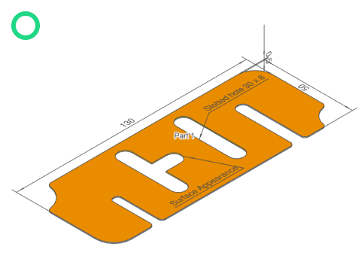

Not eligible: Bends

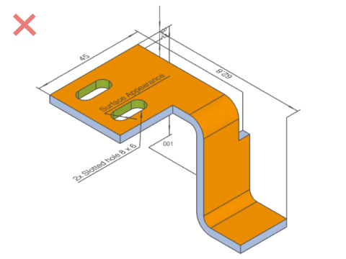

Eligible: Cutout/through holes (rectangular holes, slotted holes, etc.)

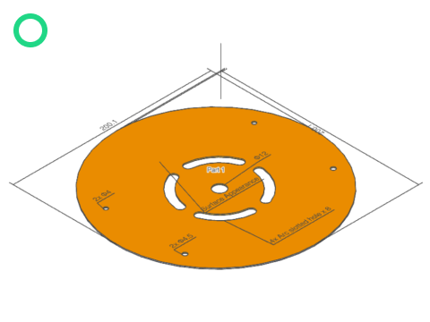

Not eligible: Molded holes

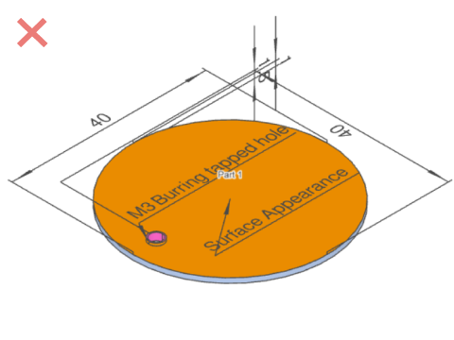

### Materials / Plate Thicknesses Eligible for Thin Shim Plates

* The plate thickness tolerance varies depending on the plate thickness and material.
* Other stainless steel materials are available with a plate thicknesses of 0.8 mm or 1.0 mm, but 304 Stainless Steel (H) (for Shims) has higher precision. (The plate thickness tolerance with standard materials is ±10% [reference value only].)

|  |  |  |  |  |
| --- | --- | --- | --- | --- |
| Eligible 1: Ferrous Metal | | Sheet Thickness | | Sheet Thickness Tolerance |
| Cold Rolled Low Carbon Steel (for Shims) | | 0.1 | | ±0.03 |
| 0.2 | | ±0.03 |
| 0.3 | | ±0.04 |
| 0.5 | | ±0.06 |
| Eligible 2: Stainless Steel | Sheet Thickness | | Sheet Thickness Tolerance | |
| 304 Stainless Steel(H) (for shim) | 0.05 | | ±0.005 | |
| 0.1 | | ±0.02 | |
| 0.2 | | ±0.03 | |
| 0.3 | | ±0.035 | |
| 0.5 | | ±0.04 | |
| 0.8 | | ±0.04 | |
| 1.0 | | ±0.05 | |

## Parts Eligible for Clear Resin

*The delivery date will be extended depending on the quantity. Please check the date displayed on the screen for the confirmed delivery date.

* Clear resin panel parts, used for equipment covers, etc. are available.
* Certain conditions regarding the shape elements, material and thickness of the part must be met in order to select clear resin. Check below for detailed specifications.

### Shapes Available in Clear Resin

Eligible: Flat plate

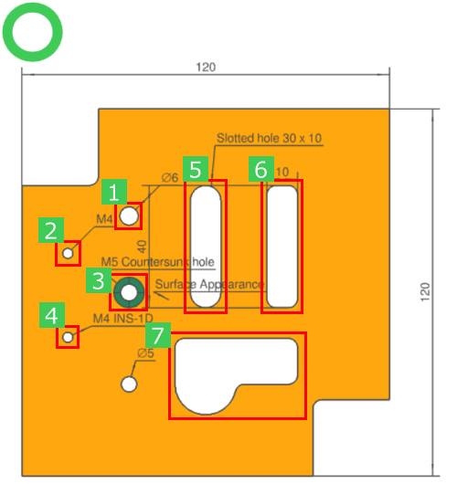

|  |  |  |  |  |  |  |  |
| --- | --- | --- | --- | --- | --- | --- | --- |
| No. | **1** | **2** | **3** | **4** | **5** | **6** | **7** |
| Hole type | Through hole | Tapped hole | Countersunk hole | Insert | Slotted hole | Rectangular hole | Free-form hole |

Not eligible: Bending

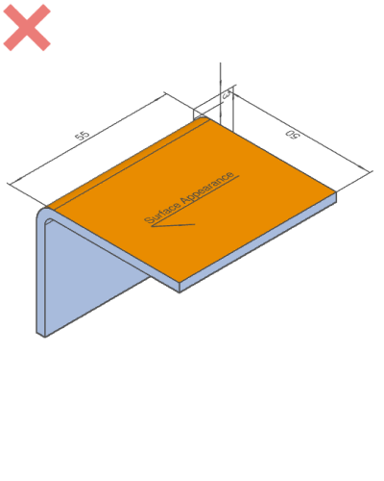

### Materials / Plate Thicknesses Eligible for Clear Resin

* Material available: PET, acrylic, polycarbonate and PVC.
* Each material is available in two grades and two colors, so please choose the material that best suits your needs.

|  |  |  |  |  |  |
| --- | --- | --- | --- | --- | --- |
| Material: Clear Resin | Grade | Color | Total Light Transmittance *1 | Operating Ambient Temperature *1 | Plate Thickness *2 |
| PET (Polyethylene terephthalate) | Standard | Transparent | 87% | * -15 to 55°C * (5 to 131°F) | 3.0mm (.1181″), 5.0mm(.1969″), 8.0mm(.3150″) |
| Smoky Brown | 28% | 3.0mm (.1181″), 5.0mm(.1969″) |
| Anti-Static | Transparent | 77% |
| Smoky Brown | 30% |
| Acrylic | Standard | Transparent | 93% | * -40 to 65°C * (-40 to 149°F) | 3.0mm (.1181″), 5.0mm(.1969″), 8.0mm(.3150″), 10.0mm(.3937″) |
| Smoky Brown | 28% | 3.0mm (.1181″), 5.0mm(.1969″) |
| Anti-Static | Transparent | 87% |
| Smoky Brown | 25% |
| Polycarbonate | Standard | Transparent | 89% | * -40 to 120°C * (-40 to 248°F) | 3.0mm (.1181″), 5.0mm(.1969″) |
| Smoky Brown | 35% |
| Anti-Static | Transparent | 86% |
| Smoky Brown | 32% |
| PVC (polyvinyl chloride) | Standard | Transparent | 83% | * -10 to 60°C * (14 to 140°F) | 3.0mm (.1181″), 5.0mm(.1969″) |
| Smoky Brown | 27% |
| Anti-Static | Transparent | 77% |
| Smoky Brown | 30% |

*1 This is an approximate value only and should not be considered a guaranteed value.

*2 The plate thickness tolerance is ±0.2 with a thickness of 3.0, and ±0.3 with a thickness of 5.0.

### Transparent resin materials

Material color may vary between orders based on availability.

## Basic Modeling Rules

| Modeling Rules | | Example |
| --- | --- | --- |
| The plate thickness must be uniform. | Example | |
| Model the inner radius (R) of a bend to be 0 or more and the plate thickness or less. Model the outer radius (R) to be [inner radius R] + [plate thickness].   * *Automatic quotation is not possible for models with non-uniform thickness. The model modification function can be used to fix these models and may allow automatic quotation.   For more information, please click [here](https://us.meviy.misumi-ec.com/help/en/technical_info-en-c/shm_guideline-en-c/9695/help/en/operation_manual-en-c/shm_configuration-en-c/9755/). | Example | |
| * *Bending inner radius should be 10mm (.254″) or more, and bending outer radius should be inner radius + plate thickness. * *For the range of bending radius, please refer to the “[Range of Bending Radius](https://us.meviy.misumi-ec.com/help/en/technical_info-en-c/shm_shape-material-en-c/16861/)“. | Example | |

## Hole Identification Specifications

* After CAD data is uploaded to meviy, it is internally converted into a neutral file format. During this conversion, the hole type information (tapped hole, countersunk hole, etc.) is lost.
* As a default hole recognition setting, hole diameter and shape features are detected and compared to the hole information database to infer the hole information that will be carried over to the meviy platform.
* However, SOLIDWORKS users can use a new function that allows you to change user settings to directly transfer original hole information from CAD data to meviy.

Please click [here](https://us.meviy.misumi-ec.com/help/en/operation_manual-en-c/first-en-c/9845/) for more information.

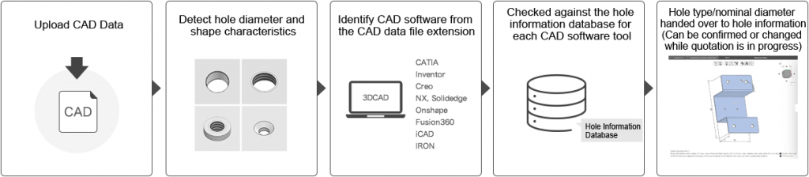

## Tapped Hole Identification and Selectable Sizes

**Inch Thickness Gauge Standard**

**Tapped Hole Identification**

* Hole diameter information in meviy’s hole information database is registered corresponding to the nominal diameters of tapped holes from each uploadable file extension. Detected hole diameters are checked against the table below (Table 1).
* *If the detected diameter does not match any entry in the table, the hole will be treated as a through hole. However, you can change the hole type or nominal diameter when configuring the quote settings.
* *If a diameter corresponds to multiple nominal diameters (below, 5.00 mm), the larger nominal diameter (M6) will be prioritized and selected.

**Table 1) With Default Settings: Table of Hole Diameters Corresponding to Tapped Hole Identification by File Extension**

| Tapped Hole Nominal Diameter | Thread Type | File Extension | | | |
| --- | --- | --- | --- | --- | --- |
| STEP (.step / .stp) Parasolid (.x_t/.x_b/.xmt /.xmt_txt) ACIS (.sat/.sab) JT (.jt) PRC (.prc) I-deas (.arc/.unv) | | | | SOLIDWORKS (.sldprt) | | | | Solid Edge (.par/.pwd) | Creo (.neu/.prt/.xpr) | | Autodesk Inventor (.ipt) | | |
| #1-64 | UNC | 1.42 | 1.43 | 1.5 | 1.51 | 1.59 | 1.85 |  | 1.51 | | | 1.51 | | 1.42 | 1.85 | | 1.51 | 1.43 |
| #1-72 | UNF | 1.47 | 1.51 | 1.54 | 1.61 | 1.85 |  |  | 1.51 | | | 1.51 | | 1.47 | 1.85 | | 1.51 | 1.47 |
| #2-56 | UNC | 1.69 | 1.78 | 1.85 | 2.18 |  |  |  | 1.78 | | | 1.78 | | 1.69 | 2.18 | | 1.78 | 1.69 |
| #2-64 | UNF | 1.76 | 1.78 | 1.83 | 1.93 | 1.99 | 2.18 |  | 1.78 | | | 2.18 | | 1.99 | 2.18 | | 1.78 | 1.76 |
| #3-48 | UNC | 1.94 | 1.99 | 2.04 | 2.18 | 2.51 |  |  | 1.99 | | | 1.99 | | 1.94 | 2.51 | | 1.99 | 1.94 |
| #3-56 | UNF | 2.02 | 2.08 | 2.11 | 2.26 | 2.51 |  |  | 2.08 | | | 2.08 | | 2.02 | 2.51 | | 2.08 | 2.02 |
| #4-40 | UNC | 2.16 | 2.26 | 2.27 | 2.44 | 2.84 |  |  | 2.26 | | | 2.26 | | 2.16 | 2.84 | | 2.26 | 2.16 |
| #4-48 | UNF | 2.12 | 2.16 | 2.27 | 2.36 | 2.37 | 2.38 | 2.49 | 2.37 | | | 2.12 | | 2.27 | 2.84 | | 2.38 | 2.27 |
| #5-40 | UNC | 2.49 | 2.58 | 2.59 | 2.78 | 3.18 |  |  | 2.58 | | | 2.58 | | 2.49 | 3.18 | | 2.58 | 2.49 |
| #5-44 | UNF | 2.55 | 2.64 | 2.65 | 2.79 | 3.18 |  |  | 2.64 | | | 2.64 | | 2.55 | 3.18 | | 2.64 | 2.55 |
| #6-32 | UNC | 2.64 | 2.65 | 2.71 | 2.77 | 2.95 | 3.51 |  | 2.71 | | | 2.71 | | 2.65 | 3.51 | | 2.71 | 2.64 |
| #6-40 | UNF | 2.82 | 2.87 | 2.92 | 3.05 | 3.51 |  |  | 2.87 | | | 2.87 | | 2.82 | 3.51 | | 2.87 | 2.82 |
| #8-32 | UNC | 3.3 | 3.31 | 3.42 | 3.45 | 3.66 | 4.17 |  | 3.45 | | | 3.45 | | 3.31 | 4.17 | | 3.45 | 3.3 |
| #8-36 | UNF | 3.4 | 3.45 | 3.51 | 3.73 | 4.17 |  |  | 3.45 | | | 3.45 | | 3.4 | 4.17 | | 3.45 | 3.4 |
| #10-24 | UNC | 3.68 | 3.8 | 3.82 | 4.09 | 4.83 |  |  | 3.8 | | | 3.8 | | 3.68 | 4.83 | | 3.8 | 3.68 |
| #10-32 | UNF | 3.96 | 3.97 | 4.04 | 4.06 | 4.31 | 4.83 |  | 4.04 | | | 4.04 | | 3.97 | 4.83 | | 4.04 | 3.96 |
| #12-24 | UNC | 4.34 | 4.47 | 4.5 | 4.8 | 5.49 |  |  | 4.5 | | | 4.5 | | 4.34 | 5.49 | | 4.5 | 4.34 |
| #12-28 | UNF | 4.5 | 4.61 | 4.62 | 4.91 | 5.49 |  |  | 4.62 | | | 4.62 | | 4.5 | 5.49 | | 4.62 | 4.5 |
| 1/4-20 | UNC | 4.98 | 5.08 | 5.11 | 5.12 | 5.56 | 6.35 |  | 5.11 | | | 5.11 | | 4.98 | 6.35 | | 5.11 | 4.98 |
| 1/4-28 | UNF | 5.36 | 5.37 | 5.41 | 5.44 | 5.47 | 5.79 | 6.35 | 5.41 | | | 5.41 | | 5.37 | 6.35 | | 5.41 | 5.36 |
| 5/16-18 | UNC | 6.4 | 6.41 | 6.53 | 6.57 | 7.04 | 7.94 |  | 6.53 | | | 6.53 | | 6.41 | 7.94 | | 6.53 | 6.4 |
| 5/16-24 | UNF | 6.78 | 6.79 | 6.91 | 7.14 | 7.94 |  |  | 6.91 | | | 6.91 | | 6.79 | 7.94 | | 6.91 | 6.78 |
| 3/8-16 | UNC | 7.8 | 7.81 | 7.94 | 7.98 | 8.43 | 9.53 |  | 7.94 | | | 7.94 | | 7.81 | 9.53 | | 7.94 | 7.8 |
| 3/8-24 | UNF | 8.38 | 8.43 | 8.51 | 8.84 | 9.53 |  |  | 8.43 | | | 8.43 | | 8.38 | 9.53 | | 8.43 | 8.38 |
| 7/16-14 | UNC | 9.14 | 9.15 | 9.35 | 9.92 | 11.11 |  |  | 9.35 | | | 9.35 | | 9.15 | 11.11 | | 9.35 | 9.14 |
| 7/16-20 | UNF | 9.73 | 9.74 | 9.88 | 9.92 | 10.32 | 11.11 |  | 9.92 | | | 9.92 | | 9.74 | 11.11 | | 9.92 | 9.73 |
| 1/2-13 | UNC | 10.58 | 10.59 | 10.72 | 10.81 | 11.51 | 12.7 |  | 10.72 | | | 10.72 | | 10.58 | 12.7 | | 10.72 | 10.59 |
| 1/2-20 | UNF | 11.33 | 11.47 | 11.51 | 11.91 | 12.7 |  |  | 11.51 | | | 11.51 | | 11.33 | 12.7 | | 11.51 | 11.33 |
| 9/16-12 | UNC | 11.99 | 12 | 12.22 | 12.3 | 13.1 | 14.29 |  | 12.3 | | | 12.3 | | 12 | 14.29 | | 12.3 | 11.99 |
| 9/16-18 | UNF | 12.75 | 12.76 | 12.86 | 12.92 | 13.1 | 13.49 | 14.29 | 13.1 | | | 13.1 | | 12.76 | 14.29 | | 12.86 | 12.75 |
| 5/8-11 | UNC | 13.38 | 13.39 | 13.49 | 13.63 | 14.29 | 15.88 |  | 13.49 | | | 13.49 | | 13.38 | 15.88 | | 13.49 | 13.39 |
| 5/8-18 | UNF | 14.28 | 14.35 | 14.52 | 14.68 | 15.08 | 15.88 |  | 14.68 | | | 14.68 | | 14.35 | 15.88 | | 14.28 | 14.35 |

* To aid correct identification of tapped holes, it is recommend that you specify the CAD package you normally use in “Automatic Hole Type Recognition.”
* Hole diameters detected by the meviy platform will then be checked against the hole diameters for the specified CAD package (Table 2).
* *The link below provides more information on configuring settings.
* [Configurable Settings on Settings Screen: Automatic Hole Type Recognition](https://us.meviy.misumi-ec.com/help/en/operation_manual-en-c/first-en-c/9845/)

**Table 2) With Tapped Hole Identification Settings: Table of Hole Diameters Identified as Tapped Holes for Each Specified CAD Package**

| Tapped Hole Nominal Diameter | | Coarse or Fine | | Tapped Hole Identification Settings | | | | | | | | | | | | | |
| --- | --- | --- | --- | --- | --- | --- | --- | --- | --- | --- | --- | --- | --- | --- | --- | --- | --- |
| SOLIDWORKS | | | Solid Edge | | | | | | | Creo | Onshape | Autodesk Inventor | |
| A Type (*1) | | B Type (*2) | Tap drill diameter | | Internal minor diameter | | | Nominal diameter | |
| #1-64 | UNC | | 1.51 | | 1.51 | | | 1.42 | | 1.85 | 1.51 | | 1.51 | | | | 1.43 |
| #1-72 | UNF | | 1.47 | | 1.47 |
| #2-56 | UNC | | 1.78 | | 1.78 | | | 1.69 | | 2.18 | 1.78 | | 1.78 | | | | 1.69 |
| #2-64 | UNF | | 2.18 | | | 1.99 | | 1.76 |
| #3-48 | UNC | | 1.99 | | 1.99 | | | 1.94 | | 2.51 | 1.99 | | 1.99 | | | | 1.94 |
| #3-56 | UNF | | 2.08 | | 2.08 | | | 2.02 | | 2.08 | | 2.08 | | | | 2.02 |
| #4-40 | UNC | | 2.26 | | 2.26 | | | 2.16 | | 2.84 | 2.26 | | 2.26 | | | | 2.16 |
| #4-48 | UNF | | 2.37 | | 2.12 | | | 2.27 | | 2.38 | | 2.37 | | | | 2.27 |
| #5-40 | UNC | | 2.58 | | 2.58 | | | 2.49 | | 3.18 | 2.58 | | 2.58 | | | | 2.49 |
| #5-44 | UNF | | 2.64 | | 2.64 | | | 2.55 | | 2.64 | | 2.64 | | | | 2.55 |
| #6-32 | UNC | | 2.71 | | 2.71 | | | 2.65 | | 3.51 | 2.71 | | 2.71 | | | | 2.64 |
| #6-40 | UNF | | 2.87 | | 2.87 | | | 2.82 | | 2.87 | | 2.87 | | | | 2.82 |
| #8-32 | UNC | | 3.45 | | 3.45 | | | 3.31 | | 4.17 | 3.45 | | 3.45 | | | | 3.3 |
| #8-36 | UNF | | 3.4 | | 3.4 |
| #10-24 | UNC | | 3.8 | | 3.8 | | | 3.68 | | 4.83 | 3.8 | | 3.8 | | | | 3.68 |
| #10-32 | UNF | | 4.04 | | 4.04 | | | 3.97 | | 4.04 | | 4.04 | | | | 3.96 |
| #12-24 | UNC | | 4.5 | | 4.5 | | | 4.34 | | 5.49 | 4.5 | | 4.5 | | | | 4.34 |
| #12-28 | UNF | | 4.62 | | 4.62 | | | 4.5 | | 4.62 | | 4.62 | | | | 4.5 |
| 1/4-20 | UNC | | 5.11 | | 5.11 | | | 4.98 | | 6.35 | 5.11 | | 5.11 | | | | 4.98 |
| 1/4-28 | UNF | | 5.41 | | 5.41 | | | 5.37 | | 5.41 | | 5.41 | | | | 5.36 |
| 5/16-18 | UNC | | 6.53 | | 6.53 | | | 6.41 | | 7.94 | 6.53 | | 6.53 | | | | 6.4 |
| 5/16-24 | UNF | | 6.91 | | 6.91 | | | 6.79 | | 6.91 | | 6.91 | | | | 6.78 |
| 3/8-16 | UNC | | 7.94 | | 7.94 | | | 7.81 | | 9.53 | 7.94 | | 7.94 | | | | 7.8 |
| 3/8-24 | UNF | | 8.43 | | 8.43 | | | 8.38 | | 8.43 | | 8.43 | | | | 8.38 |
| 7/16-14 | UNC | | 9.35 | | 9.35 | | | 9.15 | | 11.11 | 9.35 | | 9.35 | | | | 9.14 |
| 7/16-20 | UNF | | 9.92 | | 9.92 | | | 9.74 | | 9.92 | | 9.92 | | | | 9.73 |
| 1/2-13 | UNC | | 10.72 | | 10.72 | | | 10.58 | | 12.7 | 10.72 | | 10.72 | | | | 10.59 |
| 1/2-20 | UNF | | 11.51 | | 11.51 | | | 11.33 | | 11.51 | | 11.51 | | | | 11.33 |
| 9/16-12 | UNC | | 12.3 | | 12.3 | | | 12 | | 14.29 | 12.3 | | 12.3 | | | | 11.99 |
| 9/16-18 | UNF | | 13.1 | | 13.1 | | | 12.76 | | 12.86 | | 13.1 | | | | 12.75 |
| 5/8-11 | UNC | | 13.49 | | 13.49 | | | 13.38 | | 15.88 | 13.49 | | 13.49 | | | | 13.39 |
| 5/8-18 | UNF | | 14.68 | | 14.68 | | | 14.35 | | 14.28 | | 14.68 | | | | 14.35 |

*1 When the SOLIDWORKS hole options selected are “Tap drill diameter” or “Cosmetic threads.”

*2 When the SOLIDWORKS hole option selected is “Remove threads.”

**Tapped Hole Size Selection**

Tapped holes cannot be selected for perforated metals, shim plate materials (Cold Rolled Low Carbon Steel (for Shims) or 304 Stainless Steel (H) (for Shims)) or clear resin.

Available tap sizes are grouped by material and may not be available for all material types listed.

| Material | Sheet thickness (Gauge) | | Sheet thickness (Inch) | | Tapped Hole Diameter | | | | | | | | | | | | | | | | | | | | | | | | | | | | | | | | | | | | | | | | | | | | | | | | | | | | | | | | | | | |
| --- | --- | --- | --- | --- | --- | --- | --- | --- | --- | --- | --- | --- | --- | --- | --- | --- | --- | --- | --- | --- | --- | --- | --- | --- | --- | --- | --- | --- | --- | --- | --- | --- | --- | --- | --- | --- | --- | --- | --- | --- | --- | --- | --- | --- | --- | --- | --- | --- | --- | --- | --- | --- | --- | --- | --- | --- | --- | --- | --- | --- | --- | --- | --- | --- |
| UNC | | UNC | | UNC | | UNC | | UNC | | UNF | | UNC | | UNF | | UNC | | UNF | | UNC | | UNF | | UNC | | UNF | | UNC | | UNF | | UNC | | UNF | | UNC | | UNF | | UNC | | UNF | | UNC | | UNF | | UNC | | UNF | | UNF | | UNF | | UNF | | UNF | |
| * Cold Rolled Low Carbon Steel * Hot Rolled Low Carbon Steel | | 26 | | 0.0179″ | | – | | – | | – | | – | | – | | – | | – | | – | | – | | – | | – | | – | | – | | – | | – | | – | | – | | – | | – | | – | | – | | – | | – | | – | | – | | – | | – | | – | | – | | – |
| 24 | | 0.0239″ | | – | | – | | – | | – | | – | | – | | – | | – | | – | | – | | – | | – | | – | | – | | – | | – | | – | | – | | – | | – | | – | | – | | – | | – | | – | | – | | – | | – | | – | | – |
| 22 | | 0.0299″ | | – | | – | | – | | – | | – | | – | | – | | – | | – | | – | | – | | – | | – | | – | | – | | – | | – | | – | | – | | – | | – | | – | | – | | – | | – | | – | | – | | – | | – | | – |
| 20 | | 0.0359″ | | – | | – | | – | | – | | – | | – | | – | | – | | – | | – | | – | | – | | – | | – | | – | | – | | – | | – | | – | | – | | – | | – | | – | | – | | – | | – | | – | | – | | – | | – |
| 19 | | 0.0418″ | | – | | – | | – | | – | | – | | – | | – | | – | | – | | – | | – | | – | | – | | – | | – | | – | | – | | – | | – | | – | | – | | – | | – | | – | | – | | – | | – | | – | | – | | – |
| 18 | | 0.0478″ | | #2-56 * | | #2-64 * | | #3-48 * | | #3-56 * | | #4-40 | | #4-48 | | #5-40 * | | #5-44 * | | #6-32 * | | #6-40 * | | – | | – | | – | | – | | – | | – | | – | | – | | – | | – | | – | | – | | – | | – | | – | | – | | – | | – | | – | | – |
| 17 | | 0.0538″ | | – | | – | | – | | – | | #4-40 | | #4-48 | | – | | – | | – | | – | | – | | – | | – | | – | | – | | – | | – | | – | | – | | – | | – | | – | | – | | – | | – | | – | | – | | – | | – | | – |
| 16 | | 0.0598″ | | #2-56 * | | #2-64 * | | #3-48 * | | #3-56 * | | #4-40 | | #4-48 | | #5-40 * | | #5-44 * | | #6-32 * | | #6-40 * | | #8-32 * | | #8-36 * | | – | | #10-32 * | | – | | – | | – | | – | | – | | – | | – | | – | | – | | – | | – | | – | | – | | – | | – | | – |
| 14 | | 0.0747″ | | – | | – | | – | | – | | #4-40 | | #4-48 | | #5-40 | | #5-44 | | #6-32 | | #6-40 | | #8-32 | | #8-36 | | – | | – | | – | | – | | – | | – | | – | | – | | – | | – | | – | | – | | – | | – | | – | | – | | – | | – |
| 13 | | 0.0897″ | | – | | – | | – | | – | | #4-40 | | #4-48 | | #5-40 | | #5-44 | | #6-32 | | #6-40 | | #8-32 | | #8-36 | | – | | – | | – | | – | | – | | – | | – | | – | | – | | – | | – | | – | | – | | – | | – | | – | | – | | – |
| 12 | | 0.1046″ | | – | | – | | – | | – | | #4-40 | | #4-48 | | #5-40 | | #5-44 | | #6-32 | | #6-40 | | #8-32 | | #8-36 | | #10-24 | | #10-32 | | – | | – | | – | | – | | – | | – | | – | | – | | – | | – | | – | | – | | – | | – | | – | | – |
| 11 | | 0.1196″ | | – | | – | | – | | – | | #4-40 | | #4-48 | | #5-40 | | #5-44 | | #6-32 | | #6-40 | | #8-32 | | #8-36 | | #10-24 | | #10-32 | | – | | – | | – | | – | | – | | – | | – | | – | | – | | – | | – | | – | | – | | – | | – | | – |
| 10 | | 0.1345″ | | – | | – | | – | | – | | #4-40 | | #4-48 | | #5-40 | | #5-44 | | #6-32 | | #6-40 | | #8-32 | | #8-36 | | #10-24 | | #10-32 | | #12-24 | | #12-28 | | – | | – | | – | | – | | – | | – | | – | | – | | – | | – | | – | | – | | – | | – |
| 8 | | 0.1644″ | | – | | – | | – | | – | | #4-40 | | #4-48 | | #5-40 | | #5-44 | | #6-32 | | #6-40 | | #8-32 | | #8-36 | | #10-24 | | #10-32 | | #12-24 | | #12-28 | | 1/4-20 | | 1/4-28 | | 5/16-18 | | 5/16-24 | | 3/8-16 | | 3/8-24 | | 7/16-14 | | 7/16-20 | | 1/2-13 | | 1/2-20 | | – | | 5/8-18 | | – | | 3/4-16 |
| 7 | | 0.1793″ | | – | | – | | – | | – | | #4-40 | | #4-48 | | #5-40 | | #5-44 | | #6-32 | | #6-40 | | #8-32 | | #8-36 | | #10-24 | | #10-32 | | #12-24 | | #12-28 | | 1/4-20 | | 1/4-28 | | 5/16-18 | | 5/16-24 | | 3/8-16 | | 3/8-24 | | 7/16-14 | | 7/16-20 | | 1/2-13 | | 1/2-20 | | – | | 5/8-18 | | – | | 3/4-16 |
| 6 | | 0.1943″ | | – | | – | | – | | – | | #4-40 | | #4-48 | | #5-40 | | #5-44 | | #6-32 | | #6-40 | | #8-32 | | #8-36 | | #10-24 | | #10-32 | | #12-24 | | #12-28 | | 1/4-20 | | 1/4-28 | | 5/16-18 | | 5/16-24 | | – | | – | | – | | – | | – | | – | | – | | – | | – | | – |
| – | | 0.2500″ | | – | | – | | – | | – | | #4-40 | | #4-48 | | #5-40 | | #5-44 | | #6-32 | | #6-40 | | #8-32 | | #8-36 | | #10-24 | | #10-32 | | #12-24 | | #12-28 | | 1/4-20 | | 1/4-28 | | 5/16-18 | | 5/16-24 | | – | | – | | – | | – | | – | | – | | – | | – | | – | | – |
| – | | 0.3750″ | | – | | – | | – | | – | | #4-40 | | #4-48 | | #5-40 | | #5-44 | | #6-32 | | #6-40 | | #8-32 | | #8-36 | | #10-24 | | #10-32 | | #12-24 | | #12-28 | | 1/4-20 | | 1/4-28 | | 5/16-18 | | 5/16-24 | | – | | – | | – | | – | | – | | – | | – | | – | | – | | – |
| * Cold Rolled Low Carbon Steel (Electrolytic Galvanized) * Cold Rolled Low Carbon Steel (Hot Galvanized) | | 24 | | 0.0276″ | | – | | – | | – | | – | | – | | – | | – | | – | | – | | – | | – | | – | | – | | – | | – | | – | | – | | – | | – | | – | | – | | – | | – | | – | | – | | – | | – | | – | | – | | – |
| 22 | | 0.0336″ | | – | | – | | – | | – | | – | | – | | – | | – | | – | | – | | – | | – | | – | | – | | – | | – | | – | | – | | – | | – | | – | | – | | – | | – | | – | | – | | – | | – | | – | | – |
| 20 | | 0.0396″ | | – | | – | | – | | – | | – | | – | | – | | – | | – | | – | | – | | – | | – | | – | | – | | – | | – | | – | | – | | – | | – | | – | | – | | – | | – | | – | | – | | – | | – | | – |
| 18 | | 0.0516″ | | – | | – | | – | | – | | #4-40 | | #4-48 | | – | | – | | – | | – | | – | | – | | – | | – | | – | | – | | – | | – | | – | | – | | – | | – | | – | | – | | – | | – | | – | | – | | – | | – |
| 16 | | 0.0635″ | | – | | – | | – | | – | | #4-40 | | #4-48 | | #5-40 | | #5-44 | | – | | – | | – | | – | | – | | – | | – | | – | | – | | – | | – | | – | | – | | – | | – | | – | | – | | – | | – | | – | | – | | – |
| 14 | | 0.0785″ | | – | | – | | – | | – | | #4-40 | | #4-48 | | #5-40 | | #5-44 | | #6-32 | | #6-40 | | #8-32 | | #8-36 | | – | | – | | – | | – | | – | | – | | – | | – | | – | | – | | – | | – | | – | | – | | – | | – | | – | | – |
| * 304 Stainless Steel (2B) * 304 Stainless Steel (No.4) * 316 Stainless Steel (2B) | | 22 | | 0.0312″ | | – | | #2-64 | | – | | – | | – | | – | | – | | – | | – | | – | | – | | – | | – | | – | | – | | – | | – | | – | | – | | – | | – | | – | | – | | – | | – | | – | | – | | – | | – | | – |
| 20 | | 0.0375″ | | #2-56 | | #2-64 | | – | | #3-56 | | – | | #4-48 | | – | | – | | – | | – | | – | | – | | – | | – | | – | | – | | – | | – | | – | | – | | – | | – | | – | | – | | – | | – | | – | | – | | – | | – |
| 19 | | 0.0437″ | | – | | – | | – | | – | | – | | – | | – | | – | | – | | – | | – | | – | | – | | – | | – | | – | | – | | – | | – | | – | | – | | – | | – | | – | | – | | – | | – | | – | | – | | – |
| 18 | | 0.0500″ | | #2-56 | | #2-64 | | #3-48 | | #3-56 | | #4-40 | | #4-48 | | #5-40 | | #5-44 | | #6-32 | | #6-40 | | – | | – | | – | | – | | – | | – | | – | | – | | – | | – | | – | | – | | – | | – | | – | | – | | – | | – | | – | | – |
| 17 | | 0.0562″ | | – | | – | | – | | – | | #4-40 | | #4-48 | | – | | – | | – | | – | | – | | – | | – | | – | | – | | – | | – | | – | | – | | – | | – | | – | | – | | – | | – | | – | | – | | – | | – | | – |
| 16 | | 0.0625″ | | #2-56 | | #2-64 | | #3-48 | | #3-56 | | #4-40 | | #4-48 | | #5-40 | | #5-44 | | #6-32 | | #6-40 | | #8-32 | | #8-36 | | – | | #10-32 | | – | | – | | – | | – | | – | | – | | – | | – | | – | | – | | – | | – | | – | | – | | – | | – |
| 14 | | 0.0781″ | | #2-56 | | #2-64 | | #3-48 | | #3-56 | | #4-40 | | #4-48 | | #5-40 | | #5-44 | | #6-32 | | #6-40 | | #8-32 | | #8-36 | | #10-24 | | #10-32 | | #12-24 | | #12-28 | | – | | 1/4-28 | | – | | – | | – | | – | | – | | – | | – | | – | | – | | – | | – | | – |
| 13 | | 0.0937″ | | – | | – | | – | | – | | #4-40 | | #4-48 | | #5-40 | | #5-44 | | #6-32 | | #6-40 | | #8-32 | | #8-36 | | – | | – | | – | | – | | – | | – | | – | | – | | – | | – | | – | | – | | – | | – | | – | | – | | – | | – |
| 12 | | 0.1094″ | | #2-56 | | #2-64 | | #3-48 | | #3-56 | | #4-40 | | #4-48 | | #5-40 | | #5-44 | | #6-32 | | #6-40 | | #8-32 | | #8-36 | | #10-24 | | #10-32 | | #12-24 | | #12-28 | | 1/4-20 | | 1/4-28 | | – | | 5/16-24 | | – | | 3/8-24 | | – | | 7/16-20 | | – | | – | | – | | – | | – | | – |
| 11 | | 0.1250″ | | #2-56 | | #2-64 | | #3-48 | | #3-56 | | #4-40 | | #4-48 | | #5-40 | | #5-44 | | #6-32 | | #6-40 | | #8-32 | | #8-36 | | #10-24 | | #10-32 | | #12-24 | | #12-28 | | 1/4-20 | | 1/4-28 | | 5/16-18 | | 5/16-24 | | – | | 3/8-24 | | – | | 7/16-20 | | – | | 1/2-20 | | – | | – | | – | | – |
| 10 | | 0.1406″ | | #2-56 | | #2-64 | | #3-48 | | #3-56 | | #4-40 | | #4-48 | | #5-40 | | #5-44 | | #6-32 | | #6-40 | | #8-32 | | #8-36 | | #10-24 | | #10-32 | | #12-24 | | #12-28 | | 1/4-20 | | 1/4-28 | | 5/16-18 | | 5/16-24 | | 3/8-16 | | 3/8-24 | | 7/16-14 | | 7/16-20 | | – | | 1/2-20 | | – | | 5/8-18 | | – | | 3/4-16 |
| 8 | | 0.1719″ | | – | | – | | – | | – | | #4-40 | | #4-48 | | #5-40 | | #5-44 | | #6-32 | | #6-40 | | #8-32 | | #8-36 | | #10-24 | | #10-32 | | #12-24 | | #12-28 | | 1/4-20 | | 1/4-28 | | – | | – | | – | | – | | – | | – | | – | | – | | – | | – | | – | | – |
| 7 | | 0.1875″ | | – | | – | | – | | – | | – | | – | | #5-40 | | #5-44 | | #6-32 | | #6-40 | | #8-32 | | #8-36 | | #10-24 | | #10-32 | | #12-24 | | #12-28 | | 1/4-20 | | 1/4-28 | | 5/16-18 | | 5/16-24 | | 3/8-16 | | 3/8-24 | | 7/16-14 | | 7/16-20 | | 1/2-13 | | 1/2-20 | | – | | 5/8-18 | | – | | 3/4-16 |
| 3 | | 0.2500″ | | – | | – | | – | | – | | – | | – | | – | | – | | – | | – | | – | | – | | – | | – | | – | | – | | – | | – | | – | | – | | – | | – | | – | | – | | – | | – | | – | | – | | – | | – |
| * 5052 Aluminum Alloy * 6061 Aluminum Alloy | | – | | 0.020″ | | – | | – | | – | | – | | – | | – | | – | | – | | – | | – | | – | | – | | – | | – | | – | | – | | – | | – | | – | | – | | – | | – | | – | | – | | – | | – | | – | | – | | – | | – |
| – | | 0.025″ | | – | | – | | – | | – | | – | | – | | – | | – | | – | | – | | – | | – | | – | | – | | – | | – | | – | | – | | – | | – | | – | | – | | – | | – | | – | | – | | – | | – | | – | | – |
| – | | 0.032″ | | – | | – | | – | | – | | – | | – | | – | | – | | – | | – | | – | | – | | – | | – | | – | | – | | – | | – | | – | | – | | – | | – | | – | | – | | – | | – | | – | | – | | – | | – |
| – | | 0.040″ | | – | | – | | – | | – | | #4-40 | | #4-48 | | – | | – | | – | | – | | – | | – | | – | | – | | – | | – | | – | | – | | – | | – | | – | | – | | – | | – | | – | | – | | – | | – | | – | | – |
| – | | 0.050″ | | – | | – | | – | | – | | #4-40 | | #4-48 | | #5-40 | | #5-44 | | – | | – | | – | | – | | – | | – | | – | | – | | – | | – | | – | | – | | – | | – | | – | | – | | – | | – | | – | | – | | – | | – |
| – | | 0.080″ | | – | | – | | – | | – | | #4-40 | | #4-48 | | #5-40 | | #5-44 | | #6-32 | | #6-40 | | #8-32 | | #8-36 | | #10-24 | | #10-32 | | – | | – | | – | | – | | – | | – | | – | | – | | – | | – | | – | | – | | – | | – | | – | | – |
| – | | 0.090″ | | – | | – | | – | | – | | #4-40 | | #4-48 | | #5-40 | | #5-44 | | #6-32 | | #6-40 | | #8-32 | | #8-36 | | #10-24 | | #10-32 | | – | | – | | – | | – | | – | | – | | – | | – | | – | | – | | – | | – | | – | | – | | – | | – |
| – | | 0.100″ | | – | | – | | – | | – | | #4-40 | | #4-48 | | #5-40 | | #5-44 | | #6-32 | | #6-40 | | #8-32 | | #8-36 | | #10-24 | | #10-32 | | #12-24 | | #12-28 | | – | | – | | – | | – | | – | | – | | – | | – | | – | | – | | – | | – | | – | | – |
| – | | 0.125″ | | – | | – | | – | | – | | #4-40 | | #4-48 | | #5-40 | | #5-44 | | #6-32 | | #6-40 | | #8-32 | | #8-36 | | #10-24 | | #10-32 | | #12-24 | | #12-28 | | 1/4-20 | | 1/4-28 | | – | | – | | – | | – | | – | | – | | – | | – | | – | | – | | – | | – |
| – | | 0.160″ | | – | | – | | #3-48 | | #3-56 | | #4-40 | | #4-48 | | #5-40 | | #5-44 | | #6-32 | | #6-40 | | #8-32 | | #8-36 | | #10-24 | | #10-32 | | #12-24 | | #12-28 | | 1/4-20 | | 1/4-28 | | 5/16-18 | | 5/16-24 | | 3/8-16 | | 3/8-24 | | 7/16-14 | | 7/16-20 | | – | | 1/2-20 | | – | | 5/8-18 | | – | | 3/4-16 |
| – | | 0.190″ | | – | | – | | – | | – | | – | | – | | #5-40 | | #5-44 | | #6-32 | | #6-40 | | #8-32 | | #8-36 | | #10-24 | | #10-32 | | #12-24 | | #12-28 | | 1/4-20 | | 1/4-28 | | 5/16-18 | | 5/16-24 | | 3/8-16 | | 3/8-24 | | 7/16-14 | | 7/16-20 | | 1/2-13 | | 1/2-20 | | – | | 5/8-18 | | – | | 3/4-16 |
| – | | 0.250″ | | – | | – | | – | | – | | – | | – | | – | | – | | – | | – | | #8-32 | | #8-36 | | #10-24 | | #10-32 | | #12-24 | | #12-28 | | 1/4-20 | | 1/4-28 | | 5/16-18 | | 5/16-24 | | 3/8-16 | | 3/8-24 | | 7/16-14 | | 7/16-20 | | 1/2-13 | | 1/2-20 | | 5/8-11 | | 5/8-18 | | 3/4-10 | | 3/4-16 |

*Only available for 5052 Aluminum Alloy.

**Metric Thickness Gauge Standard**

Available tap sizes are grouped by material and may not be available for all material types listed.

| Material | Sheet thickness (Gauge) | Sheet thickness (Inch) | | Tapped Hole Diameter | | | | | | | | | | | |
| --- | --- | --- | --- | --- | --- | --- | --- | --- | --- | --- | --- | --- | --- | --- | --- |
| * Cold Rolled Low Carbon Steel * Hot Rolled Low Carbon Steel | | | 26 | | 0.0179″ |  |  |  |  |  |  |  |  |  |  |
| 24 | | 0.0239″ |  |  |  |  |  |  |  |  |  |  |
| 22 | | 0.0299″ |  |  |  |  |  |  |  |  |  |  |
| 20 | | 0.0359″ |  |  |  |  |  |  |  |  |  |  |
| 19 | | 0.0418″ |  |  |  |  |  |  |  |  |  |  |
| 18 | | 0.0478″ | M2* | M2.5* | M3 |  |  |  |  |  |  |  |
| 17 | | 0.0538″ |  |  | M3 |  |  |  |  |  |  |  |
| 16 | | 0.0598″ | M2* | M2.5* | M3 | M4 |  |  |  |  |  |  |
| 14 | | 0.0747″ |  |  | M3 | M4 | M5 |  |  |  |  |  |
| 13 | | 0.0897″ |  |  | M3 | M4 | M5 |  |  |  |  |  |
| 12 | | 0.1046″ |  |  | M3 | M4 | M5 |  |  |  |  |  |
| 11 | | 0.1196″ |  |  | M3 | M4 | M5 |  |  |  |  |  |
| 10 | | 0.1345″ |  |  | M3 | M4 | M5 |  |  |  |  |  |
| 8 | | 0.1644″ |  | M2.5 | M3 | M4 | M5 | M6 | M8 | M10 |  |  |
| 7 | | 0.1793″ |  |  | M3 | M4 | M5 | M6 | M8 | M10 |  |  |
| 6 | | 0.1943″ |  |  | M3 | M4 | M5 | M6 | M8 | M10 | M12 | M14 |
| – | | 0.2500 |  |  | M3 | M4 | M5 | M6 | M8 | M10 | M12 | M14 |
| – | | 0.3750 |  |  | M3 | M4 | M5 | M6 | M8 | M10 | M12 | M14 |
| * Cold Rolled Low Carbon Steel (Electrolytic Galvanized) * Cold Rolled Low Carbon Steel (Hot Galvanized) | | | 24 | | 0.0276″ |  |  | M3 | M4 | M5 | M6 | M8 |  |  |  |
| 22 | | 0.0336″ |  | M2.5* | M3 | M4 | M5 | M6 | M8 | M10 |  |  |
| 20 | | 0.0396″ |  |  | M3 | M4 | M5 | M6 | M8 | M10 |  |  |
| 18 | | 0.0516″ |  |  | M3 | M4 | M5 | M6 | M8 | M10 | M12 | M14 |
| 16 | | 0.0635″ |  |  | M3 | M4 | M5 | M6 | M8 | M10 | M12 | M14 |
| 14 | | 0.0785″ |  |  | M3 | M4 | M5 | M6 | M8 | M10 | M12 | M14 |
| * 304 Stainless Steel (2B) * 304 Stainless Steel (No.4) * 316 Stainless Steel (2B) | | | 22 | | 0.0312″ | M2* |  |  |  |  |  |  |  |  |  |
| 20 | | 0.0375″ |  |  |  |  |  |  |  |  |  |  |
| 19 | | 0.0437″ | M2* | M2.5* | M3 |  |  |  |  |  |  |  |
| 18 | | 0.0500″ |  |  | M3 |  |  |  |  |  |  |  |
| 17 | | 0.0562″ | M2* | M2.5* | M3 | M4 |  |  |  |  |  |  |
| 16 | | 0.0625″ | M2* | M2.5* | M3 | M4 | M5 |  |  |  |  |  |
| 14 | | 0.0781″ |  |  | M3 | M4 | M5 |  |  |  |  |  |
| 13 | | 0.0937″ | M2* | M2.5* | M3 | M4 | M5 | M6 | M8 |  |  |  |
| 12 | | 0.1094″ |  | M2.5* | M3 | M4 | M5 | M6 | M8 | M10 |  |  |
| 11 | | 0.1250″ |  | M2.5* | M3 | M4 | M5 | M6 | M8 | M10 |  |  |
| 10 | | 0.1406″ |  |  | M3 | M4 | M5 | M6 | M8 | M10 | M12 |  |
| 8 | | 0.1719″ |  |  | M3 | M4 | M5 | M6 | M8 | M10 |  |  |
| 7 | | 0.1875″ |  |  |  | M4 | M5 | M6 | M8 | M10 |  |  |
| 3 | | 0.2500″ |  |  |  |  |  |  |  |  |  |  |
| * 5052 Aluminum Alloy * 6061 Aluminum Alloy * 5052 AL Alloy Pre-Finish, Clear Anodize​ * 5052 AL Alloy Pre-Finish, Black Anodize​ | | | – | | 0.020″ |  |  |  |  |  |  |  |  |  |  |
| – | | 0.025″ |  |  |  |  |  |  |  |  |  |  |
| – | | 0.032″ |  |  | M3 |  |  |  |  |  |  |  |
| – | | 0.040″ |  |  | M3 | M4 |  |  |  |  |  |  |
| – | | 0.050″ |  |  | M3 | M4 | M5 |  |  |  |  |  |
| – | | 0.080″ |  |  | M3 | M4 | M5 | M6 |  |  |  |  |
| – | | 0.090″ |  |  | M3 | M4 | M5 | M6 |  |  |  |  |
| – | | 0.100″ |  |  | M3 | M4 | M5 | M6 | M8 |  |  |  |
| – | | 0.125″ |  |  | M3 | M4 | M5 | M6 | M8 | M10 | M12 |  |
| – | | 0.1600″ |  | M2.5* | M3 | M4 | M5 | M6 | M8 | M10 |  |  |
| – | | 0.1900″ |  |  | M3 | M4 | M5 | M6 | M8 | M10 |  |  |
| – | | 0.2500″ |  |  |  | M4 | M5 | M6 | M8 | M10 |  |  |

**Tapped Hole Identification**

* Hole diameter information in meviy’s hole information database is registered corresponding to the nominal diameters of tapped holes from each uploadable file extension. Detected hole diameters are checked against the table below (Table 1).
* *If the detected diameter does not match any entry in the table, the hole will be treated as a through hole. However, you can change the hole type or nominal diameter when configuring the quote settings.
* *If a diameter corresponds to multiple nominal diameters (below, 5.00 mm), the larger nominal diameter (M6) will be prioritized and selected.

**Table 1) With Default Settings: Table of Hole Diameters Corresponding to Tapped Hole Identification by File Extension**

|  |  |  |  |  |  |  |  |  |
| --- | --- | --- | --- | --- | --- | --- | --- | --- |
| Tapped Hole Nominal Diameter | File Extension | | | | | | | |
| * STEP (.step / .stp) * Parasolid (.x_t/.x_b/.xmt /.xmt_txt) * ACIS (.sat/.sab) * JT (.jt) * PRC (.prc) * I-deas (.arc/.unv) | | | | | * SOLIDWORKS(.sldprt) * Siemens PLM-NX(.prt) * Creo (.neu/.prt/.xpr) * Solid Edge (.par/.pwd) * Pro/ENGINEER (.prt/.neu/.xpr) | * Autodesk Inventor(.ipt) * CATIA V5 (.CATPart) | iCAD SX (.icd) |
| M2 | 1.57 | 1.60 | 1.62 | 2.00 |  | 1.60 | 1.57 | 2.00 |
| M2.5 | 2.01 | 2.05 | 2.08 | 2.50 |  | 2.05 | 2.01 | 2.50 |
| M3 | 2.46 | 2.50 | 2.53 | 3.00 |  | 2.50 | 2.46 | 3.00 |
| M4 | 3.24 | 3.30 | 3.33 | 4.00 |  | 3.30 | 3.24 | 4.00 |
| M5 | 4.13 | 4.20 | 4.23 | 5.00 |  | 4.20 | 4.13 | 5.00 |
| M6 | 4.92 | 5.00 | 5.04 | 6.00 |  | 5.00 | 4.92 | 6.00 |
| M8 | 6.65 | 6.75 | 6.78 | 6.80 | 8.00 | 6.80 | 6.65 | 8.00 |
| M10 | 8.38 | 8.50 | 8.53 | 10.00 |  | 8.50 | 8.38 | 10.00 |
| M12 | 10.11 | 10.20 | 10.25 | 10.27 | 10.30 | 10.20 | 10.11 | 12.00 |
| M14 | 11.84 | 12.00 | 12.02 | 12.10 |  | 12.00 | 11.84 | 14.00 |
| M16 | 13.84 | 14.00 | 14.02 | 16.00 |  | 14.00 | 13.84 | 16.00 |

* To aid correct identification of tapped holes, it is recommend that you specify the CAD package you normally use in “Automatic Hole Type Recognition.”
* Hole diameters detected by the meviy platform will then be checked against the hole diameters for the specified CAD package (Table 2).
* *The link below provides more information on configuring settings.
* [Configurable Settings on Settings Screen: Automatic Hole Type Recognition](https://us.meviy.misumi-ec.com/help/en/operation_manual-en-c/first-en-c/9845/)

**Table 2) With Tapped Hole Identification Settings: Table of Hole Diameters Identified as Tapped Holes for Each Specified CAD Package**

|  |  |  |  |  |  |  |  |
| --- | --- | --- | --- | --- | --- | --- | --- |
| Tapped Hole Nominal Diameter | Tapped Hole Identification Settings | | | | | | |
| SOLIDWORKS (Select from 2 types) | | Siemens PLM-NX Creo Solid Edge Onshape | Autodesk Inventor CATIA | iCAD SX | IronCAD | Autodesk Fusion |
| A Type (*1) | B Type (*2) |
| M2 | 1.60 | 2.00 | 1.60 | 1.56 | 2.00 | 1.60 | 1.62 |
| M2.5 | 2.05 | 2.50 | 2.05 | 2.01 | 2.50 | 2.05 | 2.08 |
| M3 | 2.50 | 3.00 | 2.50 | 2.46 | 3.00 | 2.50 | 2.53 |
| M4 | 3.30 | 4.00 | 3.30 | 3.24 | 4.00 | 3.30 | 3.33 |
| M5 | 4.20 | 5.00 | 4.20 | 4.13 | 5.00 | 4.20 | 4.23 |
| M6 | 5.00 | 6.00 | 5.00 | 4.92 | 6.00 | 5.00 | 5.04 |
| M8 | 6.80 | 8.00 | 6.80 | 6.65 | 8.00 | 6.80 | 6.78 |
| M10 | 8.50 | 10.00 | 8.50 | 8.38 | 10.00 | 8.50 | 8.53 |
| M12 | 10.20 | 12.00 | 10.20 | 10.11 | 12.00 | 10.2 | 10.27 |
| M14 | 12.00 | 14.00 | 12.00 | 11.84 | 14.00 | 12.00 | 12.02 |
| M16 | 14.00 | 16.00 | 14.00 | 13.84 | 16.00 | 14.00 | 14.02 |

*1 When the SOLIDWORKS hole options selected are “Tap drill diameter” or “Cosmetic threads.”

*2 When the SOLIDWORKS hole option selected is “Remove threads.”

**Tapped Hole Size Selection**

Tapped holes cannot be selected for perforated metals or the material with thickness of 0.8㎜ or less.

Available tap sizes are grouped by material and may not be available for all material types listed.

| Material : Ferrous Metals | Plate Thickness | Tapped Hole Diameter | | | | | | | | | | |
| --- | --- | --- | --- | --- | --- | --- | --- | --- | --- | --- | --- | --- |
| * Low Carbon Steel (Cold/Hot Rolled) * 1018 Carbon Steel * Low Carbon Steel (Cold Rolled) (Electrolytic Zinc Plating) | 1.0 | M2 | M2.5 | M3 |  |  |  |  |  |  |  |  |
| 1.2 | M2 | M2.5 | M3 |  |  |  |  |  |  |  |  |
| 1.6 | M2 | M2.5 | M3 | M4 | M5 |  |  |  |  |  |  |
| 2.0 | M2 | M2.5 | M3 | M4 | M5 | M6 |  |  |  |  |  |
| 2.3 | M2 | M2.5 | M3 | M4 | M5 | M6 |  |  |  |  |  |
| 3.2 | M2(*1) | M2.5 | M3 | M4 | M5 | M6 | M8 |  |  |  |  |
| 4.5 |  |  | M3 | M4 | M5 | M6 | M8 | M10 |  |  |  |
| 6.0 |  |  |  | M4 | M5 | M6 | M8 | M10 |  |  |  |
| 9.0 |  |  |  |  | M5(*2) | M6 | M8 | M10 |  |  |  |
| 10.0 |  |  |  |  |  | M6 | M8 | M10 | M12 | M14 | M16 |
| 12.0 |  |  |  |  |  | M6 | M8 | M10 | M12 | M14 | M16 |
| 16.0 |  |  |  |  |  | M6 | M8 | M10 | M12 | M14 | M16 |

* *1 M2 is Hot and Cold Rolled Low Carbon Steel  (Trivalent chromate black) and Cold Rolled Low Carbon Steel (electrolytic galvanized) only
* *2 Only available for Low Carbon Steel (Hot Rolled).

| Material : Stainless Steel | Plate Thickness | Tapped Hole Diameter | | | | | | | | | | | | | | | | | | | | | |
| --- | --- | --- | --- | --- | --- | --- | --- | --- | --- | --- | --- | --- | --- | --- | --- | --- | --- | --- | --- | --- | --- | --- | --- |
| * 304 Stainless Steel (No. 1) * 304 Stainless Steel (2B) * 430 Stainless Steel (2B) | 1.0 | M2 | | M2.5 | | M3 | |  | |  |  | |  | |  | |  | |  | |  | | |
| 1.2 | M2 | | M2.5 | | M3 | |  | |  |  | |  | |  | |  | |  | |  | | |
| 1.5 | M2 | | M2.5 | | M3 | | M4 | |  |  | |  | |  | |  | |  | |  | | |
| 2.0 | M2 | | M2.5 | | M3 | | M4 | | M5 | M6 | |  | |  | |  | |  | |  | | |
| 2.5 | M2 | | M2.5 | | M3 | | M4 | | M5 | M6 | |  | |  | |  | |  | |  | | |
| 3.0 | M2 | | M2.5 | | M3 | | M4 | | M5 | M6 | | M8 | |  | |  | |  | |  | | |
| 4.0 |  | |  | | M3 | | M4 | | M5 | M6 | | M8 | | M10 | |  | |  | |  | | |
| 5.0 |  | |  | |  | | M4 | | M5 | M6 | | M8 | | M10 | |  | |  | |  | | |
| 6.0 |  | |  | |  | |  | | M5 | M6 | | M8 | | M10 | |  | |  | |  | | |
| 9.0 |  | |  | |  | |  | |  | M6 | | M8 | | M10 | | M12 | | M14 | | M16 | | |
| 10.0 |  | |  | |  | |  | |  | M6 | | M8 | | M10 | | M12 | | M14 | | M16 | | |
| 12.0 |  | |  | |  | |  | |  | M6 | | M8 | | M10 | | M12 | | M14 | | M16 | | |
| * 304 Stainless Steel Single-Sided #400-Grit Polished) * 304 Stainless Steel (Single-sided hairline finish) | 1.0 |  | |  | | M3 | |  | |  |  | |  | |  | |  | |  | |  | | |
| 1.2 |  | |  | | M3 | |  | |  |  | |  | |  | |  | |  | |  | | |
| 1.5 |  | |  | | M3 | | M4 | |  |  | |  | |  | |  | |  | |  | | |
| 2.0 |  | |  | | M3 | | M4 | | M5 | M6 | |  | |  | |  | |  | |  | | |
| 3.0 |  | |  | | M3 | | M4 | | M5 | M6 | | M8 | |  | |  | |  | |  | | |
| Material : Aluminum | Plate Thickness | | Tapped Hole Diameter | | | | | | | | | | | | | | | | | | | | |
| 5052 Aluminum Alloy | 1.0 | | M2 | | M2.5 | | M3 | |  | | |  | |  | |  | |  | |  | |  |  |
| 1.2 | | M2 | | M2.5 | | M3 | |  | | |  | |  | |  | |  | |  | |  |  |
| 1.5 | | M2 | | M2.5 | | M3 | | M4 | | |  | |  | |  | |  | |  | |  |  |
| 1.6 | | M2 | | M2.5 | | M3 | | M4 | | | M5 | |  | |  | |  | |  | |  |  |
| 2.0 | | M2 | | M2.5 | | M3 | | M4 | | | M5 | | M6 | |  | |  | |  | |  |  |
| 2.5 | |  | | M2.5 | | M3 | | M4 | | | M5 | | M6 | |  | |  | |  | |  |  |
| 3.0 | |  | | M2.5 | | M3 | | M4 | | | M5 | | M6 | | M8 | |  | |  | |  |  |
| 4.0 | |  | |  | | M3 | | M4 | | | M5 | | M6 | | M8 | | M10 | |  | |  |  |
| 5.0 | |  | |  | | M3 | | M4 | | | M5 | | M6 | | M8 | | M10 | |  | |  |  |
| 6.0 | |  | |  | |  | | M4 | | | M5 | | M6 | | M8 | | M10 | |  | |  |  |

| Material : Clear Resin | Plate Thickness | Tapped Hole Diameter | | | | | | | | | | |
| --- | --- | --- | --- | --- | --- | --- | --- | --- | --- | --- | --- | --- |
| * PET (Polyethylene Terephthalate) * Acrylic * Polycarbonate * PVC (polyvinyl chloride) | 3.0 |  |  | M3 | M4 | M5 |  |  |  |  |  |  |
| 5.0 |  |  | M3 | M4 | M5 | M6 |  |  |  |  |  |
| 8.0 |  |  | M3 | M4 | M5 | M6 | M8 |  |  |  |  |
| 10.0 |  |  | M3 | M4 | M5 | M6 | M8 | M10 |  |  |  |

## Friction Drilled/Tapped Holes Modeling and Sizes

### Inch Thickness Gauge Standard

Friction Drilled Tapping is not applicable for Inch Thickness Sheetmetal

### Metric Thickness Gauge Standard

#### Friction Drilled Tapping Holes Modeling Rules

When a cylindrical flange shape element is detected, it will be identified as a friction drilled/tapped hole.

|  |  |
| --- | --- |
| Modeling Rules | Example |
| The inner diameter (d) should follow the same rules as for Tapped Hole Identification described above. Model the flange height (h) and thickness (t) to be less than or equal to the Sheet Thickness. | Example |

#### Friction Drilled/Tapped Hole Size Selection

Friction drilled/tapped holes cannot be selected for perforated metals, shim plate materials (Cold Rolled Low Carbon Steel (for Shims) or 304 Stainless Steel (H) (for Shims)) or clear resin.

|  |  |  |  |  |  |  |
| --- | --- | --- | --- | --- | --- | --- |
| Material | Plate Thickness | Friction Drilled/Tapped Hole Diameter（*1） | | | | |
| * EN 1.0330 equiv. * EN 1.0320 equiv. (hot coiled) * EN 1.0330 equiv. (Electrolytic Zinc Plating) | 0.8 |  |  | M3 | M4 |  |
| 1.0 | M2​ | M2.5​ | M3 | M4 | M5 |
| 1.2 | M2​ | M2.5​ | M3 | M4 | M5 |
| 1.6 | M2​ | M2.5​ | M3 | M4 | M5 |
| * EN 1.4301 equiv.(2B) * EN 1.4301 equiv. (single-sided #400-grit polished) * EN 1.4301 equiv.(single-sided hairline finish) * EN 1.4016 equiv. * EN AW−5052 equiv. * 5052 AL Alloy Pre-Finish, Clear Anodize​ * 5052 AL Alloy Pre-Finish, Black Anodize​ | 0.8 |  |  | M3 | M4 |  |
| 1.0 |  |  | M3 | M4 | M5 |
| 1.2 |  |  | M3 | M4 | M5 |
| 1.5 |  |  | M3 | M4 | M5 |

*1 M2 and M2.5 are limited to Cold Rolled Low Carbon Steel (hot galvanized) and Cold Rolled Low Carbon Steel (electrolytic galvanized).

## Countersink Modeling and Selectable Sizes

### Modeling Rules for Countersunk Holes

When a conical shape element is detected, it will be identified as a countersink.

|  |  |
| --- | --- |
| Modeling Rules | Example |
| Model the angle of the conical shape to be 90°. The ratio between the outer hole diameter (D) and inner hole diameter (d) must be as follows: If d ≤ 4.0 mm, the ratio must be above 1.4, If d > 4.0 mm, the ratio must be above 1.7. | Example |

### Countersunk Hole Identification

The countersunk hole is recognized through two steps below.

**STEP1**

* The pilot hole diameters for countersunk holes for each CAD package are registered in the meviy hole information database. Detected hole diameters will be checked against this during modeling (see table below).

|  |  |  |  |  |  |  |  |  |  |
| --- | --- | --- | --- | --- | --- | --- | --- | --- | --- |
| Countersunk Hole Nominal Diameter | File Extension | | | | | | | | |
| STEP (.step / .stp) Parasolid (.x_t/.x_b/.xmt /.xmt_txt) ACIS (.sat/.sab) JT (.jt) PRC (.prc) I-deas (.arc/.unv) Autodesk Inventor (.ipt) CATIA V5 (.CATPart) | | | | | | Siemens PLM-NX (.prt) *1 Creo (.neu/.prt/.xpr) Solid Edge (.par/.pwd) | iCAD SX (.icd) | SOLIDWORKS (.sldprt) Siemens PLM-NX (.prt) *2 |
| M3 | 3.20 | 3.30 | 3.40 | 3.58 | 3.6 | 4.00 | 3.20 | 3.30 | 3.40 |
| M4 | 4.30 | 4.40 | 4.50 | 4.60 | 4.68 | 4.80 | 4.30 | 4.40 | 4.50 |
| M5 | 5.30 | 5.50 | 5.80 | 6.00 | 6.18 | 6.50 | 5.30 | 5.50 | 5.50 |
| M6 | 6.40 | 6.60 | 6.82 | 7.00 | – | – | 6.40 | 6.60 | 6.60 |
| M8 | 8.40 | 8.54 | 9.00 | 9.22 | 10.00 | – | 8.40 | 8.54 | 9.00 |
| M10 | 10.50 | 10.62 | 11.00 | 11.27 | 12.00 | – | 10.50 | 10.62 | 11.00 |
| M12 | 13.00 | 13.50 | 14.50 | － | － | － | 13.00 | － | 13.50 |
| M14 | 15.00 | 15.50 | 16.50 | － | － | － | － | － | － |
| M16 | 17.00 | 17.50 | 18.50 | － | － | － | 17.00 | － | 17.50 |

* *1 Pilot hole diameter for Siemens PLM-NX JIS model
* *2 Pilot hole diameter for Siemens PLM-NX ISO model

**STEP2**

* Once the countersunk hole is recognized according to the aforementioned modeling rules, the nominal diameter is determined according to the pilot hole diameter range. (Table below)
* If the detected hole diameter does not match any of the entries on the list of pilot hole diameters, the hole is treated as a through hole (or tapped hole).

However, you can change the hole type or hole diameter when configuring the quote settings.

|  |  |  |
| --- | --- | --- |
| Countersunk diameter | Pilot hole(d) range | Example |
| M3 | 3.2≦d≦4.0 | Example |
| M4 | 4.3≦d≦4.8 |
| M5 | 5.3≦d≦6.5 |
| M6 | 6.3≦d≦7.0 |
| M8 | 8.4≦d≦10.0 |
| M10 | 10.5≦d≦12.0 |
| M12 | 13.0≦d≦14.5 |
| M14 | 15.0≦d≦16.5 |
| M16 | 17.0≦d≦18.5 |

### Countersunk Hole Size Selection for Inch Thickness Gauge Standard

* Available sizes vary depending on material and Sheet Thickness. See the table below for details.
* Countersunk holes cannot be selected for perforated metals or shim plate materials. Inch sized tapped hole is not available.

| Material | Sheet Thickness (inch) | | (mm) | | Available Bolt Nominal Diameter | | | | | | | |
| --- | --- | --- | --- | --- | --- | --- | --- | --- | --- | --- | --- | --- |
| * Cold Rolled Low Carbon Steel * Hot Rolled Low Carbon Steel | | 0.0179 (#26) | | 0.454 | |  |  |  |  |  |  |  |  |
| 0.0239 (#24) | | 0.607 | |  |  |  |  |  |  |  |  |
| 0.0299 (#22) | | 0.759 | |  |  |  |  |  |  |  |  |
| 0.0359 (#20) | | 0.912 | |  |  |  |  |  |  |  |  |
| 0.0418 (#19) | | 1.062 | |  |  |  |  |  |  |  |  |
| 0.0478 (#18) | | 1.214 | |  |  |  |  |  |  |  |  |
| 0.0538 (#17) | | 1.367 | |  |  |  |  |  |  |  |  |
| 0.0598 (#16) | | 1.519 | |  |  |  |  |  |  |  |  |
| 0.0747 (#14) | | 1.897 | | M3 |  |  |  |  |  |  |  |
| 0.0897 (#13) | | 2.278 | | M3 |  |  |  |  |  |  |  |
| 0.1046 (#12) | | 2.657 | | M3 | M4 |  |  |  |  |  |  |
| 0.1196 (#11) | | 3.038 | | M3 | M4 | M5 |  |  |  |  |  |
| 0.1345 (#10) | | 3.416 | | M3 | M4 | M5 |  |  |  |  |  |
| 0.1644 (#8) | | 4.175 | | M3 | M4 | M5 | M6 |  |  |  |  |
| 0.1793 (#7) | | 4.554 | | M3 | M4 | M5 | M6 |  |  |  |  |
| 0.1943 (#6) | | 4.935 | | M3 | M4 | M5 | M6 | M8 |  |  |  |
| 0.250 | | 6.35 | | M3 | M4 | M5 | M6 | M8 |  |  |  |
| 0.375 | | 9.525 | | M3 | M4 | M5 | M6 | M8 |  |  |  |
| * Cold Rolled Low Carbon Steel   (Electrolytic Galvanized)   * Cold Rolled Low Carbon Steel   (Hot Galvanized) | | 0.0276″ (#24) | | 0.607 | |  |  |  |  |  |  |  |  |
| 0.0336″ (#22) | | 0.759 | |  |  |  |  |  |  |  |  |
| 0.0396″ (#20) | | 0.912 | |  |  |  |  |  |  |  |  |
| 0.0516 (#18) | | 1.214 | |  |  |  |  |  |  |  |  |
| 0.0635″ (#16) | | 1.519 | |  |  |  |  |  |  |  |  |
| 0.0785″ (#14) | | 1.897 | | M3 |  |  |  |  |  |  |  |
| * 304 Stainless Steel (2B) * 304 Stainless Steel (No.4) * 316 Stainless Steel (2B) | | 0.01875″ (#26) | | 0.475 | |  |  |  |  |  |  |  |  |
| 0.025″ (#24) | | 0.635 | |  |  |  |  |  |  |  |  |
| 0.0312″ (#22) | | 0.892 | |  |  |  |  |  |  |  |  |
| 0.0375″ (#20), | | 0.952 | |  |  |  |  |  |  |  |  |
| 0.0437″ (#19), | | 1.110 | |  |  |  |  |  |  |  |  |
| 0.0500″ (#18) | | 1.270 | |  |  |  |  |  |  |  |  |
| 0.0562″ (#17) | | 1.427 | |  |  |  |  |  |  |  |  |
| 0.0625″ (#16), | | 1.587 | |  |  |  |  |  |  |  |  |
| 0.0781″ (#14) | | 1.983 | | M3 |  |  |  |  |  |  |  |
| 0.0937″ (#13), | | 2.379 | | M3 |  |  |  |  |  |  |  |
| 0.1094″ (#12), | | 2.778 | | M3 | M4 |  |  |  |  |  |  |
| 0.1250″ (#11) | | 3.175 | | M3 | M4 | M5 |  |  |  |  |  |
| 0.1406″ (#10), | | 3.571 | | M3 | M4 | M5 |  |  |  |  |  |
| 0.1719″ (#8), | | 4.366 | | M3 | M4 | M5 | M6 |  |  |  |  |
| 0.1875″ (#7) | | 4.762 | | M3 | M4 | M5 | M6 |  |  |  |  |
| 0.2500″ (#3) | | 6.350 | |  |  |  |  |  |  |  |  |
| * 5052 Aluminum Alloy * 6061 Aluminum Alloy | | 0.020″ | | 0.508 | |  |  |  |  |  |  |  |  |
| 0.025″ | | 0.635 | |  |  |  |  |  |  |  |  |
| 0.032″ | | 0.813 | |  |  |  |  |  |  |  |  |
| 0.040″ | | 1.016 | |  |  |  |  |  |  |  |  |
| 0.050″ | | 1.270 | |  |  |  |  |  |  |  |  |
| 0.080″ | | 2.032 | | M3 |  |  |  |  |  |  |  |
| 0.090″ | | 2.286 | | M3 |  |  |  |  |  |  |  |
| 0.100″ | | 2.540 | | M3 | M4 |  |  |  |  |  |  |
| 0.125″ | | 3.175 | | M3 | M4 | M5 |  |  |  |  |  |
| 0.160″ | | 4.064 | | M3 | M4 | M5 | M6 |  |  |  |  |
| 0.190″ | | 4.826 | | M3 | M4 | M5 | M6 | M8 |  |  |  |
| 0.250″ | | 6.35 | | M3 | M4 | M5 | M6 | M8 | M10 |  |  |

*Only available for A5052 Aluminum Alloy.

### Countersunk Hole Size Selection for Metric Thickness Gauge Standard

* Available sizes vary depending on material and Sheet Thickness. See the table below for details.
* Countersunk holes cannot be selected for perforated metals or shim plate materials (Cold Rolled Low Carbon Steel (for Shims) or 304 Stainless Steel (H) (for Shims)).

| Material | | Sheet Thickness | | Countersunk Hole Bolt Nominal Diameter | | | | | | | | |
| --- | --- | --- | --- | --- | --- | --- | --- | --- | --- | --- | --- | --- |
| * Low Carbon Steel (Cold/Hot Rolled) * 1018 Carbon Steel * Cold Rolled Low Carbon Steel (Electrolytic Zinc Plating) | 2.0 | | M3 | |  |  |  |  |  |  |  |  | |
| 2.3 | | M3 | |  |  |  |  |  |  |  |  | |
| 3.2 | | M3 | | M4 | M5 |  |  |  |  |  |  | |
| 4.5 | | M3 | | M4 | M5 | M6 |  |  |  |  |  | |
| 6.0 | | M3 | | M4 | M5 | M6 | M8 | M10 |  |  |  | |
| 9.0 | |  | |  | M5 | M6 | M8 | M10 |  |  |  | |
| 10.0 | |  | |  | M5 | M6 | M8 | M10 | M12 | M14 | M16 | |
| 12.0 | |  | |  | M5 | M6 | M8 | M10 | M12 | M14 | M16 | |
| 16.0 | |  | |  | M5 | M6 | M8 | M10 | M12 | M14 | M16 | |
| * 304 Stainless Steel * (No.1 / 2B / Single-Sided #400-Grit Polished / Single-sided hairline finish) * 430 Stainless Steel (2B) * 5052 Aluminum Alloy * 5052 AL Alloy Pre-Finish, Clear Anodize​ * 5052 AL Alloy Pre-Finish, Black Anodize​ | 2.0 | | M3 | |  |  |  |  |  |  |  |  | |
| 2.5 | | M3 | |  |  |  |  |  |  |  |  | |
| 3.0 | | M3 | | M4 | M5 |  |  |  |  |  |  | |
| 4.0 | | M3 | | M4 | M5 | M6 |  |  |  |  |  | |
| 5.0 | | M3 | | M4 | M5 | M6 | M8 |  |  |  |  | |
| 6.0 | | M3 (*1) | | M4 | M5 | M6 | M8 |  |  |  |  | |
| 9.0 | |  | |  | M5 | M6 | M8 | M10 | M12 | M14 | M16 | |
| 10.0 | |  | |  | M5 | M6 | M8 | M10 | M12 | M14 | M16 | |
| 12.0 | |  | |  | M5 | M6 | M8 | M10 | M12 | M14 | M16 | |
| PET Acrylic Polycarbonate PVC | 3.0 | | M3 | | M4 | M5 |  |  |  |  |  |  | |
| 5.0 | | M3 | | M4 | M5 | M6 | M8 |  |  |  |  | |
| 8.0 (*2) | | M3 | | M4 | M5 | M6 | M8 | M10 |  |  |  | |
| 10.0 (*3) | | M3 | | M4 | M5 | M6 | M8 | M10 |  |  |  | |

* *1 Only available for A5052 Aluminum Alloy.
* *2 Only available in PET (standard, transparent) OR Acrylic (standard, transparent)
* *3 Only available in Acrylic (standard, transparent)

## Threaded Insert Specifications

* This section describes the specifications for threaded inserts.
* Threaded inserts can be specified by changing the Hole Type. The modeling rules are the same as for tapped holes.（[Tapped Hole Identification and Selectable Sizes](https://us.meviy.misumi-ec.com/help/en/technical_info-en-c/shm_guideline-en-c/9694/)）
* * The insert material is 304 SS.

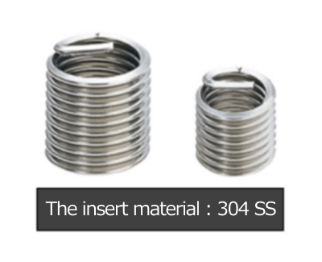

Threaded Insert

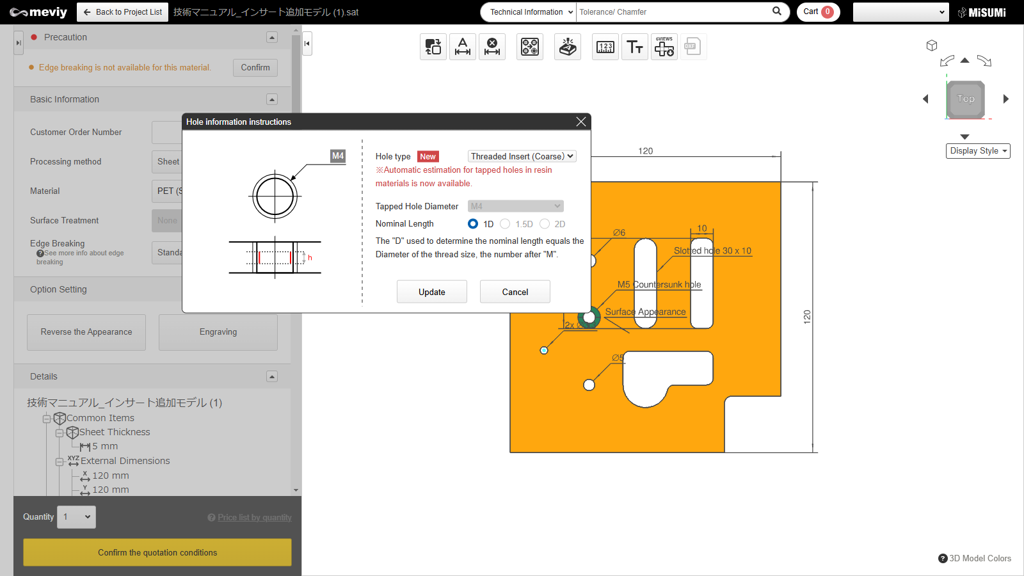＋

### Threaded insert nominal diameter and length

There are three insert lengths available for each nominal diameter: “1D”, “1.5D” and “2D”.

|  |  |  |  |  |  |  |  |
| --- | --- | --- | --- | --- | --- | --- | --- |
| Material | Sheet Thickness | Nominal length | Nominal diameter | | | | |
| M3 | M4 | M5 | M6 | M8 |
| * PET (Polyethylene Terephthalate) * Acrylic * Polycarbonate * PVC (polyvinyl chloride) | 3.0 | ー |  |  |  |  |  |
| 5.0 | 1D | 〇 | 〇 |  |  |  |
| 1.5D | 〇 |  |  |  |  |
| 2D |  |  |  |  |  |
| 8.0 | 1D | 〇 | 〇 | 〇 | 〇 |  |
| 1.5D | 〇 | 〇 | 〇 |  |  |
| 2D | 〇 |  |  |  |  |
| 10.0 | 1D |  | 〇 | 〇 | 〇 | 〇 |
| 1.5D |  | 〇 | 〇 | 〇 |  |
| 2D |  | 〇 |  |  |  |

### Insert quantity per model that can be automatically quoted

The maximum number of threaded inserts per model that can be automatically quoted is 50. Please request a manual quotation if more than 50 inserts are required.

### Lead time for Threaded Inserts

* Lead time will increase with the number of inserts per model.
* * There is no additional lead time for Economy Shipping.

|  |  |  |  |  |  |  |
| --- | --- | --- | --- | --- | --- | --- |
| Material：Clear Resin | Grade | Color | Sheet Thickness | Number of inserts per model | | |
| Standard Shipping | | Economy Shipping |
| Quantity: 1~20 inserts | Quantity: 21~50 inserts | Quantity: ~50 inserts |
| * PET * (Polyethylene Terephthalate) | Standard | transparent | 3.0  5.0  8.0 | +2 days | ＋3 days | No additional lead time |
| smoky brown | 3.0  5.0 |
| Antistatic | transparent | 3.0  5.0 |
| smoky brown |
| Acrylic | Standard | transparent | 3.0  5.0  8.0  10.0 | ＋2 days | ＋3 days |
| smoky brown | 3.0  5.0 |
| Antistatic | transparent | 3.0  5.0 |
| smoky brown |
| Polycarbonate | Standard | transparent | 3.0  5.0 | ＋2 days | ＋3 days |
| smoky brown |
| Antistatic | transparent |
| smoky brown |
| * PVC * (polyvinyl chloride) | Standard | transparent | 3.0  5.0 | ＋2 days | ＋3 days |
| smoky brown |
| Antistatic | transparent |
| smoky brown |

## Modeling Rules for Keyhole Type Holes

When a keyhole shaped element is detected, it will be identified as a keyhole type hole.

|  |  |
| --- | --- |
| Modeling Rules | Example |
| * Model the keyhole type hole to meet all of the following conditional expressions: * d1 ≥ 4.5mm (.177″) * d2 ≥ (2 x d1)+2mm(.079″) * h>0 | Example |

## Hanging holes for Plating / Painting

* For plating / painting, the product is hung and immersed in treatment baths.
* If the model does not have holes already, be sure to add through holes near the corners or end face of the part.
* *Model the holes so that they are approximately ø4 to ø5.2 mm (.157 – .205″).
* *For models with a length of 420mm (16.535″) or greater, or for models with a weight that exceeds 8 kg (17.6Lb.), add at least 2 holes to the model.
* Depending on the size and shape of the part, you may need to add more holes or change the hanging holes.
* You will be contacted if this is the case.

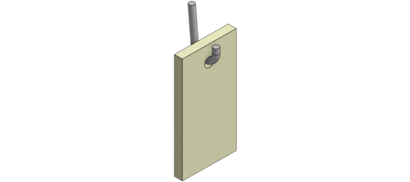

## Selectable nut sizes

### Upper limit of the nut's pilot hole diameter

* On meviy, when you would select nut mounting, please change the hole information indication for mounting holes.
* You can select press-fit, weld (spot), or weld (arc) as the mounting method.
* However, multiple mounting methods cannot be used on the same model.
* The nominal diameters which can be selected depend on the hole diameter of the mounting hole.
* The upper limit of hole diameter is specified for each nominal diameter. Please refer to the table below.

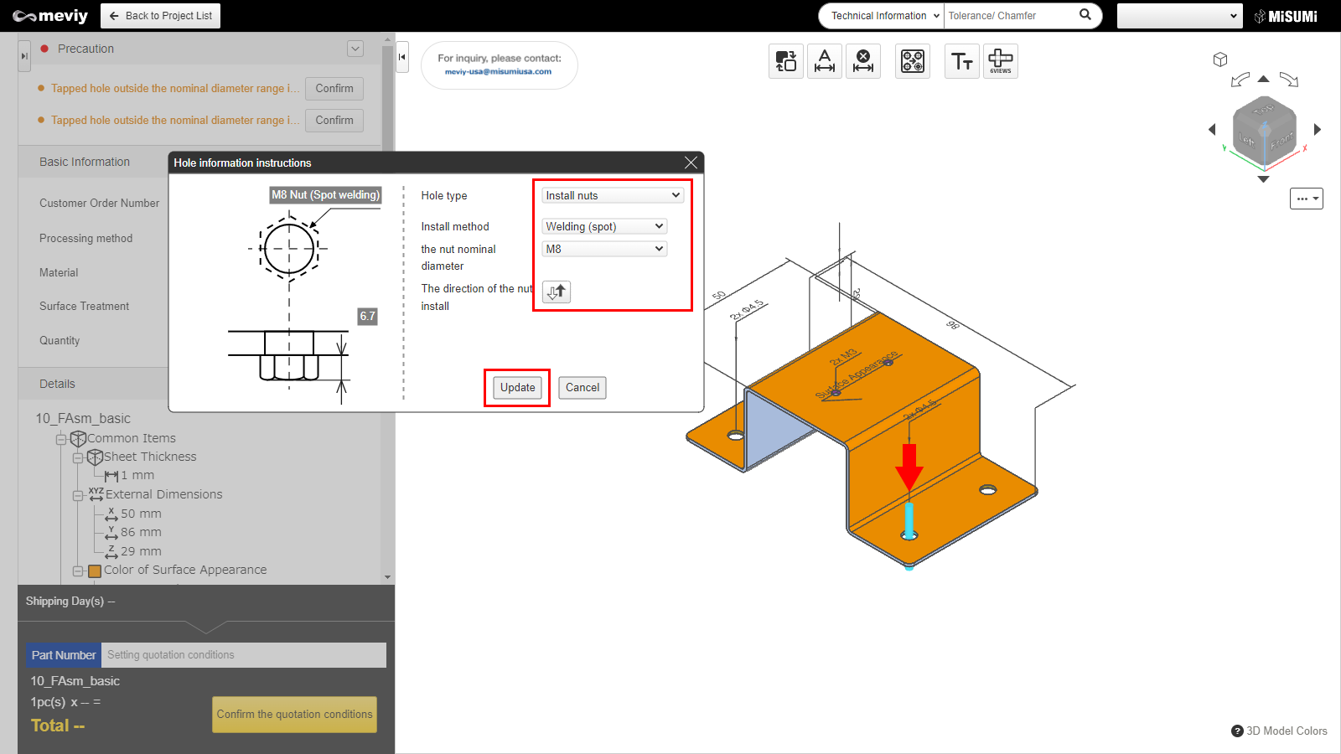＋

**Press-fit nut**

|  |  |  |
| --- | --- | --- |
| Press-fit nut nominal diameter | Upper limit of the pilot hole diameter (d) | Example |
| M3 | d ≦ 5.5 |  |
| M4 | d ≦ 7.0 |
| M5 | d ≦ 8.0 |
| M6 | d ≦ 10.0 |
| M8 | d ≦ 13.0 |

**Weld (spot) nut and weld (arc) nut**

|  |  |  |
| --- | --- | --- |
| Weld nut nominal diameter | Upper limit of the pilot hole diameter (d) | Example |
| M4 | d ≦ 11.0 |  |
| M5 | d ≦ 11.0 |
| M6 | d ≦ 13.0 |
| M8 | d ≦ 15.0 |
| M10 | d ≦ 17.0 |
| M12 | d ≦ 19.0 |

### Maximum number of nuts which can quote automatically

* As a condition of the automatic quotation, there is a limit that the number of nuts mounted per model. Please refer to the table below.
* If the number of nuts is more than the limit, meviy support can provide a quotation (request a manual quotation).
* If you wish to use weld (arc) nuts, please request a quotation from meviy support regardless of the number of nuts.

|  |  |
| --- | --- |
| Types of nut | Maximum number of nut which can automatic quotation per model |
| Press-fit nut | 12 |
| Weld (spot) nut | 12 |

### Select the size of nut

* Selectable sizes vary by material and thickness. Please refer to the table below.
* Nut mounting cannot be selected for perforated metal, shim plate (Cold Rolled Low Carbon Steel (for Shims), 304 Stainless Steel (for Shims)), and resin.

**Press-fit nut**

|  |  |  |  |  |  |  |
| --- | --- | --- | --- | --- | --- | --- |
| Material | Thickness | Press-fit nut nominal diameter | | | | |
| * Low Carbon Steel (Cold/Hot Rolled) | 0.8 | M3 | M4 |  |  |  |
| 1.0 | M3 | M4 | M5 | M6 |  |
| 1.2 | M3 | M4 | M5 | M6 |  |
| 1.6 | M3 | M4 | M5 | M6 |  |
| 2.0 | M3 | M4 | M5 | M6 | M8 |
| 2.3 | M3 | M4 | M5 | M6 | M8 |
| 3.2 | M3 | M4 | M5 | M6 | M8 |
| * 304 Stainless Steel (2B) * 304 Stainless Steel (Single-Sided #400-Grit Polished) * 304 Stainless Steel (Single-sided hairline finish) * 430 Stainless Steel (2B) | 1.0 | M3 | M4 | M5 | M6 |  |
| 1.2 | M3 | M4 | M5 | M6 |  |
| 1.5 | M3 | M4 | M5 | M6 |  |
| 2.0 | M3 | M4 | M5 | M6 | M8 |
| 2.5 | M3 | M4 | M5 | M6 | M8 |
| 3.0 | M3 | M4 | M5 | M6 | M8 |
| 5052 Aluminum Alloy | 0.8 | M3 | M4 |  |  |  |
| 1.0 | M3 | M4 | M5 | M6 |  |
| 1.2 | M3 | M4 | M5 | M6 |  |
| 1.5 | M3 | M4 | M5 | M6 |  |
| 1.6 | M3 | M4 | M5 | M6 |  |
| 2.0 | M3 | M4 | M5 | M6 | M8 |
| 2.5 | M3 | M4 | M5 | M6 | M8 |
| 3.0 | M3 | M4 | M5 | M6 | M8 |
| * 5052 AL Alloy Pre-Finish, Clear Anodize（Clear Anodize） * 5052 AL Alloy Pre-Finish, Black Anodize（Black Anodize） | 1.0 | M3 | M4 | M5 | M6 |  |
| 1.5 | M3 | M4 | M5 | M6 |  |
| 2.0 | M3 | M4 | M5 | M6 | M8 |
| 3.0 | M3 | M4 | M5 | M6 | M8 |

**Weld (spot) nut**

|  |  |  |  |  |  |  |  |  |
| --- | --- | --- | --- | --- | --- | --- | --- | --- |
| Material | Thickness | Weld (spot) nut nominal diameter | | | | | | |
| * Low Carbon Steel (Cold/Hot Rolled) | 0.8 | M4 | M5 | M6 |  |  |  |  |
| 1.0 | M4 | M5 | M6 |  |  |  |  |
| 1.2 | M4 | M5 | M6 | M8 |  |  |  |
| 1.6 | M4 | M5 | M6 | M8 | M10 | M12 |  |
| 2.0 | M4 | M5 | M6 | M8 | M10 | M12 |  |
| 2.3 | M4 | M5 | M6 | M8 | M10 | M12 |  |
| 3.2 | M4 | M5 | M6 | M8 | M10 | M12 |  |
| * 304 Stainless Steel (2B) * 304 Stainless Steel (Single-Sided #400-Grit Polished) * 304 Stainless Steel (Single-sided hairline finish) * 430 Stainless Steel (2B) | 0.8 | M4 | M5 | M6 | M8 | M10 | M12 |  |
| 1.0 | M4 | M5 | M6 | M8 | M10 | M12 |  |
| 1.2 | M4 | M5 | M6 | M8 | M10 | M12 |  |
| 1.5 | M4 | M5 | M6 | M8 | M10 | M12 |  |
| 2.0 | M4 | M5 | M6 | M8 | M10 | M12 |  |
| 2.5 | M4 | M5 | M6 | M8 | M10 | M12 |  |
| 3.0 | M4 | M5 | M6 | M8 | M10 | M12 |  |
| 4.0 | M4 | M5 | M6 | M8 | M10 | M12 |  |
| 5.0 | M4 | M5 | M6 | M8 | M10 | M12 |  |
| 6.0 | M4 | M5 | M6 | M8 | M10 | M12 |  |

## Range of Machining Limits

**Inch Thickness Gauge Standard**

* [Minimum Distance Between a Hole and an Edge or Between Two Holes](https://us.meviy.misumi-ec.com/help/en/technical_info-en-c/shm_guideline-en-c/9689/#box_a_1)
* [Minimum Diameter for Through Holes, Minimum Width of Rectangular/Slotted Holes](https://us.meviy.misumi-ec.com/help/en/technical_info-en-c/shm_guideline-en-c/9689/#box_a_2)
* [Minimum Distance Between a Hole and Bend: Normal Bending](https://us.meviy.misumi-ec.com/help/en/technical_info-en-c/shm_guideline-en-c/9689/#box_a_3)
* [Minimum Distance Between a Hole and Bend: R-bend shape](https://us.meviy.misumi-ec.com/help/en/technical_info-en-c/shm_guideline-en-c/9689/#box_a_4)
* [Slit on the bending line (except for acute angle bending shapes with an internal angle of less than 90°)](https://us.meviy.misumi-ec.com/help/en/technical_info-en-c/shm_guideline-en-c/9689/#box_a_5)
* [Minimum Bending Height: Normal Bending](https://us.meviy.misumi-ec.com/help/en/technical_info-en-c/shm_guideline-en-c/9689/#box_a_6)
* [Minimum Bending Height : R-bend shape](https://us.meviy.misumi-ec.com/help/en/technical_info-en-c/shm_guideline-en-c/9689/#box_a_7)
* [Width Specification Range for Bending](https://us.meviy.misumi-ec.com/help/en/technical_info-en-c/shm_guideline-en-c/9689/#box_a_8)
* [Minimum Angle for Acute Angle Bending](https://us.meviy.misumi-ec.com/help/en/technical_info-en-c/shm_guideline-en-c/9689/#box_a_9)
* [Minimum Radius of Rectangular Holes](https://us.meviy.misumi-ec.com/help/en/technical_info-en-c/shm_guideline-en-c/9689/#box_a_10)

**Metric Thickness Gauge Standard**

* [Minimum Distance Between a Hole and an Edge or Between Two Holes](https://us.meviy.misumi-ec.com/help/en/technical_info-en-c/shm_guideline-en-c/9689/#box_1)
* [Minimum Diameter for Through Holes Minimum Width of Rectangular/Slotted Holes](https://us.meviy.misumi-ec.com/help/en/technical_info-en-c/shm_guideline-en-c/9689/#box_2)
* [Minimum Size of Cutout Shape](https://us.meviy.misumi-ec.com/help/en/technical_info-en-c/shm_guideline-en-c/9689/#box_3)
* [Minimum Slit Width (when the part is unfolded).](https://us.meviy.misumi-ec.com/help/en/technical_info-en-c/shm_guideline-en-c/9689/#box_18)
* [Minimum Bending Height](https://us.meviy.misumi-ec.com/help/en/technical_info-en-c/shm_guideline-en-c/9689/#box_6)
* [The minimum bending height](https://us.meviy.misumi-ec.com/help/en/technical_info-en-c/shm_guideline-en-c/9689/#box_19)
* [Width Specification Range for Bending](https://us.meviy.misumi-ec.com/help/en/technical_info-en-c/shm_guideline-en-c/9689/#box_7)
* [Minimum Distance Between a Hole and Bend](https://us.meviy.misumi-ec.com/help/en/technical_info-en-c/shm_guideline-en-c/9689/#box_4)
* [Minimum distance between engravings, between edge or hole](https://us.meviy.misumi-ec.com/help/en/technical_info-en-c/shm_guideline-en-c/9689/#box_15) |
* [Minimum distance between engraving and nut](https://us.meviy.misumi-ec.com/help/en/technical_info-en-c/shm_guideline-en-c/9689/#box_16)
* [Minimum distance between engraving and bending](https://us.meviy.misumi-ec.com/help/en/technical_info-en-c/shm_guideline-en-c/9689/#box_17)
* [Slit on the bending line (except for acute angle bending shapes with an internal angle of less than 90°).](https://us.meviy.misumi-ec.com/help/en/technical_info-en-c/shm_guideline-en-c/9689/#box_10)
* [*Reference) Comparative example of machining limits of hole positions with or without openings](https://us.meviy.misumi-ec.com/help/en/technical_info-en-c/shm_guideline-en-c/9689/#box_10-2)
* [Minimum distance between nuts](https://us.meviy.misumi-ec.com/help/en/technical_info-en-c/shm_guideline-en-c/9689/#box_11)
* [Minimum distance between nut and hole](https://us.meviy.misumi-ec.com/help/en/technical_info-en-c/shm_guideline-en-c/9689/#box_12)
* [Minimum distance between nut and edge of the material](https://us.meviy.misumi-ec.com/help/en/technical_info-en-c/shm_guideline-en-c/9689/#box_13)
* [Maximum distance between nut and edge of the material](https://us.meviy.misumi-ec.com/help/en/technical_info-en-c/shm_guideline-en-c/9689/#box_14)
* [Minimum distance between engravings, between edge or hole](https://us.meviy.misumi-ec.com/help/en/technical_info-en-c/shm_guideline-en-c/9689/#box_15) |
* [Minimum distance between engraving and nut](https://us.meviy.misumi-ec.com/help/en/technical_info-en-c/shm_guideline-en-c/9689/#box_16)
* [Minimum distance between engraving and bending](https://us.meviy.misumi-ec.com/help/en/technical_info-en-c/shm_guideline-en-c/9689/#box_17)
* [Minimum Angle for Acute Angle Bending](https://us.meviy.misumi-ec.com/help/en/technical_info-en-c/shm_guideline-en-c/9689/#box_8)
* [Minimum Radius of Rectangular Holes](https://us.meviy.misumi-ec.com/help/en/technical_info-en-c/shm_guideline-en-c/9689/#box_9)
* The limits for machining and the size ranges are defined for each standard part. Make sure that any models you create fall within the standard range.
* *Values may differ from those listed depending on surface treatment, shape, and processing conditions.

**Inch Thickness Gauge Standard**

**Minimum Distance Between a Hole and an Edge or Between Two Holes**

Machining Limits, Size Range

| Material | Sheet thickness(Gauge) | | | Thickness (Inch) | | Limit a | | Limit b | | Limit c |
| --- | --- | --- | --- | --- | --- | --- | --- | --- | --- | --- |
| * Cold Rolled Low Carbon Steel * Hot Rolled Low Carbon Steel | | 26 | 0.0179″ | | 1.0 | | Friction drilled tapped hole is not available in Inch gauge sheetmetal | |
| 24 | 0.0239″ | | 1.0 | |
| 22 | 0.0299″ | | 0.5 | |
| 20 | 0.0359″ | | 0.5 | |
| 19 | 0.0418″ | | 0.5 | |
| 18 | 0.0478″ | | 1.0 | |
| 17 | 0.0538″ | | 1.0 | |
| 16 | 0.0598″ | | 1.0 | |
| 14 | 0.0747″ | | 1.0 | |
| 13 | 0.0897″ | | 1.0 | |
| 12 | 0.1046″ | | 1.5 | |
| 11 | 0.1196″ | | 1.5 | |
| 10 | 0.1345″ | | 2.0 | |
| 8 | 0.1644″ | | 2.0 | |
| 7 | 0.1793″ | | 2.0 | |
| 6 | 0.1943″ | | 2.0 | |
| (1/4) | 0.2500″ | | 2.5 | |
| (3/8) | 0.3750″ | | 4.0 | |
| * Low Carbon Steel (Electrolytic Galvanized) * Low Carbon Steel (Hot Galvanized) | | 24 | 0.0276″ | | 0.5 | |
| 22 | 0.0336″ | | 0.5 | |
| 20 | 0.0396″ | | 0.5 | |
| 18 | 0.0516″ | | 1.0 | |
| 16 | 0.0635″ | | 1.0 | |
| 14 | 0.0785″ | | 1.0 | |
| * 304 Stainless Steel (2B) * 304 Stainless Steel (No.4) | | 26 | 0.0187″ | | 1.0 | |
| 24 | 0.0250″ | | 1.0 | |
| 22 | 0.0312″ | | 0.5 | |
| 20 | 0.0375″ | | 0.5 | |
| 19 | 0.0437″ | | 0.5 | |
| 18 | 0.0500″ | | 1.0 | |
| 17 | 0.0562″ | | 1.0 | |
| 16 | 0.0625″ | | 1.0 | |
| 14 | 0.0781″ | | 1.0 | |
| 13 | 0.0937″ | | 1.0 | |
| 12 | 0.1094″ | | 1.5 | |
| 11 | 0.1250″ | | 1.5 | |
| 10 | 0.1406″ | | 2.0 | |
| 8 | 0.1719″ | | 2.0 | |
| 7 | 0.1875″ | | 2.0 | |
| 3 | 0.2500″ | | 2.5 | |
| * 316 Stainless Steel (2B) | | 26 | 0.0187″ | | 1.0 | |
| 24 | 0.0250″ | | 1.0 | |
| 22 | 0.0312″ | | 1.0 | |
| 20 | 0.0375″ | | 1.0 | |
| 18 | 0.0500″ | | 1.0 | |
| 16 | 0.0625″ | | 1.0 | |
| 14 | 0.0781″ | | 1.0 | |
| 12 | 0.1094″ | | 1.5 | |
| 11 | 0.1250″ | | 1.5 | |
| 10 | 0.1406″ | | 2.0 | |
| 7 | 0.1875″ | | 2.0 | |
| * 5052 Aluminum Alloy * 6061 Aluminum Alloy | | – | 0.0200″ | | 0.5 | |
| – | 0.0250″ | | 0.5 | |
| – | 0.0320″ | | 0.5 | |
| – | 0.0400″ | | 0.5 | |
| – | 0.0500″ | | 1.0 | |
| – | 0.0630″ | | 1.0 | |
| – | 0.0800″ | | 1.0 | |
| – | 0.0900″ | | 1.0 | |
| – | 0.1000″ | | 1.0 | |
| – | 0.1250″ | | 1.5 | |
| – | 0.1600″ | | 2.0 | |
| – | 0.1900″ | | 2.0 | |
| – | 0.2500″ | | 3.0 | |

Example

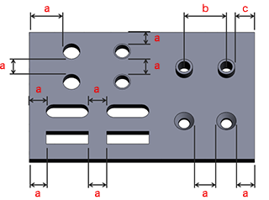

**Minimum Diameter for Through Holes ; Minimum Width of Rectangular/Slotted Holes**

Machining Limits, Size Range

| Material | Sheet thickness(Gauge) | | | Thickness (Inch) | | Limit d | | Limit w1 | | | Limit w2 |
| --- | --- | --- | --- | --- | --- | --- | --- | --- | --- | --- | --- |
| * Cold Rolled Low Carbon Steel * Hot Rolled Low Carbon Steel | | 26 | 0.0179″ | | 1.0 | | 1.0 | | 1.0 |
| 24 | 0.0239″ | | 1.0 | | 1.0 | | 1.0 |
| 22 | 0.0299″ | | 0.4 | | 0.8 | | 0.8 |
| 20 | 0.0359″ | | 0.5 | | 1.0 | | 1.0 |
| 19 | 0.0418″ | | 0.5 | | 1.0 | | 1.0 |
| 18 | 0.0478″ | | 0.6 | | 1.2 | | 1.2 |
| 17 | 0.0538″ | | 0.6 | | 1.2 | | 1.2 |
| 16 | 0.0598″ | | 0.8 | | 1.6 | | 1.6 |
| 14 | 0.0747″ | | 1.0 | | 2.0 | | 2.0 |
| 13 | 0.0897″ | | 1.2 | | 2.3 | | 2.3 |
| 12 | 0.1046″ | | 1.4 | | 2.7 | | 2.7 |
| 11 | 0.1196″ | | 1.6 | | 3.2 | | 3.2 |
| 10 | 0.1345″ | | 1.8 | | 3.5 | | 3.5 |
| 8 | 0.1644″ | | 2.0 | | 2.0 | | 2.0 |
| 7 | 0.1793″ | | 2.0 | | 2.0 | | 2.0 |
| 6 | 0.1943″ | | 2.6 | | 4.9 | | 4.9 |
| (1/4) | 0.2500″ | | 6.1 | | 6.1 | | 6.1 |
| (3/8) | 0.3750″ | | 9.1 | | 9.1 | | 9.1 |
| * Low Carbon Steel (Electrolytic Galvanized) * Low Carbon Steel (Hot Galvanized) | | 24 | 0.0276″ | | 0.3 | | 0.6 | | 0.6 |
| 22 | 0.0336″ | | 0.4 | | 0.8 | | 0.8 |
| 20 | 0.0396″ | | 0.5 | | 1.0 | | 1.0 |
| 18 | 0.0516″ | | 0.6 | | 1.2 | | 1.2 |
| 16 | 0.0635″ | | 0.8 | | 1.6 | | 1.6 |
| 14 | 0.0785″ | | 1.0 | | 2.0 | | 2.0 |
| * 304 Stainless Steel (2B) * 304 Stainless Steel (No.4) | | 26 | 0.0187″ | | 1.0 | | 1.0 | | 1.0 |
| 24 | 0.0250″ | | 1.0 | | 1.0 | | 1.0 |
| 22 | 0.0312″ | | 0.4 | | 0.8 | | 0.8 |
| 20 | 0.0375″ | | 0.5 | | 1.0 | | 1.0 |
| 19 | 0.0437″ | | 0.5 | | 1.0 | | 1.0 |
| 18 | 0.0500″ | | 0.6 | | 1.2 | | 1.2 |
| 17 | 0.0562″ | | 0.6 | | 1.2 | | 1.2 |
| 16 | 0.0625″ | | 0.8 | | 1.6 | | 1.6 |
| 14 | 0.0781″ | | 1.0 | | 2.0 | | 2.0 |
| 13 | 0.0937″ | | 1.2 | | 2.3 | | 2.3 |
| 12 | 0.1094″ | | 1.4 | | 2.7 | | 2.7 |
| 11 | 0.1250″ | | 1.6 | | 3.2 | | 3.2 |
| 10 | 0.1406″ | | 1.8 | | 3.5 | | 3.5 |
| 8 | 0.1719″ | | 2.2 | | 4.3 | | 4.3 |
| 7 | 0.1875″ | | 2.3 | | 4.0 | | 4.0 |
| 3 | 0.2500″ | | 3.0 | | 4.0 | | 4.0 |
| * 316 Stainless Steel (2B) | | 26 | 0.0187″ | | 1.0 | | 1.0 | | 1.0 |
| 24 | 0.0250″ | | 1.0 | | 1.0 | | 1.0 |
| 22 | 0.0312″ | | 1.0 | | 1.0 | | 1.0 |
| 20 | 0.0375″ | | 1.0 | | 1.0 | | 1.0 |
| 18 | 0.0500″ | | 1.0 | | 1.0 | | 1.0 |
| 16 | 0.0625″ | | 1.0 | | 1.0 | | 1.0 |
| 14 | 0.0781″ | | 1.0 | | 1.0 | | 1.0 |
| 12 | 0.1094″ | | 1.5 | | 1.5 | | 1.5 |
| 11 | 0.1250″ | | 1.5 | | 1.5 | | 1.5 |
| 10 | 0.1406″ | | 2.0 | | 2.0 | | 2.0 |
| 7 | 0.1875″ | | 2.0 | | 2.0 | | 2.0 |
| * 5052 Aluminum Alloy * 6061 Aluminum Alloy | | – | 0.0200″ | | 0.2 | | 0.5 | | 0.5 |
| – | 0.0250″ | | 0.3 | | 0.6 | | 0.6 |
| – | 0.0320″ | | 0.4 | | 0.8 | | 0.8 |
| – | 0.0400″ | | 0.5 | | 1.0 | | 1.0 |
| – | 0.0500″ | | 0.6 | | 1.2 | | 1.2 |
| – | 0.0630″ | | 0.8 | | 1.6 | | 1.6 |
| – | 0.0800″ | | 1.0 | | 2.0 | | 2.0 |
| – | 0.0900″ | | 1.2 | | 2.3 | | 2.3 |
| – | 0.1000″ | | 1.2 | | 2.3 | | 2.3 |
| – | 0.1250″ | | 1.6 | | 3.2 | | 3.2 |
| – | 0.1600″ | | 1.5 | | 1.5 | | 1.5 |
| – | 0.1900″ | | 2.0 | | 2.0 | | 2.0 |
| – | 0.2500″ | | 2.0 | | 2.0 | | 2.0 |

Example

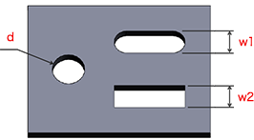

**Minimum Distance Between a Hole and Bend: Normal Bending**

Machining Limits, Size Range

| Material | Sheet thickness (Gauge) | Thickness (Inch) | | | Through Hole Slotted Hole Rectangular Hole | | | | Tapped Hole | | | | | Burring Tap | | | Countersunk Hole | | |
| --- | --- | --- | --- | --- | --- | --- | --- | --- | --- | --- | --- | --- | --- | --- | --- | --- | --- | --- | --- |
| Minimum Value a | Limit a | | | Minimum Value a | | | Limit a | | Limit a | | | Minimum Value a | | Limit a |
| * Cold Rolled Low Carbon Steel * Hot Rolled Low Carbon Steel | | | 26 | 0.0187″ | | | – | 9.0 | | – | 9.0 | |  | | – | 9.0 | |
| 24 | 0.0179″ | | | – | 9.0 | | – | 9.0 | | – | 9.0 | |
| 22 | 0.0239″ | | | – | 2.0 | | – | 1.9 | | – | 1.0 | |
| 20 | 0.0359″ | | | – | 2.0 | | – | 2.7 | | – | 1.4 | |
| 19 | 0.0418″ | | | – | 2.0 | | – | 2.7 | | – | 1.8 | |
| 18 | 0.0478″ | | | – | 3.0 | | – | 3.9 | | – | 2.2 | |
| 17 | 0.0538″ | | | – | 3.0 | | – | 3.9 | | – | 2.6 | |
| 16 | 0.0598″ | | | – | 3.5 | | – | 5.2 | | – | 3.0 | |
| 14 | 0.0747″ | | | – | 4.0 | | – | 6.6 | | – | 4.0 | |
| 13 | 0.0897″ | | | – | 5.0 | | – | 7.8 | | – | 5.0 | |
| 12 | 0.1046″ | | | – | 5.6 | | – | 9.2 | | – | 6.0 | |
| 11 | 0.1196″ | | | – | 6.5 | | – | 11.7 | | – | 6.5 | |
| 10 | 0.1345″ | | | – | 7.2 | | – | 12.5 | | – | 8.0 | |
| 8 | 0.1644″ | | | – | 22.5 | | – | 22.5 | | – | 22.5 | |
| 7 | 0.1793″ | | | – | 22.5 | | – | 22.5 | | – | 22.5 | |
| 6 | 0.1943″ | | | – | 10.3 | | – | 18.3 | | – | 11.3 | |
| * Low Carbon Steel (Electrolytic Galvanized) * Low Carbon Steel (Hot Galvanized) | | | 24 | 0.0276″ | | | – | 1.5 | | – | 1.3 | | – | 0.6 | |
| 22 | 0.0336″ | | | – | 2.0 | | – | 1.9 | | – | 1.0 | |
| 20 | 0.0396″ | | | – | 2.0 | | – | 2.7 | | – | 1.4 | |
| 18 | 0.0516″ | | | – | 3.0 | | – | 3.9 | | – | 2.2 | |
| 16 | 0.0635″ | | | – | 3.5 | | – | 5.2 | | – | 3.0 | |
| 14 | 0.0785″ | | | – | 4.0 | | – | 6.6 | | – | 4.0 | |
| * 304 Stainless Steel (2B) * 304 Stainless Steel (No.4) | | | 26 | 0.0187″ | | | – | 9.0 | | – | 9.0 | |  | | – | 9.0 | |
| 24 | 0.0250″ | | | – | 9.0 | | – | 9.0 | | – | 9.0 | |
| 22 | 0.0312″ | | | – | 2.0 | | – | 1.9 | | – | 1.0 | |
| 20 | 0.0375″ | | | – | 2.0 | | – | 2.7 | | – | 1.4 | |
| 19 | 0.0437″ | | | – | 2.0 | | – | 2.7 | | – | 1.8 | |
| 18 | 0.0500″ | | | – | 3.0 | | – | 3.9 | | – | 2.2 | |
| 17 | 0.0562″ | | | – | 3.5 | | – | 5.2 | | – | 3.0 | |
| 16 | 0.0625″ | | | – | 3.5 | | – | 5.2 | | – | 3.0 | |
| 14 | 0.0781″ | | | – | 4.0 | | – | 6.6 | | – | 4.0 | |
| 13 | 0.0937″ | | | – | 5.0 | | – | 7.8 | | – | 5.0 | |
| 12 | 0.1094″ | | | – | 5.6 | | – | 9.2 | | – | 6.0 | |
| 11 | 0.1250″ | | | – | 6.5 | | – | 11.7 | | – | 6.5 | |
| 10 | 0.1406″ | | | – | 7.2 | | – | 12.5 | | – | 8.0 | |
| 8 | 0.1719″ | | | – | 8.8 | | – | 15.5 | | – | 10.0 | |
| 7 | 0.1875″ | | | – | 9.5 | | – | 16.3 | | – | 9.5 | |
| 3 | 0.2500″ | | | – | 13.1 | | – | 23.0 | | – | 14.7 | |
| * 316 Stainless Steel (2B) | | | 26 | 0.0187″ | | | – | 9.0 | | – | 9.0 | |  | | – | 9.0 | |
| 24 | 0.0250″ | | | – | 9.0 | | – | 9.0 | | – | 9.0 | |
| 22 | 0.0312″ | | | – | 9.0 | | – | 9.0 | | – | 9.0 | |
| 20 | 0.0375″ | | | – | 9.0 | | – | 9.0 | | – | 9.0 | |
| 18 | 0.0500″ | | | – | 9.0 | | – | 9.0 | | – | 9.0 | |
| 16 | 0.0625″ | | | – | 9.0 | | – | 9.0 | | – | 9.0 | |
| 14 | 0.0781″ | | | – | 9.0 | | – | 9.0 | | – | 9.0 | |
| 12 | 0.1094″ | | | – | 9.0 | | – | 9.0 | | – | 9.0 | |
| 11 | 0.1250″ | | | – | 16.0 | | – | 16.0 | | – | 16.0 | |
| 10 | 0.1406″ | | | – | 22.5 | | – | 22.5 | | – | 22.5 | |
| 7 | 0.1875″ | | | – | 22.5 | | – | 22.5 | | – | 22.5 | |
| * 5052 Aluminum Alloy * 6061 Aluminum Alloy | | | – | 0.0200″ | | | – | 1.3 | | – | 1.0 | | – | 0.6 | |
| – | 0.0250″ | | | – | 1.5 | | – | 1.3 | | – | 0.6 | |
| – | 0.0320″ | | | – | 2.0 | | – | 1.9 | | – | 1.0 | |
| – | 0.0400″ | | | – | 2.0 | | – | 2.7 | | – | 1.4 | |
| – | 0.0500″ | | | – | 3.0 | | – | 3.9 | | – | 2.2 | |
| – | 0.0630″ | | | – | 3.5 | | – | 5.2 | | – | 3.0 | |
| – | 0.0800″ | | | – | 4.0 | | – | 6.6 | | – | 4.0 | |
| – | 0.0900″ | | | – | 5.0 | | – | 7.8 | | – | 5.0 | |
| – | 0.1000″ | | | – | 5.0 | | – | 7.8 | | – | 5.0 | |
| – | 0.1250″ | | | – | 6.5 | | – | 11.7 | | – | 6.5 | |
| – | 0.1600″ | | | – | 16.0 | | – | 16.0 | | – | 16.0 | |
| – | 0.1900″ | | | – | 16.0 | | – | 16.0 | | – | 16.0 | |
| – | 0.2500″ | | | – | 22.5 | | – | 22.5 | | – | 22.5 | |

* *1 The hole may be deformed if it is below the minimum value.

The dimensions are therefore inaccurate, but will be processed as they are.

* *2 If the distance is under the minimum value, re-tapping will be necessary and the fit may be affected.

Example

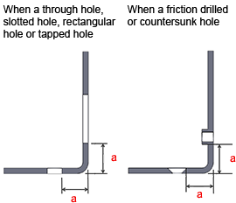

If there are internal angles of less than 90°, machining may not be possible even within the safe value range. If this is the case, meviy Support will contact you.

**Minimum Distance Between a Hole and Bend: R-bend shape**

Machining Limits, Size Range

| Material | Sheet thickness (Gauge) | Thickness (Inch) | | Through Hole Slotted Hole Rectangular Hole | | | Tapped Hole | | | Burring Tap | | Countersunk Hole |
| --- | --- | --- | --- | --- | --- | --- | --- | --- | --- | --- | --- | --- |
| Limit a | | | Limit a | | | Limit a | | Limit a |
| * Cold Rolled Low Carbon Steel * Hot Rolled Low Carbon Steel | | 22 | 0.0299″ | | 0.5 | 0.4 | |  | 0.1 | |
| 20 | 0.0359″ | | 0.2 | 0.9 | | 0.1 | |
| 19 | 0.0418″ | | 0.1 | 0.6 | | 0.1 | |
| 18 | 0.0478″ | | 0.6 | 1.5 | | 0.1 | |
| 17 | 0.0538″ | | 0.3 | 1.2 | | 0.1 | |
| 16 | 0.0598″ | | 0.5 | 2.2 | | 0.1 | |
| 14 | 0.0747″ | | 0.2 | 2.8 | | 0.2 | |
| 13 | 0.0897″ | | 0.4 | 3.2 | | 0.4 | |
| 12 | 0.1046″ | | 0.3 | 3.9 | | 0.7 | |
| 11 | 0.1196″ | | 0.4 | 5.6 | | 0.4 | |
| * Cold Rolled Low Carbon Steel (Electrolytic Galvanized) * Cold Rolled Low Carbon Steel (Hot Galvanized) | | 24 | 0.0276″ | | 0.1 | 0.1 | | 0.1 | |
| 22 | 0.0336″ | | 0.3 | 0.2 | | 0.1 | |
| 20 | 0.0396″ | | 0.1 | 0.7 | | 0.1 | |
| 18 | 0.0516″ | | 0.4 | 1.3 | | 0.1 | |
| 16 | 0.0635″ | | 0.3 | 2.0 | | 0.1 | |
| 14 | 0.0785″ | | 0.1 | 2.6 | | 0.1 | |
| * 304 Stainless Steel (2B) * 304 Stainless Steel (No.4) | | 22 | 0.0312″ | | 0.4 | 0.3 | | 0.1 | |
| 20 | 0.0375″ | | 0.1 | 0.8 | | 0.1 | |
| 19 | 0.0437″ | | 0.1 | 0.5 | | 0.1 | |
| 18 | 0.0500″ | | 0.5 | 1.4 | | 0.1 | |
| 17 | 0.0562″ | | 0.6 | 2.3 | | 0.1 | |
| 16 | 0.0625″ | | 0.3 | 2.0 | | 0.1 | |
| 14 | 0.0781″ | | 0.1 | 2.6 | | 0.1 | |
| 13 | 0.0937″ | | 0.2 | 3.0 | | 0.2 | |
| 12 | 0.1094″ | | 0.1 | 3.6 | | 0.4 | |
| 11 | 0.1250″ | | 0.1 | 5.3 | | 0.1 | |
| * 5052 Aluminum Alloy | | – | 0.0250″ | | 0.2 | 0.1 | | 0.1 | |
| – | 0.0320″ | | 0.4 | 0.3 | | 0.1 | |
| – | 0.0400″ | | 0.1 | 0.7 | | 0.1 | |
| – | 0.0500″ | | 0.5 | 1.4 | | 0.1 | |
| – | 0.0630″ | | 0.3 | 2.0 | | 0.1 | |
| – | 0.0800″ | | 0.1 | 2.5 | | 0.1 | |
| – | 0.0900″ | | 0.4 | 3.2 | | 0.4 | |
| – | 0.1000″ | | 0.1 | 2.7 | | 0.1 | |
| – | 0.1250″ | | 0.1 | 5.3 | | 0.1 | |

Example

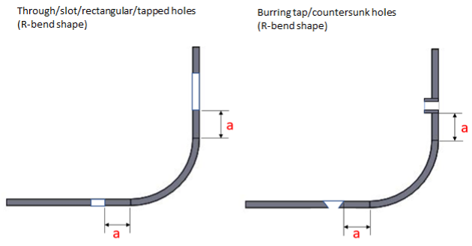

**Slit on the bending line (except for acute angle bending shapes with an internal angle of less than 90°)**

Machining Limits, Size Range

| Material | Sheet thickness | Thickness (Inch) | | | Minimum Value a *1 | | | Minimum Value b *2 | | | Limit c |
| --- | --- | --- | --- | --- | --- | --- | --- | --- | --- | --- | --- |
| * Cold Rolled Low Carbon Steel * Hot Rolled Low Carbon Steel | | | 26 | 0.0179″ | | 0.45 | 0.68 | | 0.5 |
| 24 | 0.0239″ | | 0.61 | 0.92 | | 0.5 |
| 22 | 0.0299″ | | 0.8 | 1.14 | | 0.5 |
| 20 | 0.0359″ | | 0.9 | 1.37 | | 0.5 |
| 19 | 0.0418″ | | 1.1 | 1.59 | | 0.5 |
| 18 | 0.0478″ | | 1.2 | 1.82 | | 1.0 |
| 17 | 0.0538″ | | 1.4 | 2.06 | | 1.0 |
| 16 | 0.0598″ | | 1.5 | 2.28 | | 1.0 |
| 14 | 0.0747″ | | 1.9 | 2.85 | | 1.0 |
| 13 | 0.0897″ | | 2.3 | 3.42 | | 1.0 |
| 12 | 0.1046″ | | 2.7 | 3.99 | | 1.5 |
| 11 | 0.1196″ | | 3.0 | 4.56 | | 1.5 |
| 10 | 0.1345″ | | 3.4 | 5.13 | | 2.0 |
| 8 | 0.1644″ | | 4.81 | 6.27 | | 2.0 |
| 7 | 0.1793″ | | 4.55 | 6.83 | | 2.0 |
| 6 | 0.1943″ | | 4.9 | 7.41 | | 2.0 |
| * Cold Rolled Low Carbon Steel (Electrolytic Galvanized) * Cold Rolled Low Carbon Steel (Hot Galvanized) | | | 24 | 0.0276″ | | 0.7 | 1.05 | | 0.5 |
| 22 | 0.0336″ | | 0.9 | 1.28 | | 0.5 |
| 20 | 0.0396″ | | 1.0 | 1.52 | | 0.5 |
| 18 | 0.0516″ | | 1.3 | 1.97 | | 1.0 |
| 16 | 0.0635″ | | 1.6 | 2.42 | | 1.0 |
| 14 | 0.0785″ | | 2.0 | 2.99 | | 1.0 |
| * 304 Stainless Steel (2B) * 304 Stainless Steel (No.4) * 316 Stainless Steel (2B) | | | 26 | 0.0187″ | | 0.47 | 0.71 | | 0.5 |
| 24 | 0.0250″ | | 0.64 | 0.96 | | 0.5 |
| 22 | 0.0312″ | | 0.8 | 1.19 | | 0.5 |
| 20 | 0.0375″ | | 1.0 | 1.43 | | 0.5 |
| 19 | 0.0437″ | | 1.1 | 1.67 | | 0.5 |
| 18 | 0.0500″ | | 1.3 | 1.91 | | 1.0 |
| 17 | 0.0562″ | | 1.6 | 2.39 | | 1.0 |
| 16 | 0.0625″ | | 1.6 | 2.39 | | 1.0 |
| 14 | 0.0781″ | | 2.0 | 2.97 | | 1.0 |
| 13 | 0.0937″ | | 2.4 | 3.57 | | 1.0 |
| 12 | 0.1094″ | | 2.8 | 4.17 | | 1.5 |
| 11 | 0.1250″ | | 3.2 | 4.77 | | 1.5 |
| 10 | 0.1406″ | | 3.6 | 5.36 | | 2.0 |
| 8 | 0.1719″ | | 4.4 | 6.56 | | 2.0 |
| 7 | 0.1875″ | | 4.8 | 7.14 | | 2.0 |
| 3 | 0.2500″ | | 6.4 | 9.53 | | 2.5 |
| * 5052 Aluminum Alloy * 6061 Aluminum Alloy | | | – | 0.0200″ | | 0.5 | 0.76 | | 0.5 |
| – | 0.0250″ | | 0.6 | 0.95 | | 0.5 |
| – | 0.0320″ | | 0.8 | 1.22 | | 0.5 |
| – | 0.0400″ | | 1.0 | 1.52 | | 0.5 |
| – | 0.0500″ | | 1.3 | 1.91 | | 1.0 |
| – | 0.0630″ | | 1.6 | 2.40 | | 1.0 |
| – | 0.0800″ | | 2.0 | 3.05 | | 1.0 |
| – | 0.0900″ | | 2.3 | 3.43 | | 1.0 |
| – | 0.1000″ | | 2.5 | 3.81 | | 1.0 |
| – | 0.1250″ | | 3.2 | 4.76 | | 1.5 |
| – | 0.1600″ | | 4.06 | 6.10 | | 2.0 |
| – | 0.1900″ | | 4.83 | 7.24 | | 2.0 |
| – | 0.2500″ | | 6.35 | 9.53 | | 2.5 |

* *1 When a is not secured by the slit’s horizontal width, or when there is an acute angle bend, we can still provide an estimate, but instead of the limit value c, the aforementioned “Minimum distance between the hole and the bend” will be the limit value for the hole position.
* *2 If the slit’s height is smaller than b or the outside R (fillet size) of the bend, automatic quotation is not possible.
* *3 The limit value c is uniformly 3.0 mm only when the nearby hole in the right figure is a burring tap.

Example

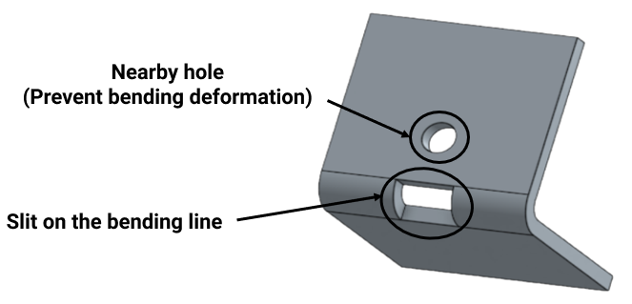

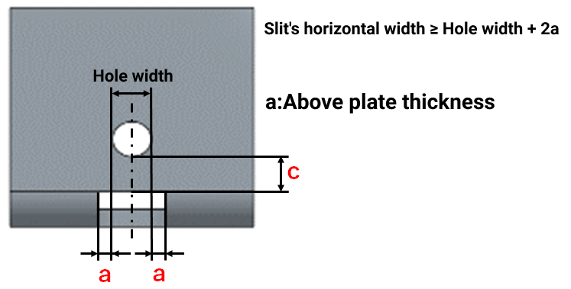

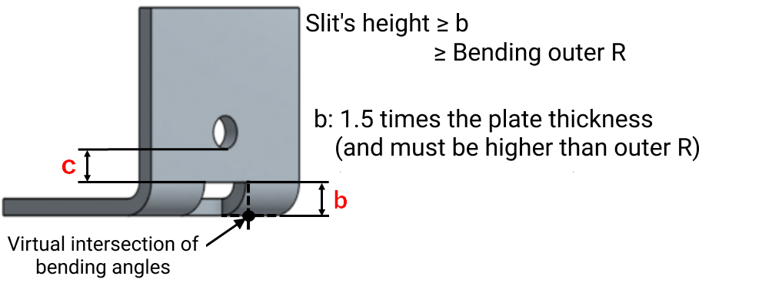

**Minimum Bending Height: Normal Bending**

Machining Limits, Size Range

| Material | Sheet thickness (Gauge) | | Thickness (Inch) | | Limit h (mm) | |
| --- | --- | --- | --- | --- | --- | --- |
| * Cold Rolled Low Carbon Steel * Hot Rolled Low Carbon Steel | | 26 | | 0.0179″ | | 9.0 |
| 24 | | 0.0239″ | | 9.0 |
| 22 | | 0.0299″ | | 4.2 |
| 20 | | 0.0359″ | | 4.3 |
| 19 | | 0.0418″ | | 4.3 |
| 18 | | 0.0478″ | | 5.5 |
| 17 | | 0.0538″ | | 5.5 |
| 16 | | 0.0598″ | | 6.8 |
| 14 | | 0.0747″ | | 8.2 |
| 13 | | 0.0897″ | | 9.4 |
| 12 | | 0.1046″ | | 10.7 |
| 11 | | 0.1196″ | | 13.3 |
| 10 | | 0.1345″ | | 13.9 |
| 8 | | 0.1644″ | | 22.5 |
| 7 | | 0.1793″ | | 22.5 |
| 6 | | 0.1943″ | | 19.5 |
| * Low Carbon Steel (Electrolytic Galvanized) * Low Carbon Steel (Hot Galvanized) | | 24 | | 0.0276″ | | 3.2 |
| 22 | | 0.0336″ | | 4.2 |
| 20 | | 0.0396″ | | 4.3 |
| 18 | | 0.0516″ | | 5.5 |
| 16 | | 0.0635″ | | 6.8 |
| 14 | | 0.0785″ | | 8.2 |
| * 304 Stainless Steel (2B) * 304 Stainless Steel (No.4) | | 26 | | 0.0187″ | | 9.0 |
| 24 | | 0.0250″ | | 9.0 |
| 22 | | 0.0312″ | | 4.2 |
| 20 | | 0.0375″ | | 4.3 |
| 19 | | 0.0437″ | | 4.3 |
| 18 | | 0.0500″ | | 5.5 |
| 17 | | 0.0562″ | | 6.8 |
| 16 | | 0.0625″ | | 6.8 |
| 14 | | 0.0781″ | | 8.2 |
| 13 | | 0.0937″ | | 9.4 |
| 12 | | 0.1094″ | | 10.7 |
| 11 | | 0.1250″ | | 13.3 |
| 10 | | 0.1406″ | | 13.9 |
| 8 | | 0.1719″ | | 16.8 |
| 7 | | 0.1875″ | | 17.4 |
| 3 | | 0.2500″ | | 23.5 |
| * 316 Stainless Steel (2B) | | 26 | | 0.0187″ | | 9.0 |
| 24 | | 0.0250″ | | 9.0 |
| 22 | | 0.0312″ | | 9.0 |
| 20 | | 0.0375″ | | 9.0 |
| 18 | | 0.0500″ | | 9.0 |
| 16 | | 0.0625″ | | 9.0 |
| 14 | | 0.0781″ | | 9.0 |
| 12 | | 0.1094″ | | 9.0 |
| 11 | | 0.1250″ | | 16.0 |
| 10 | | 0.1406″ | | 16.0 |
| 7 | | 0.1875″ | | 22.5 |
| * 5052 Aluminum Alloy * 6061 Aluminum Alloy | | – | | 0.0200″ | | 2.7 |
| – | | 0.0250″ | | 3.2 |
| – | | 0.0320″ | | 4.2 |
| – | | 0.0400″ | | 4.3 |
| – | | 0.0500″ | | 5.5 |
| – | | 0.0630″ | | 6.8 |
| – | | 0.0800″ | | 8.2 |
| – | | 0.0900″ | | 9.4 |
| – | | 0.1000″ | | 9.4 |
| – | | 0.1250″ | | 13.3 |
| – | | 0.1600″ | | 16.0 |
| – | | 0.1900″ | | 16.0 |
| – | | 0.2500″ | | 22.5 |

Example

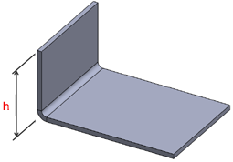

**Minimum Bending Height : R-bend shape**

Machining Limits, Size Range

| Material | Sheet thickness (Gauge) | Thickness (Inch) | | | Limit h (mm) | |
| --- | --- | --- | --- | --- | --- | --- |
| * Cold Rolled Low Carbon Steel * Hot Rolled Low Carbon Steel | | | 22 | 0.0299″ | | 2.7 |
| 20 | 0.0359″ | | 2.5 |
| 19 | 0.0418″ | | 2.2 |
| 18 | 0.0478″ | | 3.1 |
| 17 | 0.0538″ | | 2.8 |
| 16 | 0.0598″ | | 3.8 |
| 14 | 0.0747″ | | 4.4 |
| 13 | 0.0897″ | | 4.8 |
| 12 | 0.1046″ | | 5.4 |
| 11 | 0.1196″ | | 7.2 |
| * Cold Rolled Low Carbon Steel (Electrolytic Galvanized) * Cold Rolled Low Carbon Steel (Hot Galvanized) | | | 24 | 0.0276″ | | 1.8 |
| 22 | 0.0336″ | | 2.5 |
| 20 | 0.0396″ | | 2.3 |
| 18 | 0.0516″ | | 2.9 |
| 16 | 0.0635″ | | 3.6 |
| 14 | 0.0785″ | | 4.2 |
| * 304 Stainless Steel (2B) * 304 Stainless Steel (No.4) | | | 22 | 0.0312″ | | 2.6 |
| 20 | 0.0375″ | | 2.4 |
| 19 | 0.0437″ | | 2.1 |
| 18 | 0.0500″ | | 3.0 |
| 17 | 0.0562″ | | 3.9 |
| 16 | 0.0625″ | | 3.6 |
| 14 | 0.0781″ | | 4.2 |
| 13 | 0.0937″ | | 4.6 |
| 12 | 0.1094″ | | 5.1 |
| 11 | 0.1250″ | | 6.9 |
| * 5052 Aluminum Alloy | | | – | 0.0250″ | | 1.9 |
| – | 0.0320″ | | 2.6 |
| – | 0.0400″ | | 2.3 |
| – | 0.0500″ | | 3.0 |
| – | 0.0630″ | | 3.6 |
| – | 0.0800″ | | 4.1 |
| – | 0.0900″ | | 4.8 |
| – | 0.1000″ | | 4.3 |
| – | 0.1250″ | | 6.9 |

Example

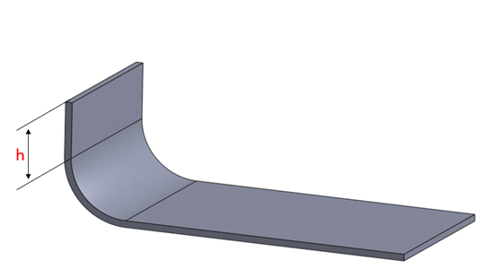

**Width Specification Range for Bending**

Machining Limits, Size Range

| Material | Sheet thickness | | Thickness (Inch) | | Dimensional range w | |
| --- | --- | --- | --- | --- | --- | --- |
| * Cold Rolled Low Carbon Steel * Hot Rolled Low Carbon Steel | | 26 | | 0.0179″ | | 25~1016 |
| 24 | | 0.0239″ | |
| 22 | | 0.0299″ | | 5~1200 |
| 20 | | 0.0359″ | |
| 19 | | 0.0418″ | |
| 18 | | 0.0478″ | |
| 17 | | 0.0538″ | |
| 16 | | 0.0598″ | |
| 14 | | 0.0747″ | |
| 13 | | 0.0897″ | | 10~1200 |
| 12 | | 0.1046″ | |
| 11 | | 0.1196″ | |
| 10 | | 0.1345″ | |
| 8 | | 0.1644″ | | 25~762 |
| 7 | | 0.1793″ | | 25~635 |
| 6 | | 0.1943″ | | 10~1200 |
| * Low Carbon Steel (Electrolytic Galvanized) * Low Carbon Steel (Hot Galvanized) | | 24 | | 0.0276″ | | 5~1200 |
| 22 | | 0.0336″ | |
| 20 | | 0.0396″ | |
| 18 | | 0.0516″ | |
| 16 | | 0.0635″ | |
| 14 | | 0.0785″ | |
| * 304 Stainless Steel * 304 Stainless Steel (No.4) | | 26 | | 0.0179″ | | 25~1016 |
| 24 | | 0.0239″ | |
| 22 | | 0.0312″ | | 5~1200 |
| 20 | | 0.0375″ | |
| 19 | | 0.0437″ | |
| 18 | | 0.0500″ | |
| 17 | | 0.0562″ | |
| 16 | | 0.0625″ | |
| 14 | | 0.0781″ | | 10~1200 |
| 13 | | 0.0937″ | |
| 12 | | 0.1094″ | |
| 11 | | 0.1250″ | |
| 10 | | 0.1406″ | |
| 8 | | 0.1719″ | |
| 7 | | 0.1875″ | |
| 3 | | 0.2500″ | |
| * 316 Stainless Steel (2B) | | 26 | | 0.0187″ | | 25~1016 |
| 24 | | 0.0250″ | |
| 22 | | 0.0312″ | |
| 20 | | 0.0375″ | |
| 18 | | 0.0500″ | |
| 16 | | 0.0625″ | |
| 14 | | 0.0781″ | |
| 12 | | 0.1094″ | | 25~635 |
| 11 | | 0.1250″ | | 25~1016 |
| 10 | | 0.1406″ | | 25~762 |
| 7 | | 0.1875″ | | 25~635 |
| * 5052 Aluminum Alloy * 6061 Aluminum Alloy | | – | | 0.0200″ | | 10~1200 |
| – | | 0.0250″ | |
| – | | 0.0320″ | |
| – | | 0.0400″ | |
| – | | 0.0500″ | |
| – | | 0.0630″ | |
| – | | 0.0800″ | |
| – | | 0.0900″ | |
| – | | 0.1000″ | |
| – | | 0.1250″ | |
| – | | 0.160″ | | 25~1016 |
| – | | 0.190″ | | 25~635 |
| – | | 0.250″ | | 25~508 |

Example

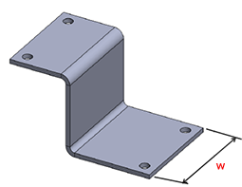

**Minimum Angle for Acute Angle Bending**

Machining Limits, Size Range

The angle (θ) for acute angle bending must be 30° or more.

Example

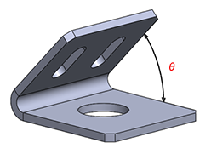

**Minimum Radius of Rectangular Holes**

Machining Limits, Size Range

* The radius (R) of the corners of a rectangular hole must be 0.5 mm or more.
* (For clear resin, this must be 3 mm or more.)

Example

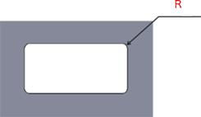

**Metric Thickness Gauge Standard**

**Minimum Distance Between a Hole and an Edge or Between Two Holes**

Machining Limits, Size Range

|  |  |  |  |  |  |  |
| --- | --- | --- | --- | --- | --- | --- |
| Sheet Thickness | | | | Limit a | Limit b | Limit c |
| * Low Carbon Steel (Cold/Hot) * 1018 Carbon Steel * Low Carbon Steel (Electrolytic Zinc Plating) | * 304 SS (No.1) * 304 SS (2B) * 304 SS (#400) * 304 SS (Hairline Finish) * 430 SS (2B) | * 5052 Aluminum Alloy * 5052 AL Alloy Pre-Finish, Clear Anodize​ * 5052 AL Alloy Pre-Finish, Black Anodize​ | * Perforated Metal * —60° staggered round hole type— |
| 0.8 | 0.8 | 0.8 | 0.8 | 0.5 | 11.5 | 3.0 |
| 1.0 | 1.0 | 1.0 | 1.0 |
| 1.2 | 1.2 | 1.2 | – | 0.6 |
| – | 1.5 | 1.5 | 1.5 | 0.7 |
| 1.6 | – | 1.6 | – | 0.8 |
| 2.0 | 2.0 | 2.0 | 1.0 | – | |
| 2.3 | – | – |
| – | 2.5 | 2.5 | 1.2 |
| – | 3.0 | 3.0 | 1.5 |
| 3.2 | – | – |
| – | 4.0 | 4.0 | 2.0 |
| 4.5 | – | – | 2.2 |
| – | 5.0 | 5.0 | 2.5 |
| 6.0 | 6.0 | 6.0 | 3.0 |
| 9.0 | 9.0 | – | 4.0 |
| 10.0 | 10.0 | 5.0 |
| 12.0 | 12.0 | 6.0 |
| 16.0 | – | 8.0 |

|  |  |  |  |
| --- | --- | --- | --- |
| Sheet Thickness | Limit a | Limit b | Limit c |
| * Cold Rolled Low Carbon Steel (for Shims) |
| 0.1 | 1.0 | – | |
| 0.2 |
| 0.3 |
| 0.5 |

|  |  |  |  |
| --- | --- | --- | --- |
| Sheet Thickness | Limit a | Limit b | Limit c |
| * 304 Stainless Steel (H) (for Shims) |
| 0.05 | 0.5 | – | |
| 0.1 |
| 0.2 |
| 0.3 |
| 0.5 |
| 0.8 | 0.8 |
| 1.0 | 1.0 |

|  |  |  |  |  |  |  |
| --- | --- | --- | --- | --- | --- | --- |
| Sheet Thickness | | | | Limit a | Limit b | Limit c |
| PET | Acrylic | Polycarbonate | PVC |
| 3.0 | 3.0 | 3.0 | 3.0 | 2.0 | – | |
| 5.0 | 5.0 | 5.0 | 5.0 |

Example



* *The distance between a tapped hole and the edge or between tapped holes is determined by the minimum distance from the outermost diameter of the tapped hole.
* *The distance between friction drilled/tapped holes is determined from the minimum distance from the center of the hole.
* *The distance between a countersunk hole and the edge or between countersunk holes is determined by the minimum distance from the outermost diameter of the counterbored part.

**Minimum Diameter for Through Holes ; Minimum Width of Rectangular/Slotted Holes**

Machining Limits, Size Range

|  |  |  |  |  |  |  |
| --- | --- | --- | --- | --- | --- | --- |
| Sheet Thickness | | | | Limit d | Limit w1 | Limit w2 |
| * Low Carbon Steel (Cold/Hot) * 1018 Carbon Steel * Low Carbon Steel (Electrolytic Zinc Plating) | * 304 SS (No.1) * 304 SS (2B) * 430 SS (2B) | * 5052 Aluminum Alloy * 5052 AL Alloy Pre-Finish, Clear Anodize​ * 5052 AL Alloy Pre-Finish, Black Anodize​ | * Perforated Metal * —60° staggered round hole type— |
| 0.8 | 0.8 | 0.8 | 0.8 | 0.4 | 0.8 | 0.8 |
| 1.0 | 1.0 | 1.0 | 1.0 | 0.5 | 1.0 | 1.0 |
| 1.2 | 1.2 | 1.2 | – | 0.6 | 1.2 | 1.2 |
| – | 1.5 | 1.5 | 1.5 | 0.7 | 1.5 | 1.5 |
| 1.6 | – | 1.6 | – | 0.8 | 1.6 | 1.6 |
| 2.0 | 2.0 | 2.0 | 1.0 | 2.0 | 2.0 |
| 2.3 | – | – | 1.1 | 2.3 | 2.3 |
| – | 2.5 | 2.5 | 1.2 | 2.5 | 2.5 |
| – | 3.0 | 3.0 | 1.5 | 3.0 | 3.0 |
| 3.2 | – | – | 1.6 | 3.0 | 3.0 |
| – | 4.0 | 4.0 | 2.0 | 3.0 | 3.0 |
| 4.5 | – | – | 2.2 | 4.0 | 4.0 |
| – | 5.0 | 5.0 | 2.5 |
| 6.0 | – | – | 3.0 |
| – | 6.0 | 6.0 | 6.0 | 6.0 |
| 9.0 | 9.0 | – | 4.5 |
| 10.0 | 10.0 | 5.0 |
| 12.0 | 12.0 | 6.0 | 8.0 | 8.0 |
| 16.0 | – | 8.0 | 10.0 | 10.0 |

|  |  |  |  |
| --- | --- | --- | --- |
| Sheet Thickness | Limit d | Limit w1 | Limit w2 |
| * 304 Stainless Steel (single-sided #400-grit polished) * 304 Stainless Steel (Single-sided hairline finish) |
| 0.8 | 1.6 | 3.0 | 3.0 |
| 1.0 | 1.6 |
| 1.2 | 2.0 |
| 1.5 | 2.5 |
| 2.0 | 4.0 | 4.5 | 4.5 |
| 3.0 | 4.5 |

|  |  |  |  |  |
| --- | --- | --- | --- | --- |
| Sheet Thickness | | Limit d | Limit w1 | Limit w2 |
| Cold Rolled Low Carbon Steel (for Shims) | 304 Stainless Steel(H) (for Shims) |
| – | 0.05 | 0.3 | 0.5 | 0.5 |
| 0.1 | 0.1 |
| 0.2 | 0.2 |
| 0.3 | 0.3 |
| 0.5 | 0.5 |
| – | 0.8 | 1.0 | 0.8 | 0.8 |
| 1.0 | 1.0 | 1.0 | 1.0 |

|  |  |  |  |  |  |  |
| --- | --- | --- | --- | --- | --- | --- |
| Sheet Thickness | | | | Limit d | Limit w1 | Limit w2 |
| PET | Acrylic | Polycarbonate | PVC |
| 3.0 | 3.0 | 3.0 | 3.0 | 1.5 | 3.0 | 7.0 |
| 5.0 | 5.0 | 5.0 | 5.0 |

Example



**Minimum Size of Cutout Shape**

Machining Limits, Size Range

|  |  |  |  |
| --- | --- | --- | --- |
| Material | Sheet Thickness | Minimum Value | Limit Value |
| Cutout Width/Depth A | |
| Cold Rolled Low Carbon Steel (for Shims) | 0.1 | 0.5 | 0.3 |
| 0.2 |
| 0.3 |
| 0.5 | 0.8 | 0.4 |
| 304 Stainless Steel(H) (for shims) | 0.05 | 0.5 | 0.3 |
| 0.1 |
| 0.2 |
| 0.3 |
| 0.5 | 0.8 | 0.4 |
| 0.8 | 1.2 | 0.5 |
| 1.0 | 1.5 |
| PET | 3.0 | – | 7.0 |
| 5.0 |
| Acrylic | 3.0 |
| 5.0 |
| Polycarbonate | 3.0 |
| 5.0 |
| PVC | 3.0 |
| 5.0 |

Example

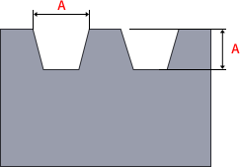

**Minimum Slit Width (when the part is unfolded).**

Machining Limits, Size Range

|  |  |  |  |  |  |
| --- | --- | --- | --- | --- | --- |
| Sheet Thickness | | | | Minimum Slit Width (when the part is unfolded). | |
| * EN 1.0330 equiv. EN 1.0320 equiv. (hot coiled) * EN 1.0038 equiv. * EN 1.0330 equiv. (Electrolytic Zinc Plating) | * 304 SS (2B) * 304 SS (#400) * 304 SS (Hairline Finish) * 430 SS (2B) | * 5052 Aluminum Alloy * 5052 AL Alloy Pre-Finish, Clear Anodize​ * 5052 AL Alloy Pre-Finish, Black Anodize​ | Perforated Metal —60° staggered round hole type— | Guaranteed Width a | Limit a |
| 0.8 | 0.8 | 0.8 | 0.8 | 0.8 | 0.5 |
| 1.0 | 1.0 | 1.0 | 1.0 | 1.0 | 0.5 |
| 1.2 | 1.2 | 1.2 | – | 1.2 | 0.5 |
| – | 1.5 | 1.5 | 1.5 | 1.5 | 0.5 |
| 1.6 | – | 1.6 | – | 1.6 | 0.5 |
| 2.0 | 2.0 | 2.0 | 2.0 | 0.5 |
| 2.3 | – | – | 2.3 | 0.8 |
| – | 2.5 | 2.5 | 2.5 | 0.8 |
| – | 3.0 | 3.0 | 3.0 | 1.5 |
| 3.2 | – | – | 3.2 | 1.6 |
| – | 4.0 | 4.0 | 4.0 | 2.0 |
| 4.5 | – | – | 4.5 | 2.3 |
| – | 5.0 | 5.0 | 5.0 | 2.5 |
| 6.0 | 6.0 | 6.0 | 6.0 | 3.0 |
| 9.0 | 9.0 | – | 9.0 | 4.5 |
| 10.0 | 10.0 | 10.0 | 5.0 |
| 12.0 | 12.0 | 12.0 | 6.0 |
| 16.0 | – | 16.0 | 8.0 |

Example

Folded Part View

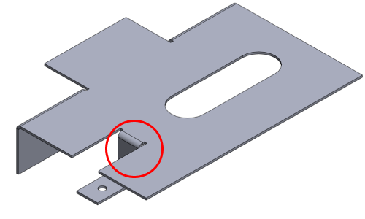

Unfolded Part View

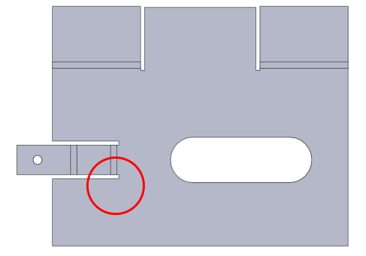

* Detailed Slit View

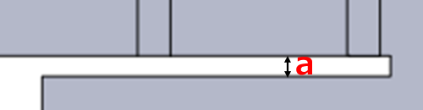

**Minimum Bending Height : Normal Bending**

Machining Limits, Size Range

| Material | Sheet Thickness | | Limit h | |
| --- | --- | --- | --- | --- |
| * Low Carbon Steel (Cold/Hot) * 1018 Carbon Steel | | 0.8 | | 4.2 |
| 1.0 | | 4.3 |
| 1.2 | | 5.5 |
| 1.6 | | 6.8 |
| 2.0 | | 8.2 |
| 2.3 | | 9.4 |
| 3.2 | | 13.3 |
| 4.5 | | 17.4 |
| 6.0 | | 23.5 |
| 9.0 | | 33.5 |
| 10.0 | | 46.5 |
| 12.0 | | 62.0 |
| 16.0 | | 88.5 |
| Low Carbon Steel (Electrolytic Zinc Plating) | | 0.8 | | 4.2 |
| 1.0 | | 4.3 |
| 1.2 | | 4.5 |
| 1.6 | | 5.8 |
| 2.0 | | 7.0 |
| 2.3 | | 8.3 |
| 3.2 | | 11.1 |
| * 304 SS (No.1) * 304 SS (2B) * 304 SS (#400) * 304 SS (Hairline Finish) * 430 SS (2B) | | 0.8 | | 4.2 |
| 1.0 | | 4.3 |
| 1.2 | | 4.5 |
| 1.5 | | 6.0 |
| 2.0 | | 7.1 |
| 2.5 | | 11.3 |
| 3.0 | | 11.5 |
| 4.0 | | 17.2 |
| 5.0 | | 23.5 |
| 6.0 | | 25.0 |
| 9.0 | | 39.0 |
| 10.0 | | 46.5 |
| 12.0 | | 62.0 |
| * 5052 Aluminum Alloy * 5052 AL Alloy Pre-Finish, Clear Anodize​ * 5052 AL Alloy Pre-Finish, Black Anodize​ | | 0.8 | | 4.2 |
| 1.0 | | 4.3 |
| 1.2 | | 5.5 |
| 1.5 | | 6.0 |
| 1.6 | | 6.0 |
| 2.0 | | 8.2 |
| 2.5 | | 10.0 |
| 3.0 | | 13.3 |
| 4.0 | | 17.2 |
| 5.0 | | 27.0 |
| 6.0 | | 28.0 |
| * Perforated Metal * —60° staggered round hole type— | | 0.8 | | 4.2 |
| 1.0 | | 4.3 |
| 1.5 | | 6.0 |

Example



**Minimum Bending Height : R-bend shape**

Machining Limits, Size Range

|  |  |  |
| --- | --- | --- |
| Material | Sheet Thickness | Limit h |
| Low Carbon Steel | 0.8 | 2.6 |
| 1.0 | 2.3 |
| 1.2 | 3.1 |
| 1.6 | 3.6 |
| 2.0 | 4.2 |
| 2.3 | 4.8 |
| 3.2 | 6.9 |
| Low Carbon Steel (Electrolytic Zinc Plating) | 0.8 | 2.6 |
| 1.0 | 2.3 |
| 1.2 | 2.1 |
| 1.6 | 2.6 |
| 2.0 | 3.0 |
| 2.3 | 3.7 |
| 3.2 | 4.7 |
| * 304 SS (2B) * 304 SS (#400) * 430 SS (2B) | 0.8 | 2.6 |
| 1.0 | 2.3 |
| 1.2 | 2.1 |
| 1.5 | 3.0 |
| 2.0 | 3.1 |
| 2.5 | 6.3 |
| 3.0 | 5.5 |
| * 5052 Aluminum Alloy * 5052 AL Alloy Pre-Finish, Clear Anodize​ * 5052 AL Alloy Pre-Finish, Black Anodize​ | 0.8 | 2.6 |
| 1.0 | 2.3 |
| 1.2 | 2.1 |
| 1.5 | 3.0 |
| 1.6 | 2.8 |
| 2.0 | 3.1 |
| 2.5 | 5.0 |
| 3.0 | 5.5 |
| * Perforated Metal * —60° staggered round hole type— | 0.8 | 2.6 |
| 1.0 | 2.3 |
| 1.5 | 3.0 |

Example



**The minimum bending height**

Machining Limits, Size Range

|  |  |  |  |  |  |
| --- | --- | --- | --- | --- | --- |
| Material | Sheet Thickness | Surface Treatment | | | |
| None | * Paint * Electroless Nickel Plating * Black oxide * Trivalent Chromate (Clear) | * Trivalent Chromate (Black) | * Electrolytic Galvanized * Hot Galvanized |
| Limit a | | | |
| * Low Carbon Steel (Cold/Hot) * 1018 Carbon Steel * Low Carbon Steel (Cold Rolled) with Electrolytic Zinc Plating * Low Carbon Steel (Cold Rolled) with Hot Zinc Plating | 0.8 | 8.2 | 6.8 | 7.1 | – |
| 1.0 | 8.5 | 6.8 | 7.5 |
| 1.2 | 9.9 | 9.0 | 8.4 |
| 1.6 | 11.6 | 9.5 | 9.2 |
| 2.0 | 13.1 | 13.5 | 11.0 |
| 2.3 | 13.7 | 14.0 | 11.6 |
| 3.2 | 19.4 | 22.0 | 15.4 |
| 4.5 | 28.0 | 28.0 | 20.0 |
| 6.0 | 37.3 | 32.0 | 30.0 |
| 9.0 | 56.8 | 57.0 | – |
| 10.0 | 75.1 | – |
| 12.0 | 91.0 |
| 16.0 | 158.0 |

|  |  |  |
| --- | --- | --- |
| Material | Sheet Thickness | Surface Finish |
| * 2B * Single-sided #400 Brushed * Single-sided hairline finish * No.1 |
| Limit a |
| * 304 Stainless Steel * 430 Stainless Steel | 0.8 | 6.9 |
| 1.0 | 7.4 |
| 1.2 | 7.9 |
| 1.5 | 9.7 |
| 2.0 | 12.6 |
| 2.5 | 17.6 |
| 3.0 | 18.6 |
| 4.0 | 26.6 |
| 5.0 | 33.8 |
| 6.0 | 36.4 |
| 9.0 | 56.8 |
| 10.0 | 75.1 |
| 12.0 | 91.0 |

|  |  |  |  |
| --- | --- | --- | --- |
| Material | Sheet Thickness | Surface Treatment | |
| None | * Clear Anodize * Black Anodize * Black Anodize (matte) * (Outer Diameter ≤ 300 mm) |
| * Clear Anodize * Black Anodize * Black Anodize (matte) * (Outer Diameter > 300 mm) |
| Limit a | |
| * 5052 Aluminum Alloy * 5052 AL Alloy Pre-Finish, Clear Anodize​ * 5052 AL Alloy Pre-Finish, Black Anodize​ | 0.8 | 6.8 | 7.1 |
| 1.0 | 6.8 | 7.5 |
| 1.2 | 9.0 | 9.0 |
| 1.5 | 9.5 | 9.0 |
| 1.6 | 9.5 | 9.5 |
| 2.0 | 13.5 | 11.0 |
| 2.5 | 15.5 | 15.5 |
| 3.0 | 22.0 | 15.0 |
| 4.0 | 28.0 | 19.0 |
| 5.0 | 44.0 | 28.0 |
| 6.0 | 48.0 | 48.0 |

|  |  |  |
| --- | --- | --- |
| Material | Sheet Thickness | Limit a |
| Perforated Metal —60° staggered round hole type— | 0.8 | 6.8 |
| 1.0 | 6.8 |
| 1.5 | 9.5 |

Example

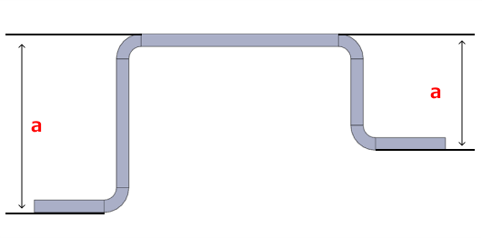

**Width Specification Range for Bending**

Machining Limits, Size Range

|  |  |  |  |
| --- | --- | --- | --- |
| Sheet Thickness | | | Dimensional Range w |
| * Low Carbon Steel (Cold/Hot) * 1018 Carbon Steel * Low Carbon Steel (Electrolytic Zinc Plating) | * 304 SS (No.1) * 304 SS (2B) * 304 SS (#400) * 304 SS (Hairline Finish) * 430 SS (2B) | * 5052 Aluminum Alloy * 5052 AL Alloy Pre-Finish, Clear Anodize​ * 5052 AL Alloy Pre-Finish, Black Anodize​ |
| 0.8 | 0.8 | 0.8 | 5～1200 |
| 1.0 | 1.0 | 1.0 |
| 1.2 | 1.2 | 1.2 |
| – | 1.5 | 1.5 |
| 1.6 | – | 1.6 |
| 2.0 | 2.0 | 2.0 |
| 2.3 | – | – | 10～1200 |
| – | 2.5 | 2.5 |
| – | 3.0 | 3.0 |
| 3.2 | – | – |
| – | 4.0 | 4.0 |
| 4.5 | – | – |
| – | 5.0 | 5.0 |
| 6.0 | – | – |
| – | 6.0 | 6.0 | 10～800 |
| 9.0 | – | – | 10～835 |
| – | 9.0 | 10～550 |
| 10.0 | – | 20～835 |
| – | 10.0 | 20～550 |
| 12.0 | – | 20～750 |
| – | 12.0 | 20～500 |
| 16.0 | – |

|  |  |
| --- | --- |
| Sheet Thickness | Dimensional Range w |
| Perforated Metal —60° staggered round hole type— |
| 0.8 | 30–900 |
| 1.0 |
| 1.5 |

Example



**Minimum Distance Between a Hole and Bend : Normal Bending**

Machining Limits, Size Range

| Material | Sheet Thickness | Hole Type | | | | | | | | | | | | | | | | | | | |
| --- | --- | --- | --- | --- | --- | --- | --- | --- | --- | --- | --- | --- | --- | --- | --- | --- | --- | --- | --- | --- | --- |
| Through Hole | | | | | | Slotted/Rectangular Hole | | | | | Tapped Hole | | | | | | Burring Tap Hole | Countersunk Holes | |
| Minimum a *1 | | | Limit a | | | Minimum a *1 | | | Limit a | | Minimum a *2 | | | | Limit a | | Limit a *1 | Minimum a | Limit a |
| * Low Carbon Steel (Cold/Hot) * 1018 Carbon Steel * Low Carbon Steel (Electrolytic Zinc Plating) | | | 0.8 | 4.2 | | 2.0 | – | | 4.2 | – | | – | | 4.2 | – | – | |
| 1.0 | 4.3 | | 4.3 | 4.8 | | 2.7 | | 4.3 |
| 1.2 | 5.5 | | 3.0 | 5.5 | 6.0 | | 3.9 | | 5.5 |
| 1.6 | 6.8 | | 3.5 | 6.8 | 7.3 | | 5.2 | | 6.8 |
| 2.0 | 8.0 | | 4.0 | 8.0 | 8.7 | | 6.6 | | – | 8.0 | 4.0 | |
| 2.3 | 9.3 | | 5.0 | 9.3 | 9.9 | | 7.8 | | 9.3 | 5.0 | |
| 3.2 | 13.3 | | 6.5 | 13.3 | 13.8 | | 11.7 | | 12.1 | 6.5 | |
| 4.5 | 17.4 | | 9.5 | 17.4 | 18.4 | | 16.3 | | 18.4 | 9.5 | |
| 6.0 | 23.5 | | 14.0 | 23.5 | 24.5 | | 22.4 | | 24.5 | 16.0 | |
| 9.0 | 33.5 | | 21.5 | 33.5 | 34.5 | | 32.4 | | 33.5 | 21.5 | |
| 10.0 | 46.5 | | 22.5 | 48.5 | 47.5 | | 47.5 | | 46.5 | 46.5 | |
| 12.0 | 62.0 | | 26.5 | 62.0 | 63.0 | | 63.0 | | 62.0 | 62.0 | |
| 16.0 | 88.5 | | 34.5 | 88.5 | 89.5 | | 89.5 | | 88.5 | 88.5 | |
| Low Carbon Steel (Electrolytic Zinc Plating) | | | 0.8 | 4.2 | | 2.0 | 4.2 | | 2.0 | – | | – | | 4.2 | – | – | |
| 1.0 | 4.3 | | 4.3 | | 5.3 | | 3.2 | | 4.3 |
| 1.2 | 4.5 | | 3.0 | 4.5 | | 3.0 | 5.5 | | 3.4 | | 4.5 |
| 1.6 | 5.8 | | 3.5 | – | | 5.8 | 6.8 | | 4.7 | | 5.8 |
| 2.0 | 7.0 | | 4.0 | 7.0 | | 4.0 | 8.0 | | 5.9 | | – | 8.0 | 4.0 | |
| 2.3 | 8.3 | | 5.0 | 8.3 | | 5.0 | 9.3 | | 7.2 | | 9.3 | 5.0 | |
| 3.2 | 11.1 | | 6.5 | 11.1 | | 6.0 | 12.1 | | 10.0 | | 12.1 | 6.5 | |
| * 304 SS (No.1) * 304 SS (2B) * 304 SS (#400) * 304 SS (Hairline Finish) * 430 SS (2B) | | | 0.8 | 4.2 | | 2.0 | – | | 4.2 | – | | – | | 4.2 | – | – | |
| 1.0 | 4.3 | | 4.3 | 5.3 | | 3.2 | | 4.3 |
| 1.2 | 4.5 | | 3.0 | 4.5 | 5.5 | | 3.4 | | 4.5 |
| 1.5 | 6.0 | | 3.5 | 6.0 | 7.0 | | 4.9 | | 6.0 |
| 2.0 | 7.1 | | 4.0 | 7.1 | 8.1 | | 6.0 | | – | 8.1 | 4.0 | |
| 2.5 | 11.3 | | 6.3 | 11.3 | 12.3 | | 10.2 | | 12.3 | 6.3 | |
| 3.0 | 11.5 | | 6.5 | 11.5 | 12.5 | | 10.4 | | 12.5 | 6.5 | |
| 4.0 | 17.2 | | 11.5 | 17.2 | 18.2 | | 16.1 | | 18.2 | 11.5 | |
| 5.0 | 23.5 | | 14.0 | 23.5 | 24.5 | | 22.4 | | 24.5 | 15.0 | |
| 6.0 | 25.0 | | 19.0 | 25.0 | 26.0 | | 24.0 | | 26.0 | 17.0 | |
| 9.0 | 39.0 | | 20.5 | 39.0 | 40.0 | | 40.0 | | 39.0 | 39.0 | |
| 10.0 | 46.5 | | 22.5 | 46.5 | 47.5 | | 47.5 | | 46.5 | 46.5 | |
| 12.0 | 62.0 | | 26.5 | 62.0 | 63.0 | | 63.0 | | 62.0 | 62.0 | |
| * 5052 Aluminum Alloy * 5052 AL Alloy Pre-Finish, Clear Anodize​ * 5052 AL Alloy Pre-Finish, Black Anodize​ | | | 0.8 | 4.2 | | 4.2 | – | | 4.2 | – | | – | | 4.2 | – | – | |
| 1.0 | 4.3 | | 4.3 | 4.3 | 5.2 | | 4.3 | | 4.3 |
| 1.2 | 5.5 | | 5.5 | 5.5 | 5.5 | | 5.5 | | 5.5 |
| 1.5 | 6.0 | | 6.0 | 6.0 | 7.0 | | 6.0 | | 6.0 |
| 1.6 | 6.0 | | 6.0 | 6.0 | 7.0 | | 6.0 | | 6.0 |
| 2.0 | 8.2 | | 8.2 | 8.2 | 8.2 | | 8.2 | | – | 8.2 | 8.2 | |
| 2.5 | 10.0 | | 10.0 | 10.0 | 11.0 | | 10.0 | | 10.5 | 10.0 | |
| 3.0 | 13.3 | | 13.3 | 13.3 | 13.3 | | 13.3 | | 13.3 | 13.3 | |
| 4.0 | 17.2 | | 17.2 | 17.2 | 18.2 | | 17.2 | | 18.2 | 17.2 | |
| 5.0 | 27.0 | | 27.0 | 27.0 | 27.0 | | 27.0 | | 27.0 | 27.0 | |
| 6.0 | 28.0 | | 28.0 | 28.0 | 28.0 | | 28.0 | | 28.0 | 28.0 | |
| * Perforiertes Metall * —60° staggered round hole type— | | | 0.8 | 4.2 | | 2.0 | – | | 4.2 | – | | – | | – | – | – | |
| 1.0 | 4.3 | | 4.3 |
| 1.5 | 6.0 | | 3.5 | 6.0 |

* *1 The hole may be deformed if it is below the minimum value.

The dimensions are therefore inaccurate, but will be processed as they are.

* *2 If the distance is under the minimum value, re-tapping will be necessary and the fit may be affected.

Example



If there are internal angles of less than 90°, machining may not be possible even within the safe value range. If this is the case, meviy Support will contact you.

**Minimum Distance Between a Hole and Bend : R-bend shape**

Machining Limits, Size Range

| Material | Sheet Thickness | Hole Type | | | | | | | | | | | | | | | | | | | |
| --- | --- | --- | --- | --- | --- | --- | --- | --- | --- | --- | --- | --- | --- | --- | --- | --- | --- | --- | --- | --- | --- |
| Through Hole | | | | | Slotted/Rectangular Hole | | | | | | Tapped Hole | | | | | | Burring Tap Hole | Countersunk Holes | |
| Minimum a *1 | | | Limit a | | Minimum a *1 | | | | Limit a | | Minimum a *2 | | | | Limit a | | Limit a *1 | Minimum a | Limit a |
| * Low Carbon Steel * Low Carbon Steel (Hot) | | | 0.8 | 2.6 | | 0.4 | | – | 2.6 | – | | – | | 2.6 | – | – | |
| 1.0 | 2.3 | | 0.1 | | 2.3 | 2.8 | | 0.7 | | 2.3 |
| 1.2 | 3.1 | | 0.6 | | 3.1 | 3.6 | | 1.5 | | 3.1 |
| 1.6 | 3.6 | | 0.3 | | 3.6 | 4.1 | | 2.0 | | 3.6 |
| 2.0 | 4.0 | | 0.1 | | 4.0 | 4.7 | | 2.6 | | – | 4.0 | 0.1 | |
| 2.3 | 4.7 | | 0.4 | | 4.7 | 5.3 | | 3.2 | | 4.7 | 0.4 | |
| 3.2 | 6.9 | | 0.1 | | 6.9 | 7.4 | | 5.3 | | 5.7 | 0.1 | |
| Low Carbon Steel (Electrolytic Zinc Plating) | | | 0.8 | 2.6 | | 0.4 | | 2.6 | 0.4 | – | | – | | 2.6 | – | – | |
| 1.0 | 2.3 | | 0.1 | | 2.3 | 0.1 | 3.3 | | 1.2 | | 2.3 |
| 1.2 | 2.1 | | 0.6 | | 2.1 | 0.6 | 3.1 | | 1.0 | | 2.1 |
| 1.6 | 2.6 | | 0.3 | | – | 2.6 | 3.6 | | 1.5 | | 2.6 |
| 2.0 | 3.0 | | 0.1 | | 3.0 | 0.1 | 4.0 | | 1.9 | | – | 4.0 | 0.1 | |
| 2.3 | 3.7 | | 0.4 | | 3.7 | 0.4 | 4.7 | | 2.6 | | 4.7 | 0.4 | |
| 3.2 | 4.7 | | 0.1 | | 4.7 | 0.1 | 5.7 | | 3.6 | | 5.7 | 0.1 | |
| * 304 SS (2B) * 304 SS (#400) * 430 SS (2B) | | | 0.8 | 2.6 | | 0.4 | | – | 2.6 | – | | – | | 2.6 | – | – | |
| 1.0 | 2.3 | | 1.0 | | 2.3 | 3.3 | | 1.2 | | 2.3 |
| 1.2 | 2.1 | | 0.6 | | 2.1 | 3.1 | | 1.0 | | 2.1 |
| 1.5 | 3.0 | | 0.5 | | 3.0 | 4.0 | | 1.9 | | 3.0 |
| 2.0 | 3.1 | | 0.1 | | 3.1 | 4.1 | | 2.0 | | – | 4.1 | 0.1 | |
| 2.5 | 6.3 | | 1.3 | | 6.3 | 7.3 | | 5.2 | | 7.3 | 1.3 | |
| 3.0 | 5.5 | | 0.5 | | 5.5 | 6.5 | | 4.4 | | 6.5 | 0.5 | |
| * 5052 Aluminum Alloy * 5052 AL Alloy Pre-Finish, Clear Anodize​ * 5052 AL Alloy Pre-Finish, Black Anodize​ | | | 0.8 | 2.6 | | 0.4 | | – | 2.6 | – | | – | | 2.6 | – | – | |
| 1.0 | 2.2 | | 0.1 | | 2.3 | 3.2 | | 1.1 | | 2.2 |
| 1.2 | 1.9 | | 0.1 | | 3.1 | 2.9 | | 0.8 | | 1.9 |
| 1.5 | 3.0 | | 0.5 | | 3.0 | 4.0 | | 1.9 | | 3.0 |
| 1.6 | 2.8 | | 0.3 | | 2.8 | 3.8 | | 1.7 | | 2.8 |
| 2.0 | 3.1 | | 0.1 | | 4.2 | 4.1 | | 2.0 | | – | 4.1 | 0.1 | |
| 2.5 | 5.0 | | 0.1 | | 5.0 | 6.0 | | 4.0 | | 5.5 | 0.1 | |
| 3.0 | 5.5 | | 0.1 | | 7.3 | 6.5 | | 4.4 | | 6.5 | 0.1 | |
| * Perforiertes Metall * —60° staggered round hole type— | | | 0.8 | 2.6 | | 0.4 | | – | 2.6 | – | | – | | – | – | – | |
| 1.0 | 2.3 | | 0.1 | | 2.3 |
| 1.5 | 3.0 | | 0.5 | | 3.0 |

* *1 The hole may be deformed if it is below the minimum value.

The dimensions are therefore inaccurate, but will be processed as they are.

* *2 If the distance is under the minimum value, re-tapping will be necessary and the fit may be affected.

Example



**Slit on the bending line (except for acute angle bending shapes with an internal angle of less than 90°).**

Machining Limits, Size Range

|  |  |  |  |  |
| --- | --- | --- | --- | --- |
| Sheet Thickness | | Minimum a *1 | Minimum b *2 | Limit c |
| * Low Carbon Steel (Cold/Hot) * 1018 Carbon Steel * Low Carbon Steel (Electrolytic Zinc Plating) | * 304 SS (No.1) * 304 SS (2B) * 304 SS (#400) * 304 SS (Hairline Finish) * 430 SS (2B) * 5052 Aluminum Alloy * 5052 AL Alloy Pre-Finish, Clear Anodize​ * 5052 AL Alloy Pre-Finish, Black Anodize​ |
| 0.8 | 0.8 | 0.8 | 1.2 | 0.5 |
| 1.0 | 1.0 | 1.0 | 1.5 |
| 1.2 | 1.2 | 1.2 | 1.8 | 0.6 |
| – | 1.5 | 1.5 | 2.3 | 0.7 |
| 1.6 | 1.6 *4 | 1.6 | 2.4 | 0.8 |
| 2.0 | 2.0 | 2.0 | 3.0 | 1.0 |
| 2.3 | – | 2.3 | 3.5 |
| – | 2.5 | 2.5 | 3.8 | 1.2 |
| – | 3.0 | 3.0 | 4.5 | 1.5 |
| 3.2 | – | 3.2 | 4.8 |
| – | 4.0 | 4.0 | 6.0 | 2.0 |
| 4.5 | – | 4.5 | 6.7 | 2.2 |
| – | 5.0 | 5.0 | 7.5 | 2.5 |
| 6.0 | 6.0 | 6.0 | 9.0 | 3.0 |
| 9.0 | – | 9.0 | 13.5 | 4.0 |
| 10.0 | 10.0 | 10.0 | 15.0 | 5.0 |
| 12.0 | 12.0 | 12.0 | 18.0 | 6.0 |
| 16.0 | – | 16.0 | 24.0 | 8.0 |

* *1 When a is not secured by the slit’s horizontal width, or when there is an acute angle bend, we can still provide an estimate, but instead of the limit value c, the aforementioned “Minimum distance between the hole and the bend” will be the limit value for the hole position.
* *2 If the slit’s height is smaller than b or the outside R (fillet size) of the bend, automatic quotation is not possible.
* *3 The limit value c is uniformly 3.0 mm only when the nearby hole in the right figure is a burring tap.
* *4 Only for 5052 Aluminum Alloy

Example







**\*Reference) Comparative example of machining limits of hole positions with or without openings**

Machining Limits, Size Range

|  |  |  |  |  |  |
| --- | --- | --- | --- | --- | --- |
|  | | No Opening (See: Minimum Distance Between a Hole and Bend h1 | | | With Opening (Minimum Distance Between Nearest Hole and Bend) h2 |
| Material | Sheet Thickness | Minimum Distance Between a Through Hole and Bend | Minimum Distance Between a Rectangular/Slotted Hole and Bend | Minimum Distance Between a Tapped Hole and Bend |
| * Low Carbon Steel (Cold/Hot) * 1018 Carbon Steel * Low Carbon Steel (Electrolytic Zinc Plating) | 0.8 | 2.0 | 2.0 | – | 1.7 |
| 1.0 | 2.7 | 2.0 |
| 1.2 | 3.0 | 3.0 | 3.9 | 2.4 |
| 1.6 | 3.5 | 3.5 | 5.2 | 3.2 |
| 2.0 | 4.0 | 4.0 | 6.6 | 4.0 |
| 2.3 | 5.0 | 5.0 | 7.8 | 4.5 |
| 3.2 | 6.5 | 6.5 | 11.7 | 6.3 |
| 4.5 | 9.5 | 9.5 | 16.3 | 8.9 |
| 6.0 | 14.0 | 14.0 | 22.4 | 12.0 |
| 9.0 | 21.5 | 21.5 | 32.4 | 17.5 |
| 10.0 | 22.5 | 22.5 | 47.5 | 20.0 |
| 12.0 | 26.5 | 26.5 | 63.0 | 24.0 |
| 16.0 | 34.5 | 34.5 | 89.5 | 32.0 |

|  |  |  |  |  |  |
| --- | --- | --- | --- | --- | --- |
|  | | No Opening (See: Minimum Distance Between a Hole and Bend h1 | | | With Opening (Minimum Distance Between Nearest Hole and Bend) h2 |
| Material | Sheet Thickness | Minimum Distance Between a Through Hole and Bend | Minimum Distance Between a Rectangular/Slotted Hole and Bend | Minimum Distance Between a Tapped Hole and Bend |
| * 304 SS (No.1) * 304 SS (2B) * 304 SS (#400) * 304 SS (Hairline Finish) * 430 SS (2B) | 0.8 | 2.0 | 4.2 | – | 1.7 |
| 1.0 | 4.3 | 3.2 | 2.0 |
| 1.2 | 3.0 | 4.5 | 3.4 | 2.4 |
| 1.5 | 3.5 | 6.0 | 4.9 | 3.0 |
| 2.0 | 4.0 | 7.1 | 6.0 | 4.0 |
| 2.5 | 6.3 | 11.3 | 10.2 | 5.0 |
| 3.0 | 6.5 | 11.5 | 10.4 | 6.0 |
| 4.0 | 11.5 | 17.2 | 16.1 | 8.0 |
| 5.0 | 14.0 | 23.5 | 22.4 | 10.0 |
| 6.0 | 19.0 | 25.0 | 24.0 | 12.0 |
| 9.0 | 20.5 | 20.5 | 40.5 | 17.5 |
| 10.0 | 22.5 | 22.5 | 47.5 | 20.0 |
| 12.0 | 26.5 | 26.5 | 63.0 | 24.0 |

|  |  |  |  |  |  |
| --- | --- | --- | --- | --- | --- |
|  | | No Opening (See: Minimum Distance Between a Hole and Bend h1 | | | With Opening (Minimum Distance Between Nearest Hole and Bend) h2 |
| Material | Sheet Thickness | Minimum Distance Between a Through Hole and Bend | Minimum Distance Between a Rectangular/Slotted Hole and Bend | Minimum Distance Between a Tapped Hole and Bend |
| * 5052 Aluminum Alloy * 5052 AL Alloy Pre-Finish, Clear Anodize​ * 5052 AL Alloy Pre-Finish, Black Anodize​ | 0.8 | 2.0 | 2.0 | – | 1.7 |
| 1.0 | 3.1 | 2.0 |
| 1.2 | 2.5 | 2.5 | 3.2 | 2.4 |
| 1.5 | 3.5 | 3.5 | 4.9 | 3.0 |
| 1.6 | 3.2 |
| 2.0 | 4.0 | 4.0 | 6.0 | 4.0 |
| 2.5 | 4.5 | 4.5 | 9.0 | 5.0 |
| 3.0 | 5.0 | 5.0 | 10.4 | 6.0 |
| 4.0 | 11.5 | 11.5 | 16.1 | 8.0 |
| 5.0 | 12.0 | 12.0 | 16.8 | 10.0 |
| 6.0 | 13.0 | 13.0 | 21.0 | 12.0 |

Image/Prerequisites

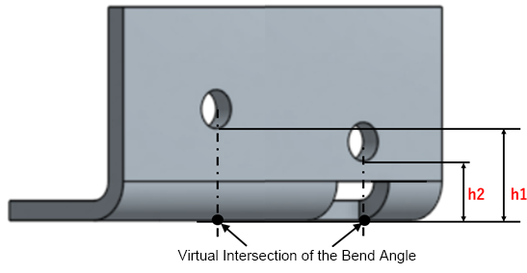

* These comparative examples are a selection of representative materials and hole types. It is also effective with other materials and hole types that are not listed.
* Comparison of the outer radius of a bend (fillet size) and the height of the opening on the bend line when modeling to the minimum value “b.” · If the height of the opening is modeled to greater than “b,” the h2value will differ.

**Minimum distance between nuts**

Machining Limits, Size Range

|  |  |  |  |  |
| --- | --- | --- | --- | --- |
| Press-fit nut | | material | | |
| * Low Carbon Steel (Cold/Hot) * Low Carbon Steel (Electrolytic Zinc Plating) | * 304 Stainless Steel (2B) * 304 Stainless Steel (Single-Sided #400-Grit Polished) * 304 Stainless Steel (Single-sided hairline finish) * 430 Stainless Steel (2B) | * 5052 Aluminum Alloy * 5052 AL Alloy Pre-Finish, Clear Anodize​ * 5052 AL Alloy Pre-Finish, Black Anodize​ |
| Nominal diameter | M3 | 14 | 15.5 | 14 |
| M4 | 15 | 17 | 15 |
| M5 | 15 | 18 | 15 |
| M6 | 17 | 20 | 17 |
| M8 | 19 | 23 | 19 |

|  |  |  |  |
| --- | --- | --- | --- |
| Weld (spot) nut | | material | |
| * Low Carbon Steel (Cold/Hot) * Low Carbon Steel (Electrolytic Zinc Plating) | * 304 Stainless Steel (2B) * 304 Stainless Steel (Single-Sided #400-Grit Polished) * 304 Stainless Steel (Single-sided hairline finish) * 430 Stainless Steel (2B) |
| Nominal diameter | M4 | 21 | 21 |
| M5 | 21 | 21 |
| M6 | 23 | 23 |
| M8 | 25 | 25 |
| M10 | 28 | 27 |
| M12 | 30 | 29 |

Example

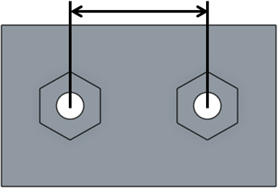

*If multiple sizes of nuts are mounted, the distance will be decided by the minimum value of the larger nut.

**Minimum distance between nut and hole**

Machining Limits, Size Range

|  |  |  |  |  |
| --- | --- | --- | --- | --- |
| Press-fit nut | | material | | |
| * Low Carbon Steel (Cold/Hot) * Low Carbon Steel (Electrolytic Zinc Plating) | * 304 Stainless Steel (2B) * 304 Stainless Steel (Single-Sided #400-Grit Polished) * 304 Stainless Steel (Single-sided hairline finish) * 430 Stainless Steel (2B) | * 5052 Aluminum Alloy * 5052 AL Alloy Pre-Finish, Clear Anodize​ * 5052 AL Alloy Pre-Finish, Black Anodize​ |
| Nominal diameter | M3 | 11.2 | 12.8 | 11.2 |
| M4 | 14.4 | 13.5 | 12.1 |
| M5 | 14.4 | 14 | 12.7 |
| M6 | 15.6 | 15 | 13.8 |
| M8 | 17 | 16.5 | 15.6 |

|  |  |  |  |
| --- | --- | --- | --- |
| Weld (spot) nut | | material | |
| * Low Carbon Steel (Cold/Hot) * Low Carbon Steel (Electrolytic Zinc Plating) | * 304 Stainless Steel (2B) * 304 Stainless Steel (Single-Sided #400-Grit Polished) * 304 Stainless Steel (Single-sided hairline finish) * 430 Stainless Steel (2B) |
| Nominal diameter | M4 | 16 | 15.5 |
| M5 | 16 | 15.5 |
| M6 | 18 | 16.5 |
| M8 | 21 | 17.5 |
| M10 | 23 | 18.5 |
| M12 | 25 | 19.5 |

Example

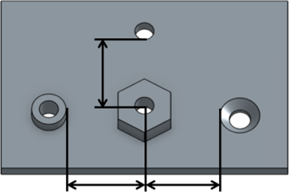

**Minimum distance between nut and edge of the material**

Machining Limits, Size Range

|  |  |  |  |  |
| --- | --- | --- | --- | --- |
| Press-fit nut | | material | | |
| * Low Carbon Steel (Cold/Hot) * Low Carbon Steel (Electrolytic Zinc Plating) | * 304 Stainless Steel (2B) * 304 Stainless Steel (Single-Sided #400-Grit Polished) * 304 Stainless Steel (Single-sided hairline finish) * 430 Stainless Steel (2B) | * 5052 Aluminum Alloy * 5052 AL Alloy Pre-Finish, Clear Anodize​ * 5052 AL Alloy Pre-Finish, Black Anodize​ |
| Nominal diameter | M3 | 4.5 | 6.7 | 4.5 |
| M4 | 5.5 | 7.6 | 5.5 |
| M5 | 6.5 | 8.2 | 6.5 |
| M6 | 8 | 9.3 | 8 |
| M8 | 10 | 11.1 | 10 |

|  |  |  |  |
| --- | --- | --- | --- |
| Weld (spot) nut | | material | |
| * Low Carbon Steel (Cold/Hot) * Low Carbon Steel (Electrolytic Zinc Plating) | * 304 Stainless Steel (2B) * 304 Stainless Steel (Single-Sided #400-Grit Polished) * 304 Stainless Steel (Single-sided hairline finish) * 430 Stainless Steel (2B) |
| Nominal diameter | M4 | 7.5 | 7.9 |
| M5 | 7.5 | 7.9 |
| M6 | 9 | 9.1 |
| M8 | 10.4 | 10.7 |
| M10 | 12.5 | 12.9 |
| M12 | 14.5 | 15 |

Example

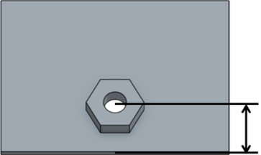

**Maximum distance between nut and edge of the material**

Machining Limits, Size Range

|  |  |  |  |
| --- | --- | --- | --- |
| Maximum distance | material | | |
| * Low Carbon Steel (Cold/Hot) * Low Carbon Steel (Electrolytic Zinc Plating) | * 304 Stainless Steel (2B) * 304 Stainless Steel (Single-Sided #400-Grit Polished) * 304 Stainless Steel (Single-sided hairline finish) * 430 Stainless Steel (2B) | * 5052 Aluminum Alloy * 5052 AL Alloy Pre-Finish, Clear Anodize​ * 5052 AL Alloy Pre-Finish, Black Anodize​ |
| Press-fit nut（coarse） | 450 | 290 | 450 |
| Weld nut（coarse） | 500 | 930 * | 500 |

*The maximum distance would be 500 when R bending is included

Example

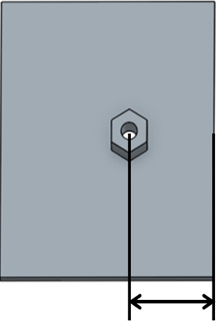

*With the plate developed into a flat plate, measure the distance between any material edge and the center of the nut, and use the smallest value to judge it can produce or not.

**Minimum distance between engravings, between edge or hole**

Machining Limits, Size Range

|  |  |  |  |  |  |  |
| --- | --- | --- | --- | --- | --- | --- |
| Range of Machining Limits | | | | | | |
| Plate Thickness | | Engraving and edge | Through Hole・Tapped Hole・Countersunk Holes・Slotted/Rectangular hole | | Burring Tap Hole | |
| * Low Carbon Steel (Cold/Hot) * 1018 Carbon Steel | * 304 SS (No.1) * 304 SS (2B) * 430 SS (2B) | Limit a | Minimum b | Limit b | Minimum c | Limit c |
| 0.8 | 0.8 | 2.0 | 4.0 | 2.0 | 5.0 | 3.0 |
| 1.0 | 1.0 |
| 1.2 | 1.2 |
| – | 1.5 |
| 1.6 | – |
| 2.0 | 2.0 | – | – |
| 2.3 | – |
| – | 2.5 |
| – | 3.0 |
| 3.2 | – |
| – | 4.0 |
| 4.5 | – |
| – | 5.0 |
| 6.0 | 6.0 |
| 9.0 | 9.0 |
| 10.0 | 10.0 |
| 12.0 | 12.0 |
| 16.0 | – |

Example

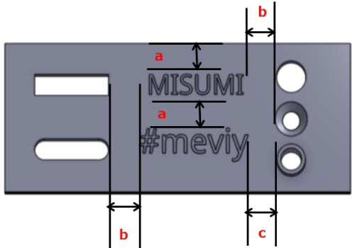

* *All holes are calculated from the outermost diameter to the minimum distance fromthe outside of the engraved letter.
* *Only for friction drilled/tapped holes, the limit valuec is uniformly3.0 mm.
* *If the value is below the guaranteed range, the engraved may be deformed.

**Minimum distance between engraving and nut**

Machining Limits, Size Range

|  |  |  |  |  |  |
| --- | --- | --- | --- | --- | --- |
| Nut (Press-fit) | | material properties | | | |
| * Low Carbon Steel (Cold/Hot) | | * 304 SS (2B) * 430 SS (2B) | |
| Minimum a | Limit a | Minimum a | Limit a |
| Nominal diameter | M3 | 6.5 | 4.5 | 8.7 | 6.7 |
| M4 | 7.5 | 5.5 | 9.6 | 7.6 |
| M5 | 8.5 | 6.5 | 10.2 | 8.2 |
| M6 | 10.0 | 8.0 | 11.3 | 9.3 |
| M8 | 12.0 | 10.0 | 13.1 | 11.1 |
| Nut (spot welding) | | material properties | | | |
| Low Carbon Steel (Cold/Hot) | | * 304 SS (2B) * 430 SS (2B) | |
| Minimum a | Limit a | Minimum a | Limit a |
| Nominal diameter | M4 | 9.5 | 7.5 | 9.9 | 7.9 |
| M5 | 9.5 | 7.5 | 9.9 | 7.9 |
| M6 | 11.0 | 9.0 | 11.1 | 9.1 |
| M8 | 12.4 | 10.4 | 12.7 | 10.7 |
| M10 | 14.5 | 12.5 | 14.9 | 12.9 |
| M11 | 16.5 | 14.5 | 17.0 | 15.0 |

Example

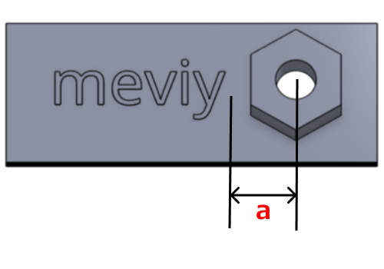

* *The minimum bending height for each material and thickness is applied to the minimum distance (limit value) from the outside of the engraved letter.
* *If the value is below the guaranteed range, the engraved may be deformed.

**Minimum distance between engraving and bending**

Machining Limits, Size Range

|  |  |  |  |
| --- | --- | --- | --- |
| Machining Limits | | | |
| material properties | Plate Thickness | Minimum h | Limit h |
| * Low Carbon Steel (Cold/Hot) * 1018 Carbon Steel | 0.8 | 6.2 | 4.2 |
| 1.0 | 6.3 | 4.3 |
| 1.2 | 7.5 | 5.5 |
| 1.6 | 8.8 | 6.8 |
| 2.0 | 10.2 | 8.2 |
| 2.3 | 11.4 | 9.4 |
| 3.2 | 15.3 | 13.3 |
| 4.5 | 19.4 | 17.4 |
| 6.0 | 25.5 | 23.5 |
| 9.0 | 41.0 | 39.0 |
| 10.0 | 48.5 | 46.5 |
| 12.0 | 64.0 | 62.0 |
| 16.0 | 90.5 | 88.5 |
| * 304 SS (2B) * 430 SS (2B) * 304 SS (No.1) | 0.8 | 6.2 | 4.2 |
| 1.0 | 6.3 | 4.3 |
| 1.2 | 6.5 | 4.5 |
| 1.5 | 8.0 | 6.0 |
| 2.0 | 9.1 | 7.1 |
| 2.5 | 13.3 | 11.3 |
| 3.0 | 13.5 | 11.5 |
| 4.0 | 19.2 | 17.2 |
| 5.0 | 25.5 | 23.5 |
| 6.0 | 27.0 | 25.0 |
| 9.0 | 41.0 | 39.0 |
| 10.0 | 48.5 | 46.5 |
| 12.0 | 64.0 | 62.0 |

Example

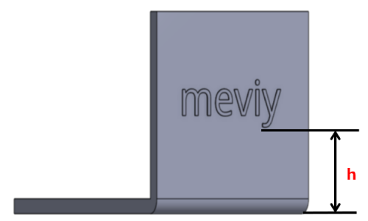

* *The minimum bending height for each material and thickness is applied to the minimum distance (limit value) from the outside of the engraved letter.
* *If the value is below the guaranteed range, the engraved may be deformed.

**Minimum Angle for Acute Angle Bending**

Machining Limits, Size Range

* The angle (θ) for acute angle bending must be 45° or more.
* (However, when the Sheet Thickness is 9 mm, the acute angle (θ) must be 88° or more.)

|  |  |  |
| --- | --- | --- |
| Material | Sheet Thickness | Bend angle |
| 304 SS (2B) | 6.0 | θ≥50° |
| * 5052 Aluminum Alloy * 5052 AL Alloy Pre-Finish, Clear Anodize​ * 5052 AL Alloy Pre-Finish, Black Anodize​ | 2.5　3.0　4.0　5.0 | θ≥60° |
| 6.0 | θ≥88° |
| Low Carbon Steel (Cold/Hot) | 4.5　6.0 |
| 304 SS (No.1) | 9.0　10.0　12.0 |
| 1018 Carbon Steel | 9.0　10.0　12.0　16.0 |

Example



**Minimum Radius of Rectangular Holes**

Machining Limits, Size Range

The radius (R) of the corners of a rectangular hole must be 0.5 mm or more. (For clear resin, this must be 3 mm or more.)

Example



## Modeling Rules for Perforated Metal

|  |  |
| --- | --- |
| Modeling Rules | Example |
| * When requesting a quote for perforated metal parts, model the part using either no holes or only through holes (mounting holes). * If the number of through holes exceeds a certain number, automatic quotation may not be possible. * (There is no need to model the staggered/lattice-like hole patterns characteristic of perforated metals.) | Hole Identification Specifications |

## Bending Conditions

* [​Bending Interference​](https://us.meviy.misumi-ec.com/help/en/technical_info-en-c/shm_guideline-en-c/9688/#box_1)　｜
* [Design Guidelines for C-Bends and Stepped Bends (Z-Bends)​​](https://us.meviy.misumi-ec.com/help/en/technical_info-en-c/shm_guideline-en-c/9688/#box_2)　｜
* [Presence of Edges Parallel to the Bend Line​​](https://us.meviy.misumi-ec.com/help/en/technical_info-en-c/shm_guideline-en-c/9688/#box_3)　｜
* [​Minimum distance between cutout and bend​​](https://us.meviy.misumi-ec.com/help/en/technical_info-en-c/shm_guideline-en-c/9688/#box_4)　｜
* [Confirmation of nut interference during bending​](https://us.meviy.misumi-ec.com/help/en/technical_info-en-c/shm_guideline-en-c/9688/#box_5)

**Bending Interference**

* For sheet metal parts, the meviy platform performs interference analysis for the bending process.
* The forming will be deemed impossible if the results of the analysis suggest there will be interference with the die.

Example 1) Model image before and after bending during normal conditions

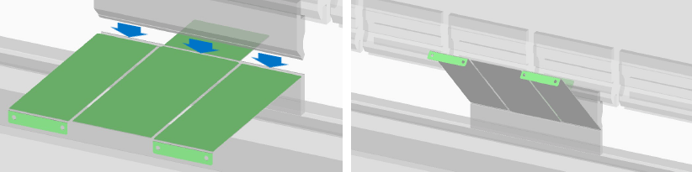

Example 2) Model image where die interference occurs

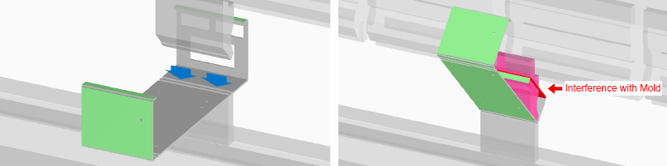

* If a warning message is displayed, check the part for any interference using “Check the interference image” and consider changing the shape.
* After taking corrective action, re-upload the 3D model and check the revised quotation results.
* The design guidelines for C-bends and stepped bends (Z-bends) are provided below as more detailed examples. See below.

**Design Guidelines for C-Bends and Stepped Bends (Z-Bends)**

To prevent die interference, design models with reference to the standard shapes shown below.

|  |  |
| --- | --- |
| Modeling Rules | Example |
| * When outer dimension A is less than or equal to outer dimension C, set inner dimension B so that it is greater than A. * Outer dimensions A and C must be at least the minimum bending height (See machining limits: minimum bending height, mentioned above) | C-bend |
| * The stepped bend height should be equal to dimension A plus double the plate thickness (t). * Dimension A must be equal to or greater than the minimum bending height (See machining limits: minimum bending height, mentioned above). | C-bend |

However, the meviy platform determines whether it is possible to manufacture the model based upon positive results of the interference analysis. (Examples given below)

Example 3) C-shaped bending interference:　Adjust the size of the channel web in order to clear any interference (the figure on the right shows the analysis image).

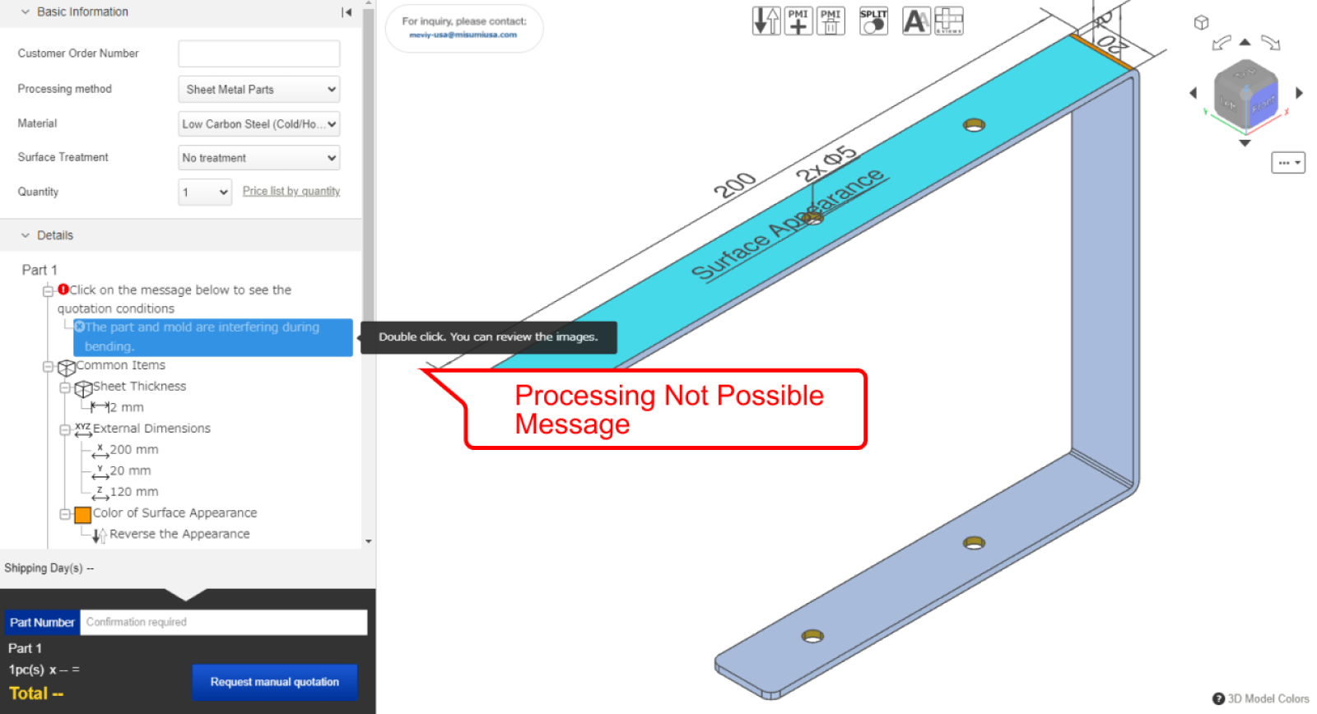＋

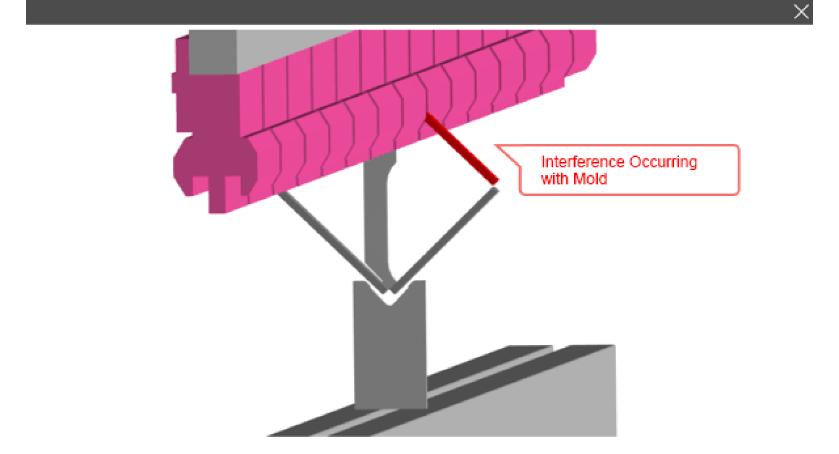





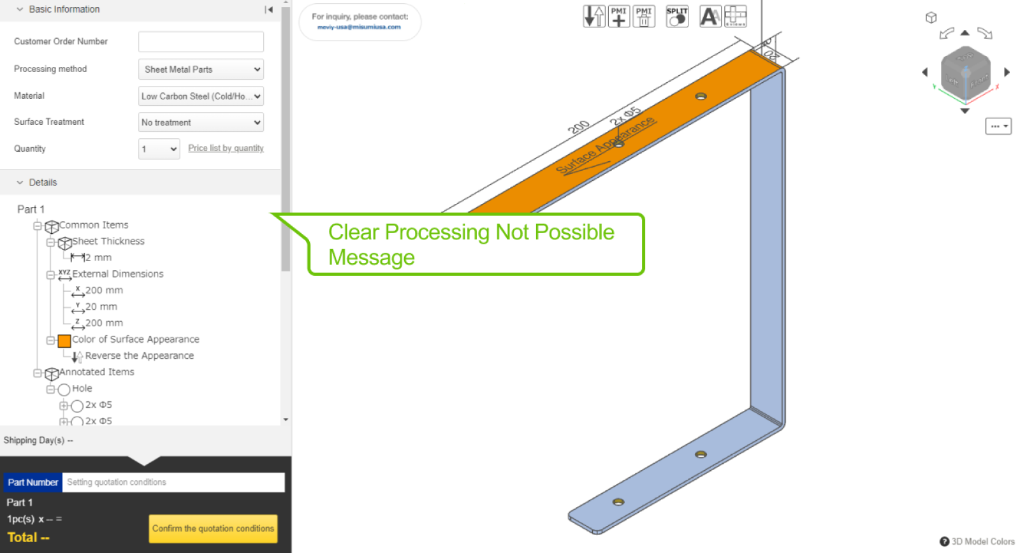＋

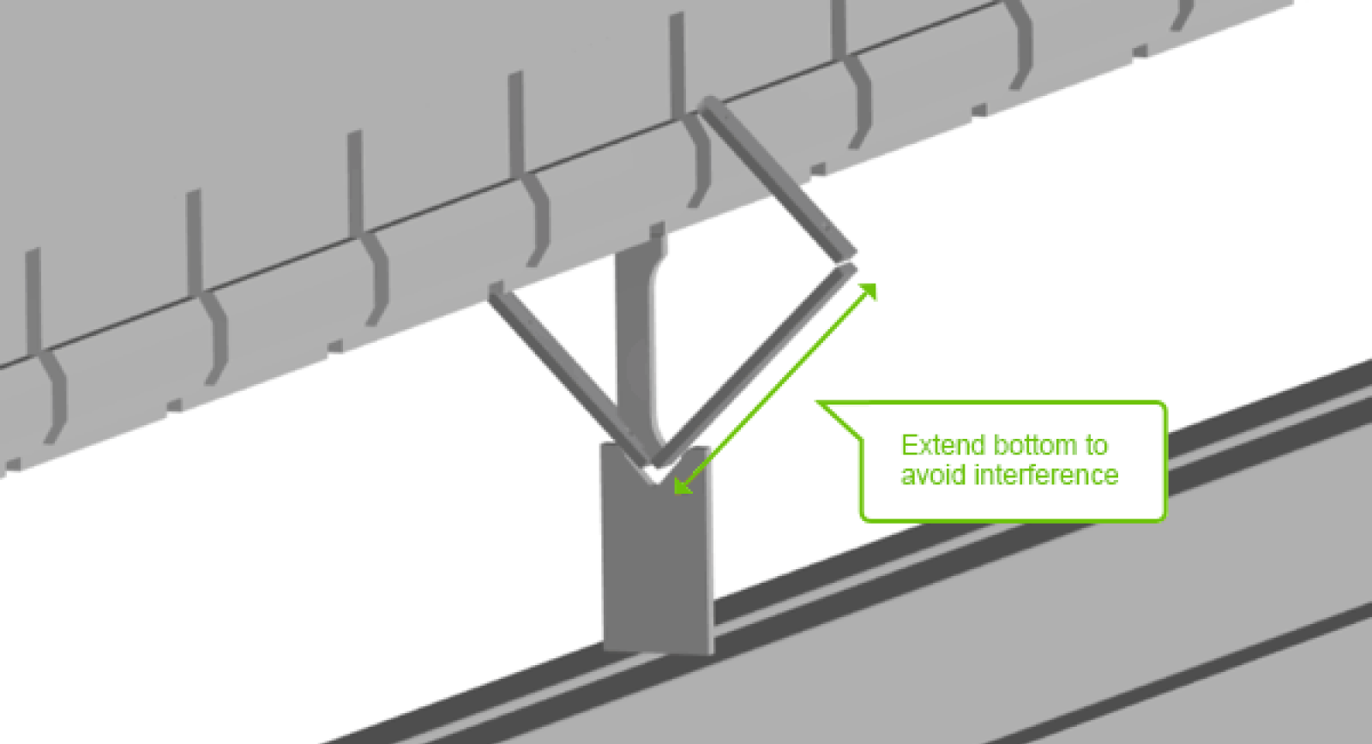

 Example 4) Stepped bending interference:　Adjust the bending height to clear any interference (the figure on the right shows the analysis image).

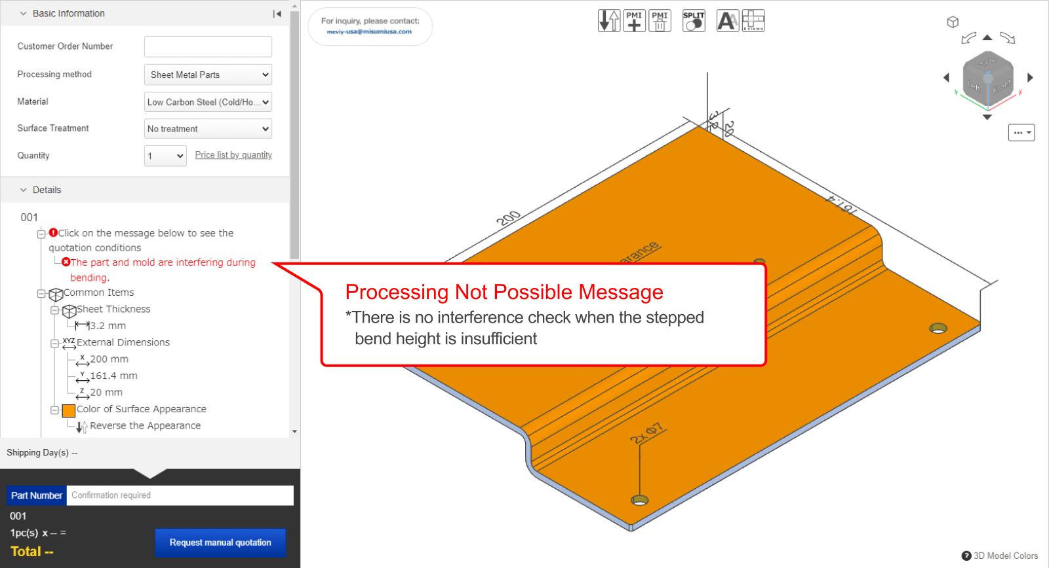＋



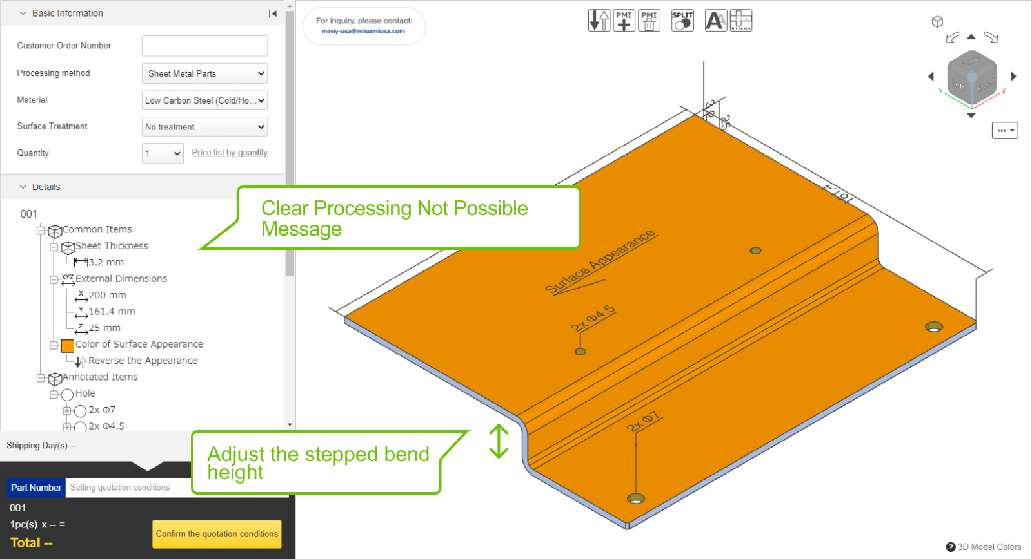＋

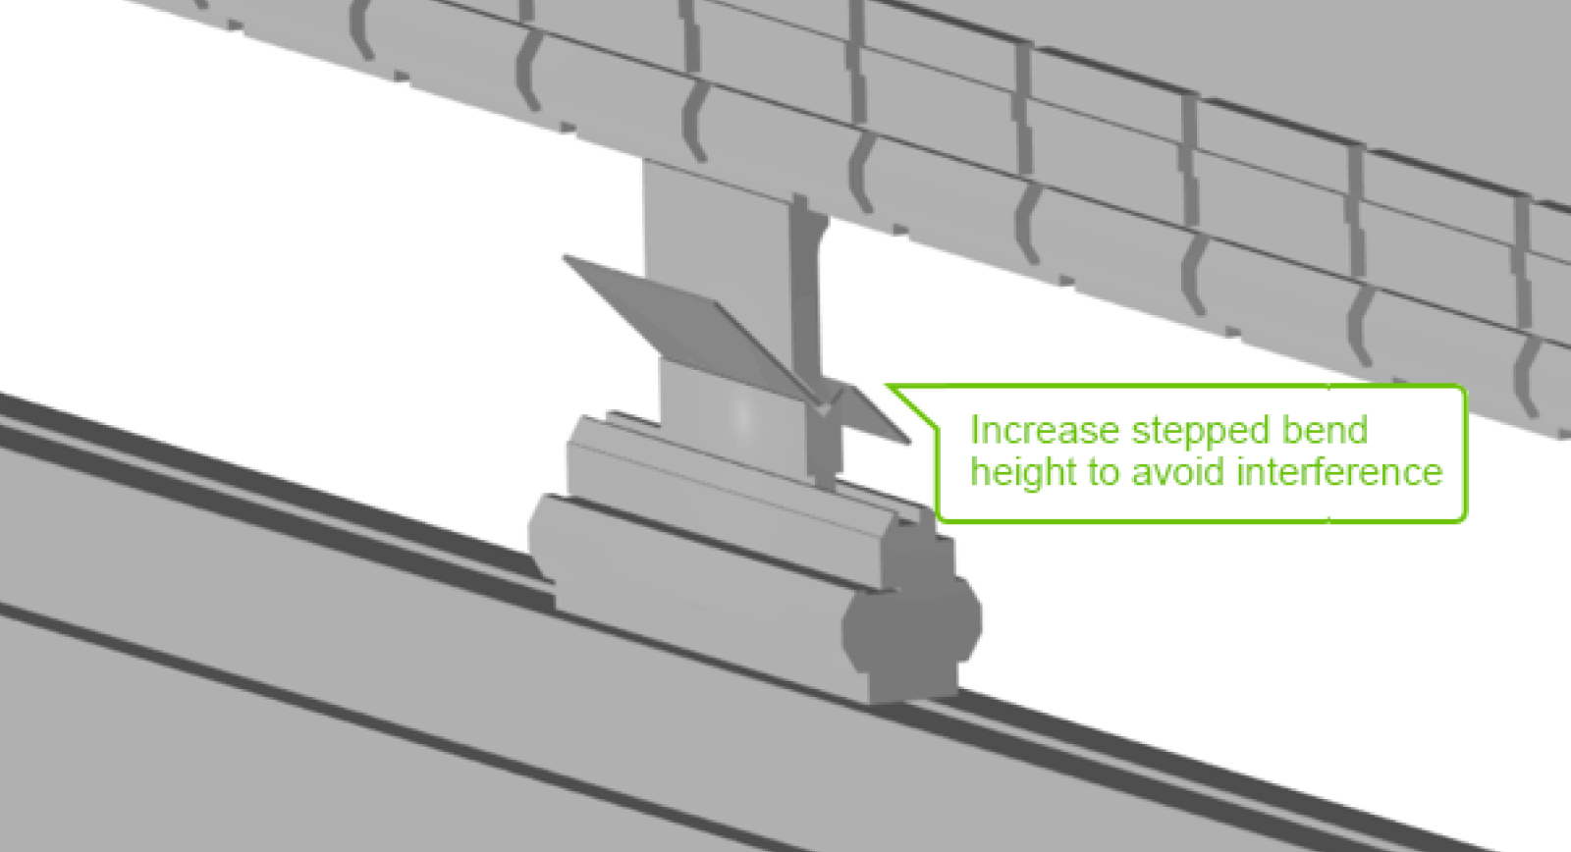

**Presence of Edges Parallel to the Bend Line**

Any backgauges used in the bending process, along with the edges of parts, are taken into consideration in the interference analysis of the bending process. The angle of the part during the bending process may not be stable if there are no edges parallel to the bend line, creating a risk that the bend may not be made in the correct position. If the below message is displayed, consider changing the shape such that the model includes edges parallel to the bend line.

Example 1) No edges parallel to the bend line

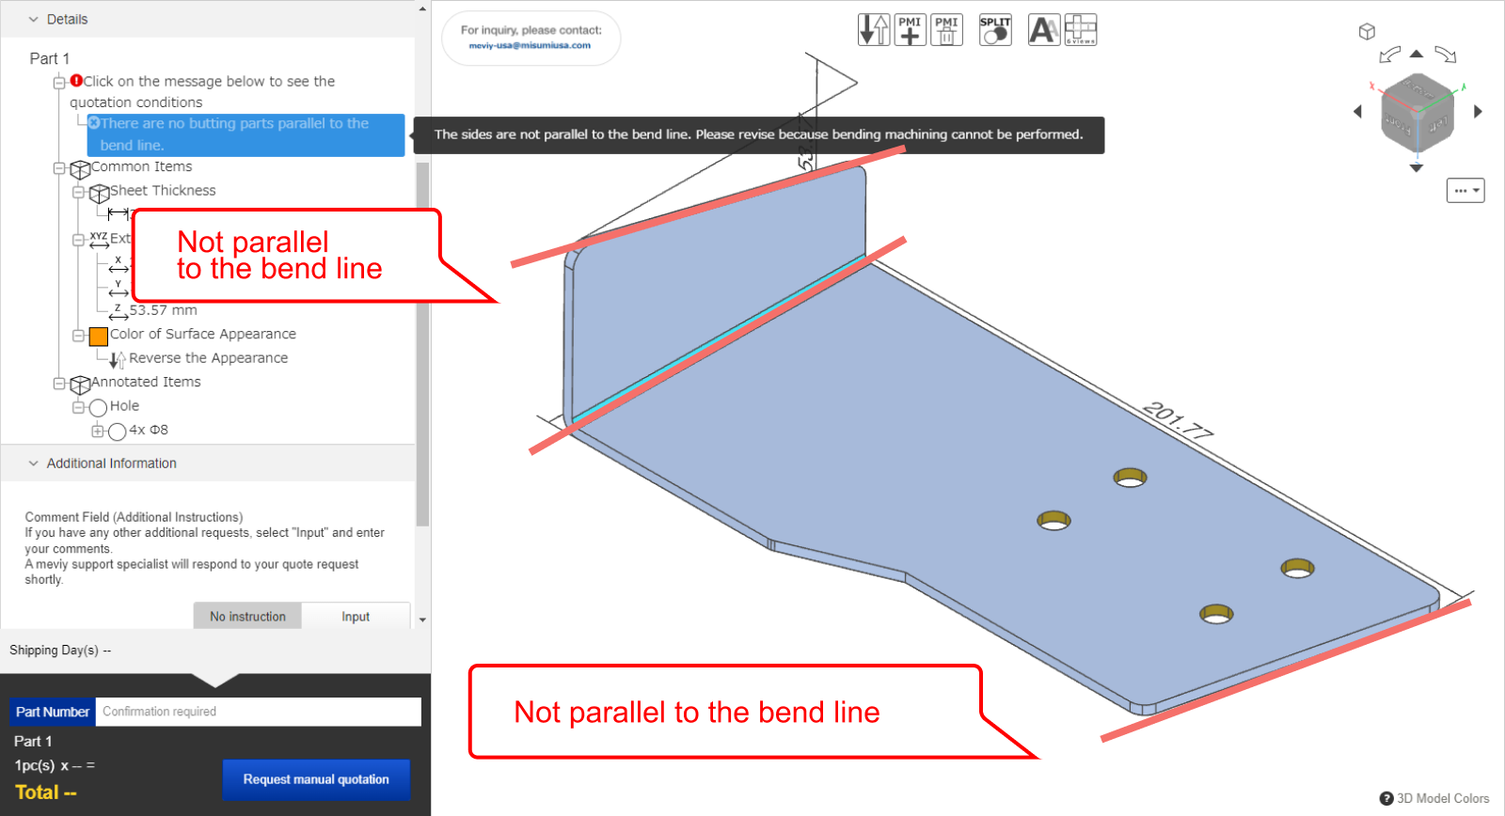＋

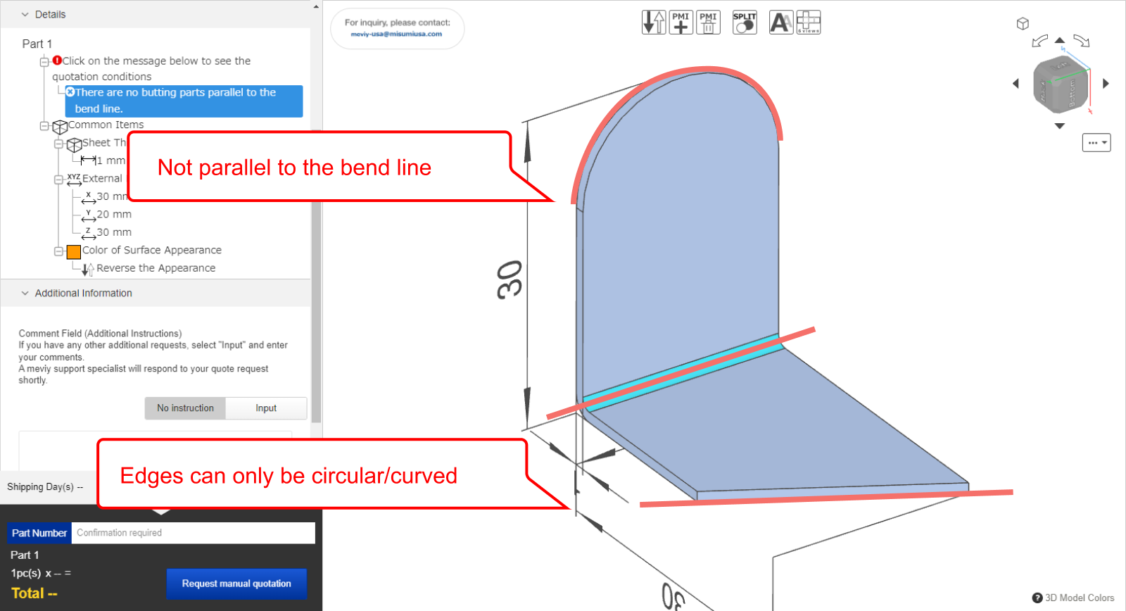＋

 Example 2) Edge parallel to the bend line [automatic quoting available]

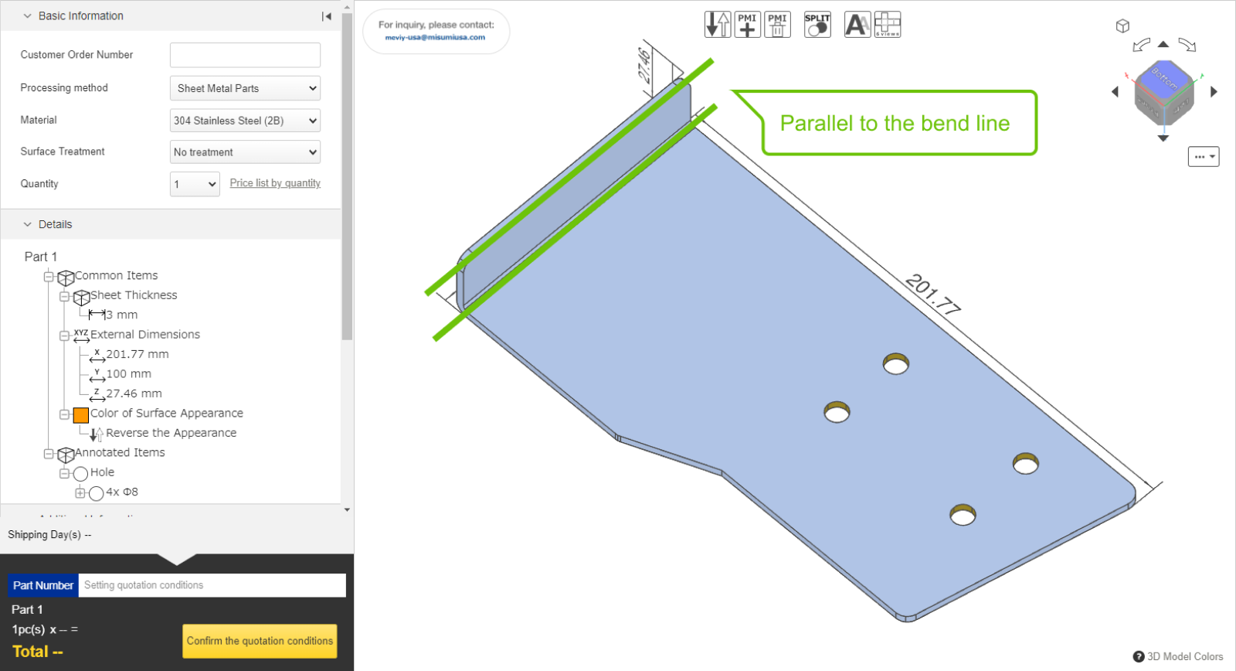＋

**Minimum distance between cutout and bend**

* The bending process is carried out by placing the workpiece (to be bent) on a die and punching it from above.
* However, if the shape of the workpiece does not align on both ends of the die, it cannot be bent.

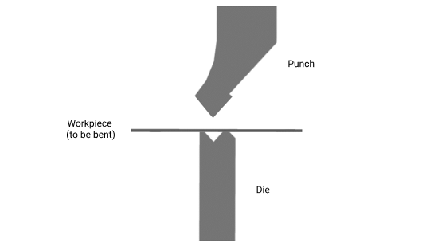

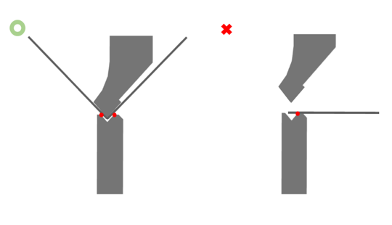

* For the minimum distance between the cutout and the bend, we recommend the following.
* Please note that if the value falls below the minimum value, the bending line may shift because part of the workpiece is no longer covered by the bending die.
* The dimensions will be inaccurate, but will be processed as they are.
* In the case of a part that falls below the limit value, it may not be possible to process it. In this case, we will contact you.

|  |  |
| --- | --- |
| Modelling rules | Location |
| * For plate thickness t, the limit value of h should be as follows * h = 5t when 0.8 ≦ t ≦ 2.0mm (.031″ ≦ t ≦ .079″) * h = 4t when 2.3 ≦ t ≦ 9.0mm (.091″ ≦ t ≦ .354″) |  |
| * For plate thickness t, the minimum and limit values of b should be as follows * b = t when 0.8 ≦ t ≦2.0 (.031″ ≦ t ≦ .079″), guaranteed value = 2t * b = 2t when 2.3 ≦ t ≦ 9.0 (.091″ ≦ t ≦ .354″), guaranteed value = none |  |

**Confirmation of nut interference during bending**

* In the interference analysis during bending, the analysis is performed with the 3D shape of the nut reproduced for the part where the nut can be mounted.
* If interference with the die is found as a result of the analysis, the area will be judged that the nut cannot be attached.

## Sheet metal parts Quoting Error Troubleshooting

* When uploading a model to meviy, a “Quotation failure” error may occur.
* Below is an overview of why these errors occur and how to resolve them,as well as some example errors.

[What is a quotation failure?](https://us.meviy.misumi-ec.com/help/en/technical_info-en-c/shm_guideline-en-c/26688/#box0)[Case 1: Failure to read uploaded file](https://us.meviy.misumi-ec.com/help/en/technical_info-en-c/shm_guideline-en-c/26688/#box1)[Case 2: Unsupported shape](https://us.meviy.misumi-ec.com/help/en/technical_info-en-c/shm_guideline-en-c/26688/#box2)[Case 3: Plate thickness not available](https://us.meviy.misumi-ec.com/help/en/technical_info-en-c/shm_guideline-en-c/26688/#box3)[Case 4: Uneven plate thickness](https://us.meviy.misumi-ec.com/help/en/technical_info-en-c/shm_guideline-en-c/26688/#box4)[Case 5: Distance between features](https://us.meviy.misumi-ec.com/help/en/technical_info-en-c/shm_guideline-en-c/26688/#box5)[Case 6: Bend-to-hole distance](https://us.meviy.misumi-ec.com/help/en/technical_info-en-c/shm_guideline-en-c/26688/#box6)[Case 7: Undersized bend height](https://us.meviy.misumi-ec.com/help/en/technical_info-en-c/shm_guideline-en-c/26688/#box7)[Case 8: Interference during bending](https://us.meviy.misumi-ec.com/help/en/technical_info-en-c/shm_guideline-en-c/26688/#box8)[Case 9: Unrecognized holeshape](https://us.meviy.misumi-ec.com/help/en/technical_info-en-c/shm_guideline-en-c/26688/#box9)[Case 10: Shape recognition failure](https://us.meviy.misumi-ec.com/help/en/technical_info-en-c/shm_guideline-en-c/26688/#box10)

**What is a quotation failure?**

When uploading a model to meviy, an error may occur where the model cannot be auto-quoted.

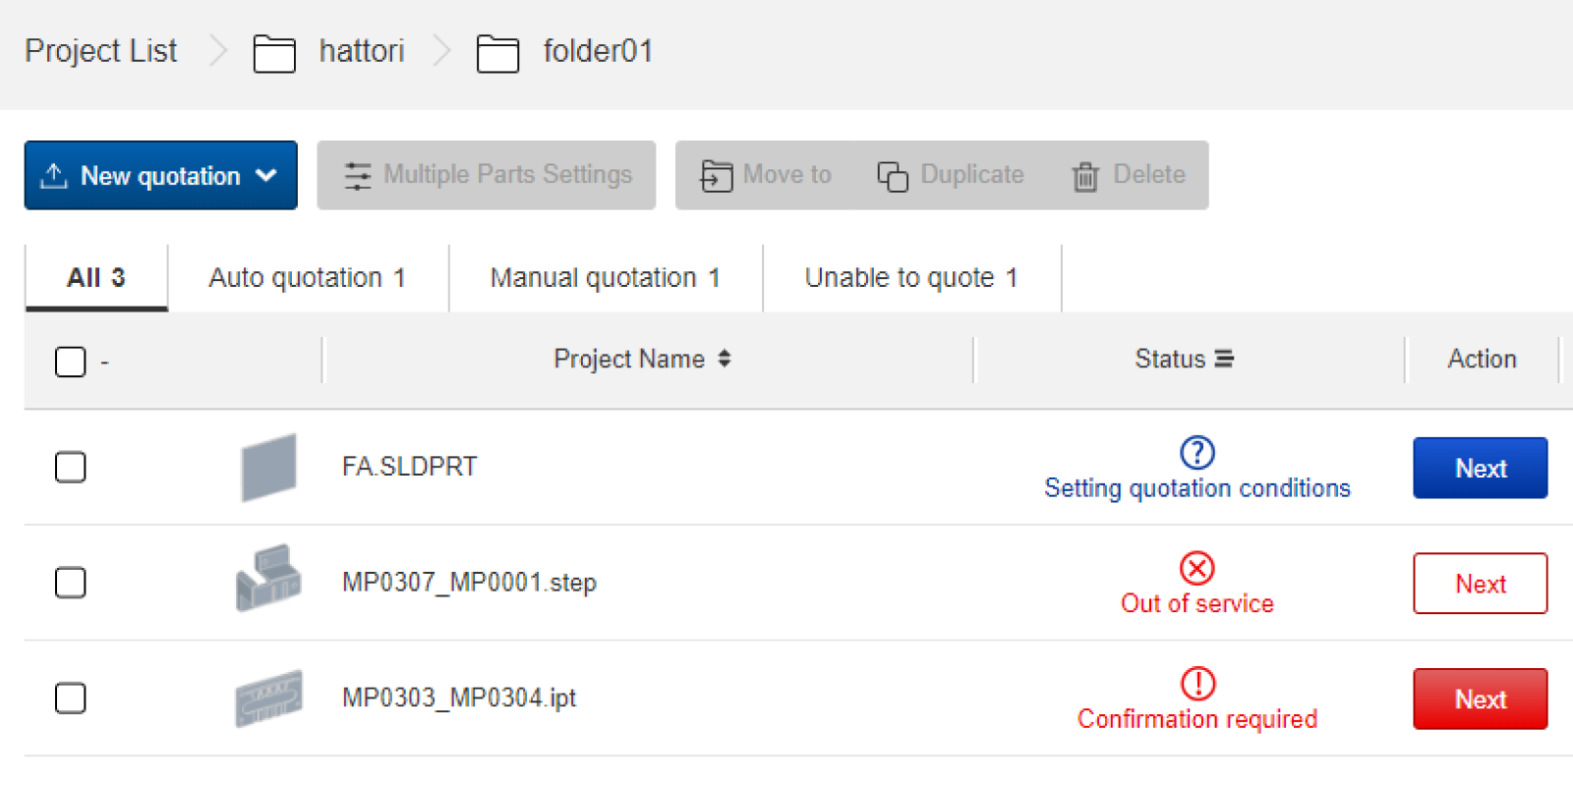

**How to check for errors in the project list**

* After uploading a model to meviy, the “” or “” icon will appear if the model cannot be auto-quoted.
* In this case, please go to the 3D Viewer and confirm the details of the error from the Precaution column.

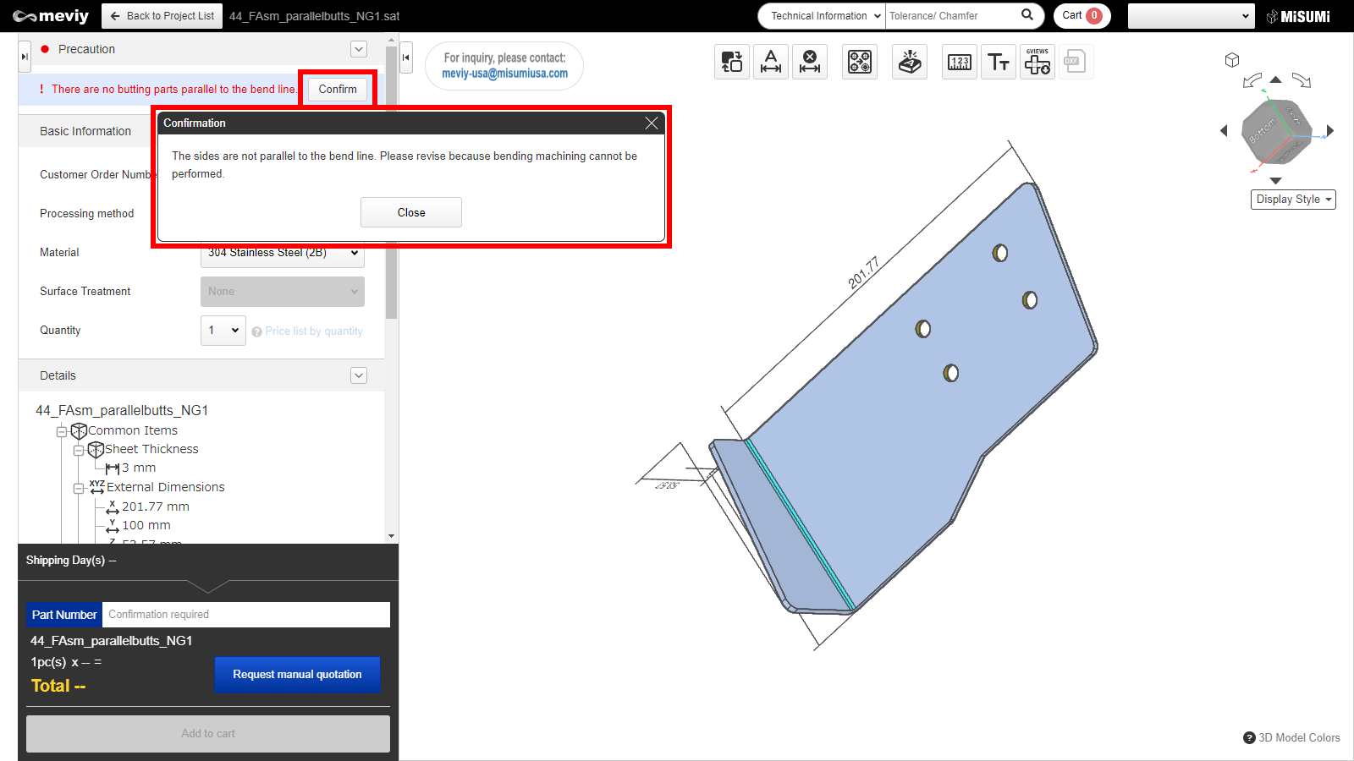＋

**How to check error messages in the 3D Viewer**

* Please open the 3D viewer and check the “Precaution” menu.
* Click the “Confirm” button to check for errors and to get the range of automatic estimation.
* Depending on the error type, a range for auto-quotation may not be displayed.

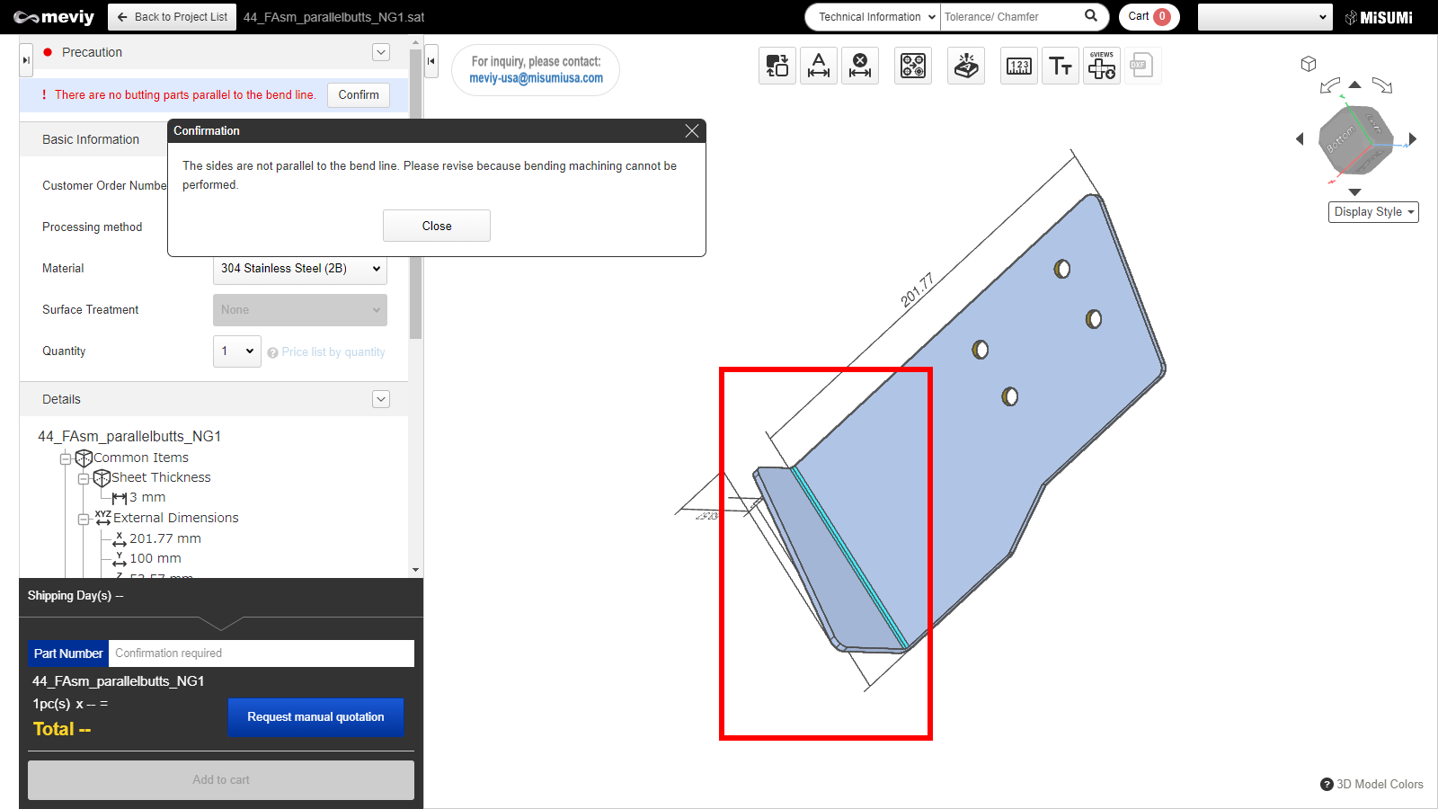＋

**How to locate an error**

* Clicking the “Confirm” button will highlight the error location in the model.
* Once this error is resolved, automatic quoting will be possible.

**Case 1: Failure to read uploaded file**

* This error occurs when a 3DCAD format or extension that is not supported by meviy is uploaded.
* To resolve this, please check the formats supported by meviy and re-upload a supported format.

Notes

* Please see below for the formats and extensions that can be uploaded to meviy.
* Before You Begin＞[Uploadable CAD File Formats](https://us.meviy.misumi-ec.com/help/en/operation_manual-en-c/first-en-c/9739/)

**Case 2: Unsupported shape**

* This error is caused by uploading a shape that is not eligible for automatic quotation with CNC Milling.
* To resolve this, please check the quotable shapes and modify the model accordingly.

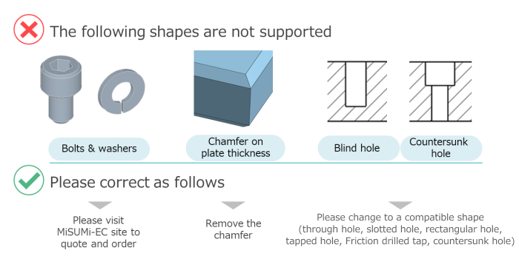

Tip

* If the following message is displayed in the 3D Viewer, it corresponds to this error.
* – “Unsupported shapes_Support”

Notes

* See below for shapes supported by the Sheet Metal service.
* →Sheet metal＞Applicable Parts/Materials＞[Shapes Eligible for Quotation](https://us.meviy.misumi-ec.com/help/en/technical_info-en-c/shm_shape-material-en-c/9656/)

**Case 3: Plate thickness not available**

* This error occurs when the requested plate thickness is not supported.
* To resolve this, modify the model to match the corresponding plate thicknesses.

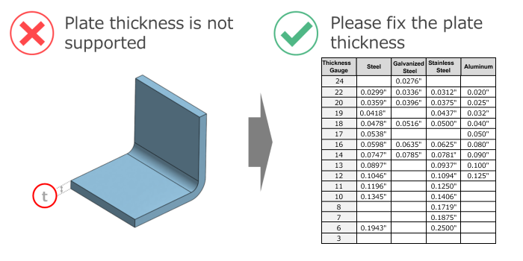

Tip

* If the following message is displayed in the 3D Viewer, it corresponds to this error.
* – “There are no supported sheet thicknesses.”

Notes

* The part thickness must match one of the gauge thicknesses supported by meviy Sheet Metal.
* Please refer to the following for available sheet thicknesses.
* →Sheet metal＞Applicable Parts/Materials＞[Material, Surface Treatment, Size](https://us.meviy.misumi-ec.com/help/en/technical_info-en-c/shm_shape-material-en-c/9657/)

**Case 4: Uneven plate thickness**

* This error occurs when the plate thickness is not constant during modeling or when the R length setting is not within the correct range.
* To resolve this, modify the model to create a uniform sheet thickness.

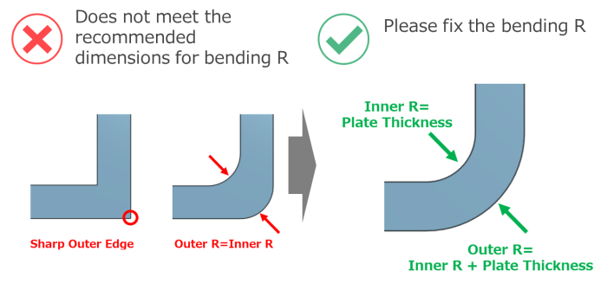

Tip

* If the following message is displayed in the 3D viewer, it corresponds to this error.
* – “Model sheet thickness is non-uniform.”

Notes

* Please see below for sheet metal modeling guidelines.
* →Sheet metal＞Design Guidelines＞[Basic Modeling Rules](https://us.meviy.misumi-ec.com/help/en/technical_info-en-c/shm_guideline-en-c/9695/)

**Case 5: Distance between features**

* This error occurs when the distance between holes and end faces, or between holes is below the limit.
* To resolve this, please increase the distance between the hole and the end face/hole.

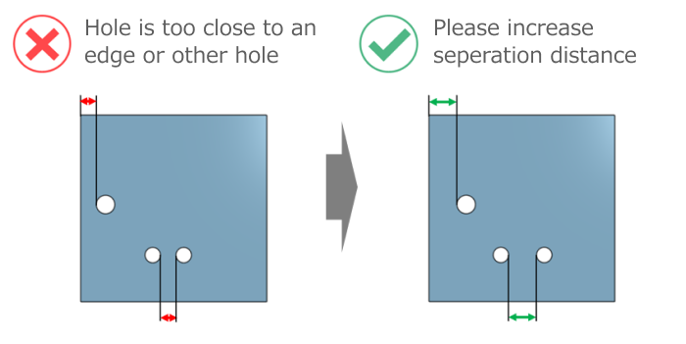

Tip

* If the following message is displayed in the 3D Viewer, it corresponds to this error.
* – “XX and XX are too close.”

Notes

* **See below for minimum distances between holes and end faces/holes.**
* →Sheet metal＞Design Guidelines＞[Range of Machining Limits](https://us.meviy.misumi-ec.com/help/en/technical_info-en-c/shm_guideline-en-c/9689/#box_1)
* **Please also use the measurement function to check the distance.**
* →[FA Sheet Metal] Quotation Settings＞[Measuring 3D models](https://us.meviy.misumi-ec.com/help/en/operation_manual-en-c/shm_configuration-en-c/24357/)
* If you have any questions, please request a manual quotation by meviy support. See below for assistance on manual quotations.
* →Quotation conditions settings＞[FA Sheet Metal] Quotation Settings＞[Information about manual quotation](https://us.meviy.misumi-ec.com/help/en/operation_manual-en-c/shm_configuration-en-c/24355/)

**Case 6: Bend-to-hole distance**

* This error occurs when the bend-to-hole distance is below the limit.
* To resolve this, either increase the distance between the bend and the hole or create an opening on the bend line (clearance hole).

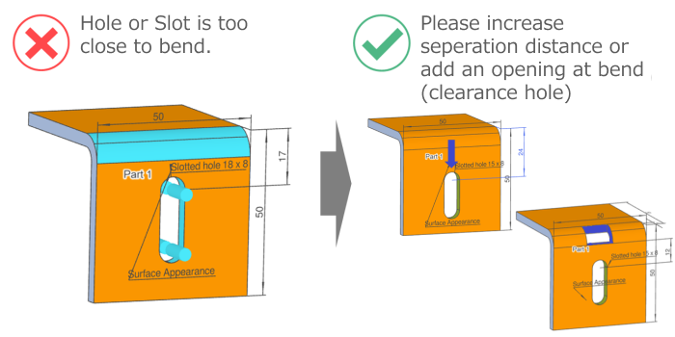

Tip

* If the following message is displayed in the 3D Viewer, it corresponds to this error.
* – “XX and XX are too close.”

Notes

* See below for rules on openings on the bend line.
* →Sheet metal＞Design Guidelines＞[Range of Machining Limits](https://us.meviy.misumi-ec.com/help/en/technical_info-en-c/shm_guideline-en-c/9689/#box_10)
* If you have any questions, please request a manual quotation by meviy support. See below for assistance on manual quotations.
* →Quotation conditions settings＞[FA Machined] Quotation Settings＞[Information about manual quotation](https://us.meviy.misumi-ec.com/help/en/operation_manual-en-c/shm_configuration-en-c/24355/)

**Case 7: Undersized bend height**

* This error occurs when the bending height is below the limit.
* To resolve this, increase the bending height to a sufficient height.

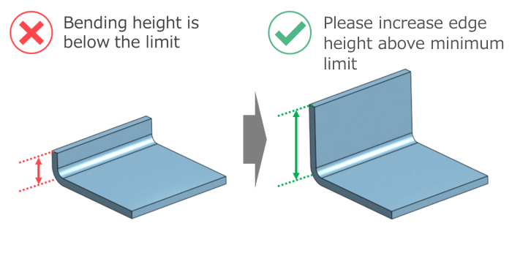

Tip

* If the following message is displayed in the 3D Viewer, it corresponds to this error.
* – “The bend height is too small.”

Notes

* See below for minimum bending heights.
* →Sheet metal＞Design Guidelines＞[Range of Machining Limits](https://us.meviy.misumi-ec.com/help/en/technical_info-en-c/shm_guideline-en-c/9689/#box_6)

**Case 8: Interference during bending**

* This error occurs when the part geometry causes interference during bending.
* To resolve this, modify the part design to avoid interference.

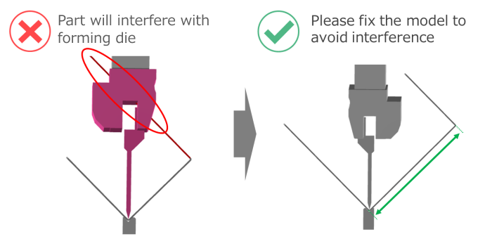

Tip

* If the following message is displayed in the 3D Viewer, it corresponds to this error.
* – “The part and mold are interfering during bending.”

Notes

* See below for guidelines on die interference during bending.
* →Sheet metal＞Design Guidelines＞[Range of Machining Limits](https://us.meviy.misumi-ec.com/help/en/technical_info-en-c/shm_guideline-en-c/9689/#box_6)

**Case 9: Unrecognized holeshape**

* This error occurs when there is an unrecognized hole shape.
* To resolve this, please change the hole to a supported shape and re-upload the file.

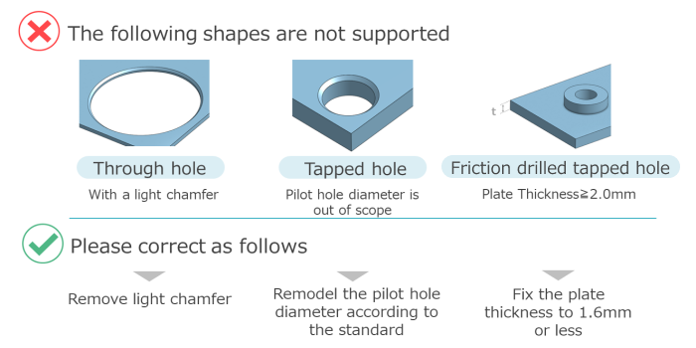

Tip

* If the following message is displayed in the 3D Viewer, it corresponds to this error.
* – “There is an unsupported hole shape.”

Notes

* See below for tapped hole recognition.
* →Sheet metal＞Design Guidelines＞[Tapped Hole Identification and Selectable Sizes](https://us.meviy.misumi-ec.com/help/en/technical_info-en-c/shm_guideline-en-c/9694/)
* →Sheet metal＞Design Guidelines＞[Friction Drilled/Tapped Holes Modeling and Sizes](https://us.meviy.misumi-ec.com/help/en/technical_info-en-c/shm_guideline-en-c/9693/)

**Case 10: Shape recognition failure**

* This error occurs when there is a problem with the quality of the uploaded 3D CAD data, and the shape is deformed when it is loaded in meviy.
* If the shape is deformed, please try the following steps to attempt to generate a quote.

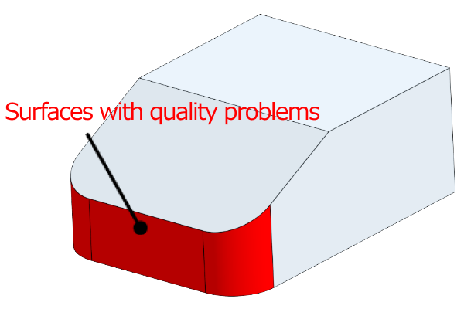

State of original data

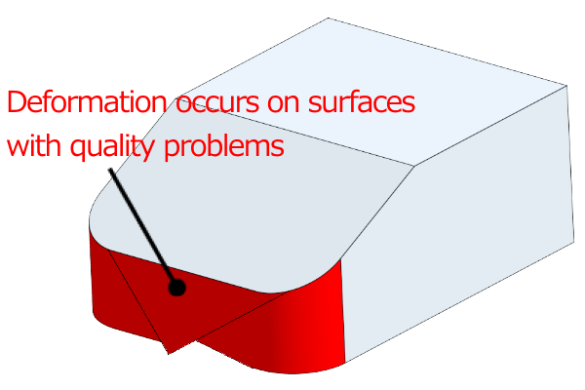

State after loading in meviy

Tip

* The following message is displayed in the 3D viewer when this error occurs.
* – “An error shape exists in the model.”
* – “Failed to load file.”

**1. Check the shape of the uploaded 3D CAD data.**

* Check the shape of the uploaded 3D CAD data.
* If there is a problem with the shape, correct it and upload the model again.

Notes

* Visual check
* – Are there any twisted surfaces?
* – Are there any unintended geometric features displayed in the cross-section view?
* – Are there any very small shapes or gaps?
* Check the shape creation method
* – Are there any 3D shapes created without drawing sketches?
* – Shapes created by importing lines from DXF
* – Shapes created using reference geometry or mating part geometry
* – Are there any intersecting lines created by intersecting holes?
* – etc.
* Confirm using CAD checking tools
* – Check for inconsistent shapes

If there is no problem with the shape check or the model loading does not improve even after correcting and re-uploading the file, please try the next step 2.

**２．Changing the file format**

Upload the file again in a 3D CAD file format different from the one you originally uploaded.

Notes

* – If meviy supports the native format of the 3D CAD file you are using, please try uploading in the [native format](https://us.meviy.misumi-ec.com/help/en/operation_manual-en-c/first-en-c/9739/).
* – If you are using an unsupported format, please try uploading as a STEP or Parasolid.

If modifying the geometry and changing the file format does not fix the error, please contact meviy support.

## Allowable Dimensional Tolerances

|  |  |  |  |  |  |  |
| --- | --- | --- | --- | --- | --- | --- |
| No. | Standard Part | Classification of Standard Dimensions | Standard Values* | | | Example |
| Normal bending | | * R bending * (FR bending) |
| * Sheet Thickness * ≦6.0mm * (0.3937in) | * Sheet Thickness * >6.0mm * (0.3937in) | * Sheet Thickness * ≦3.2mm * (0.1260in) |
| 1 | Section with no bending | 6 or less | ±0.1 | ±0.3 | ±0.3 | Example |
| More than 6, equal to or less than 30 | ±0.2 | ±0.5 | ±0.5 |
| More than 30, equal to or less than 120 | ±0.3 | ±0.8 | ±0.8 |
| More than 120, equal to or less than 400 | ±0.5 | ±1.2 | ±1.2 |
| More than 400, equal to or less than 1,000 | ±0.8 | ±2.0 | ±2.0 |
| More than 1,000, equal to or less than 2,000 | ±1.2 | ±3.0 | ±3.0 |
| 2 | Section with bending | 6 or less | ±0.3 | ±0.5 | ±0.5 |
| More than 6, equal to or less than 30 | ±0.5 | ±1.0 | ±1.0 |
| More than 30, equal to or less than 120 | ±0.8 | ±1.5 | ±1.5 |
| More than 120, equal to or less than 400 | ±1.2 | ±2.5 | ±2.5 |
| More than 400, equal to or less than 1,000 | ±2.0 | ±4.0 | ±4.0 |
| More than 1,000, equal to or less than 2,000 | ±3.0 | ±6.0 | ±6.0 |

* *General tolerance for JIS B 0408 metal pressed products: use Grade B (plate thickness≦6.0mm), Grade C (plate thickness>6.0mm). For R bend it will be Grade C.
* *If a painting/coating is specified, the standard value for material conditions is used.

The allowable dimensional tolerances are applicable only for dimensions for between holes on the same face and end-faces/perpendicular-faces that are adjacent as a result of the bending.  
The tolerances are not applicable for hole-to-hole or hole-to-end face dimensions on non-adjacent faces (across multiple bent sections).

e.g. 1) Dimensions acceptable for tolerance setting

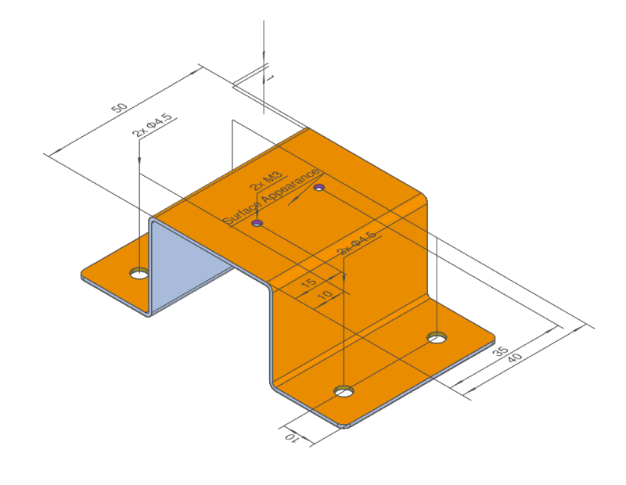

e.g. 2) Dimensions not appceptable for tolerance setting

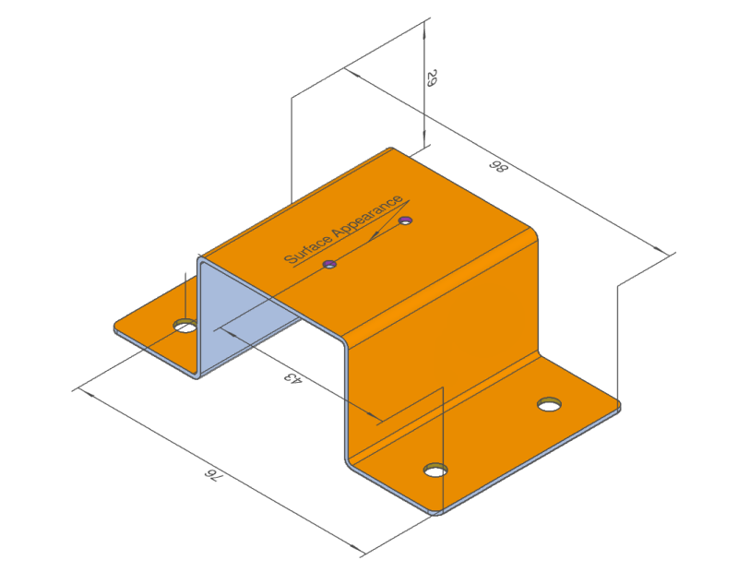

## Bending Specifications

**Normal Bending**

|  |  |  |  |
| --- | --- | --- | --- |
| No. | Standard Part | Standard Value | Example |
| 1 | Bend angle tolerance | * Sheet Thickness ≤10.0 mm: ±1.0° * Sheet Thickness >10.0 mm: ±1.5° | Example |
| 2 | Inner radius (r) | Sheet Thickness (reference value) |
| 3 | Outer radius (R) | R = Sheet Thickness × 2 (reference value) |

**R-bend shape(FR bending)**

|  |  |  |  |
| --- | --- | --- | --- |
| No. | Standard Part | Standard Value | Example |
| 1 | Bend angle tolerance | * ±2.0° | Example |
| 2 | Inner R | Modeling dimension (Reference value) |
| 3 | Outer R | Inner R+Sheet Thickness (Reference value) |

**Protrusions from Bending**

|  |  |
| --- | --- |
| Standard Value | Example |
| As shown in the right hand example, bulging/protrusions of about 15% of the Sheet Thickness can occur on each side. | Example |

**Defects Caused by Bending**

|  |  |
| --- | --- |
| Standard Value | Example |
| As shown in the right hand example, defects have occurred in the bent die. | Example |
| Since it is processed as FR bending (feed bending), die marks will be left on the R bending part. | |  |  | | --- | --- | | ■Without surface treatment (5052 Aluminum Alloy) | | | Inner bend | Outer bend | |  |  | | ■Paint | | | Inner bend | Outer bend | |  |  | |

**Cracks caused by bending (5052 Aluminum Alloy)**

|  |  |
| --- | --- |
| Standard Value | Example |
| 5052 Aluminum Alloy would have a slight crack when bent due to its material properties. | * ■5052 Aluminum Alloy (Thickness: 6.0 mm) * Beispiel |

## Appearance of Cut Surfaces

### Exterior Appearance Finish

**Cut Surface**

Note that the appearance of the cut surface may vary depending on how it was cut.

(The cutting method cannot be specified.)

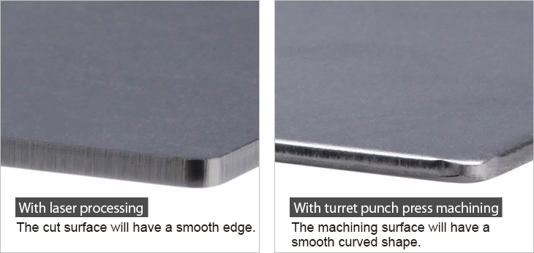

### Burring in the Pulling Direction

|  |  |
| --- | --- |
| Standard Value | Example |
| As shown in the right hand example (from behind), burrs of 0.1 mm or less may occur as a result of the machining process. | Example |

## About Edge Breaking

|  |  |
| --- | --- |
| Standard Value | Example |
| * Burrs and sharp edges resulting from the sheet metal cutting process will be removed or reduced according to the type of Edge Breaking selected. See examples of the two options in the figures to the right. | * No burrs larger than 0.1    |

**Appearance of Edge Breaking**

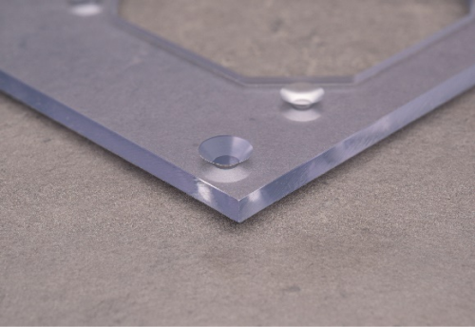Acrylic (Transparent), thickness 8.0㎜

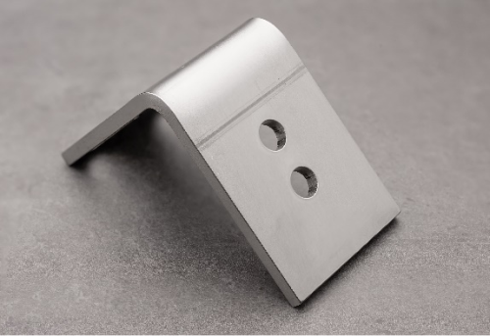304 Stainless Steel 2B, thickness 3.0㎜

**Edge Breaking Finish Notes**

* There is a possibility of minor scratches on appearance surfaces from the double-sided deburring machine used to eliminate burrs.
* Edge breaking and engraving cannot both be specified on the same model. The edge breaking process can cause the engraving to fade.
* Transparent resin parts will have the edge breaking finish as standard.

## About Hairline Direction

* 304 Stainless Steel(Single-sided hairline finish) has a hairline finish on the main appearance surface. (See the figure on the right)
* The polishing direction of the hairline finish is called the “hairline direction,” and in the meviy sheet metal service, the longitudinal direction of the unfolded drawing created by expanding the 3D model shape is used as the hairline direction.
* If you would like to use a different direction, please contact meviy support for a quote.

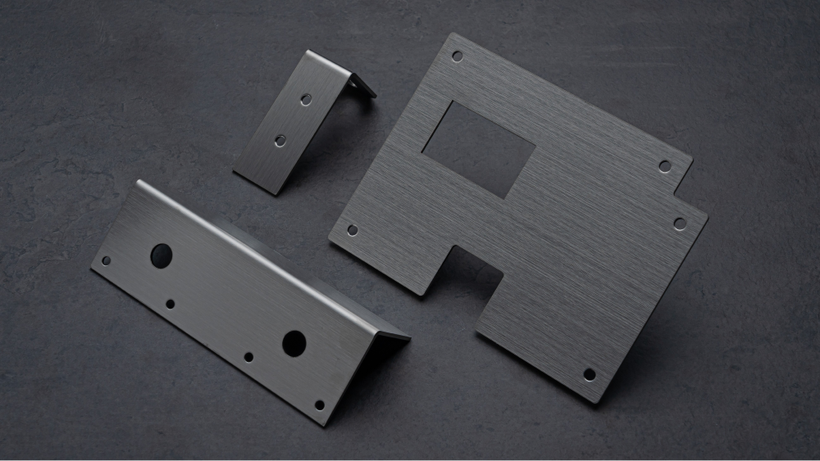

**Logic to determine the longitudinal direction of the development**

Calculates the maximum rectangle of the unfolded drawing, and develops horizontally in the direction of the longest side of the rectangle.

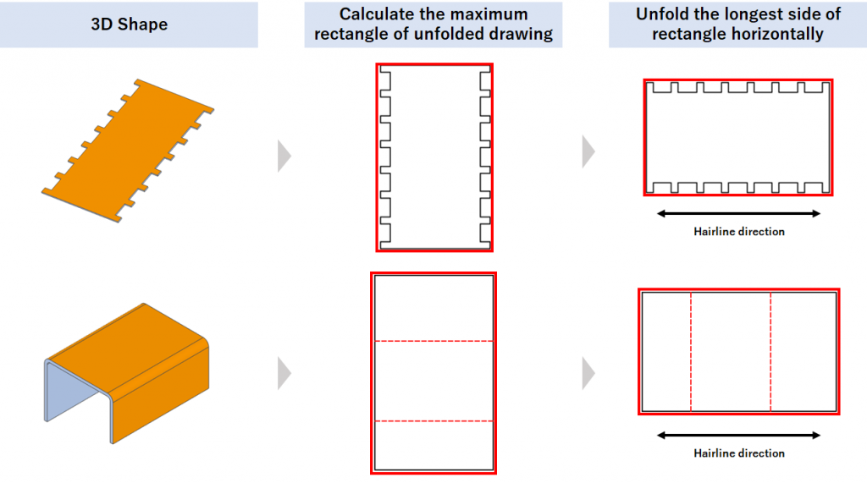

**Shape with arbitrary hairline direction**

In some cases, the maximum rectangle of the unfolded drawing is not defined, or the longest side of the rectangle cannot be defined (See the figure on the right.). For such shapes, the hairline direction is optional, and you can specify the desired direction in the quotation in meviy support.

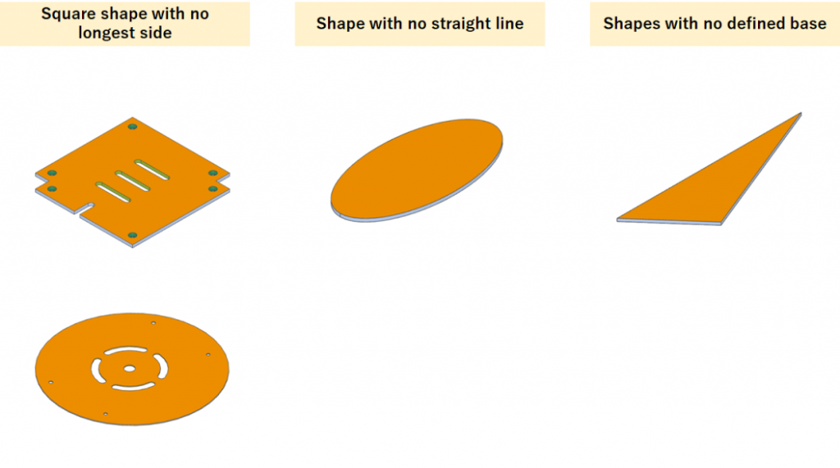

**Effects on unfolded dimension calculation**

* The effect of expansion due to bending must be taken into account when calculating the unfolded dimensions for manufacturing.
* In the case of 304 Stainless Steel(single-sided hairline), the expansion is about twice the thickness of the plate at each bending point, so the unfolded dimensions become shorter by that amount. As a result, please note that the longitudinal direction in the 3D model and the unfolded drawing may be switched. (See the figure on the right)

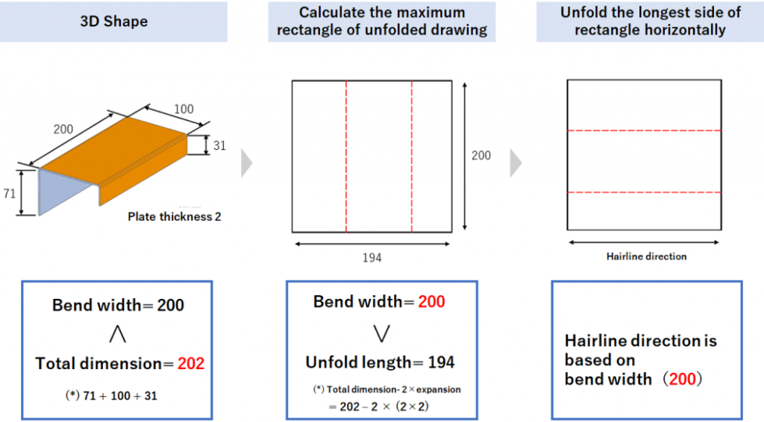

## About pre-finished sheets

5052 AL alloy (anodized clear/black) pre-finished materials can be processed. (See the figure on the right.)

Cut surfaces will not have a surface finish.

If surface treatment is required on the cut surfaces, select a material that is not pre-finished and specify anodizing as the surface treatment.

*Please [click here](https://us.meviy.misumi-ec.com/help/en/technical_info-en-c/shm_shape-material-en-c/9662/) for more information about materials.

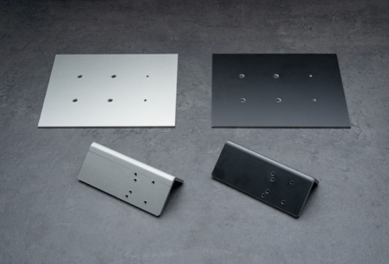

**Anodized Aluminum Sheet Appearance**

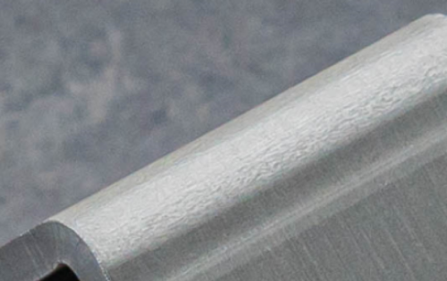

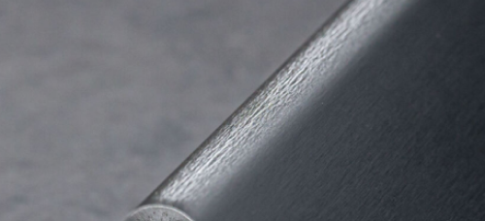

**Product Finish**

* There is a possibility the surface treatment may peel at bends.
* Cut surfaces will not have a surface finish.

*There may be color differences depending on the part shape and surfaces to be cut. Film thickness cannot be specified.

*There may be slight color differences for pre-finished products depending on the delivery option selected. Performance is equivalent.

*Assembled nuts will not be anodized.

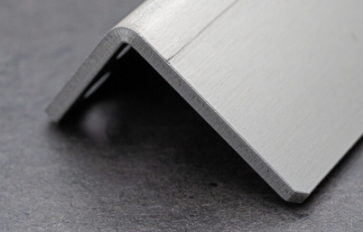5052 AL Alloy (pre-finished clear anodized sheet) Thickness 3.0mm

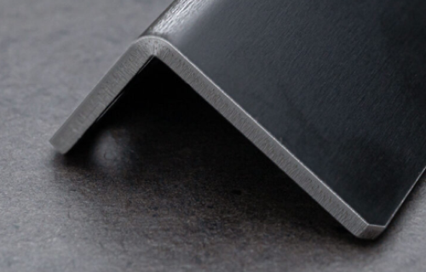5052 AL Alloy (pre-finished black anodized sheet) Thickness 3.0mm

## About Painted Sheet metal parts

Hanging jig marks may be left when painting (see picture on right).

The base coat for painted products is an iron phosphate coating.

The main quality standards are shown in the table below. The values are approximate values.

|  |  |  |
| --- | --- | --- |
|  | Powder Coating | Wet Paint​ |
| Film thickness *1 | 80±30μm | 30±15μm |
| Baking temperature | 180℃ | 140℃ |
| Baking time | 20 to 30 min | |
| Salt spray test *2 | 120 hours | 72 hours |

1: Not a guaranteed value because the paint thickness may vary depending on the shape.

2: Based on JIS Z2371 salt spray test method.

    (Powder: 60±5μm after baking at 180°C for 20 minutes, Wet Paint: 25±5μm after baking at 100°C for 20 minutes)

Quality check methods include a film thickness gauge, tape to check adhesion, and a cross-cut test using a test piece.

The appearance is visually checked for color, dust, spots, dimples, etc. by referring to a defect size estimation chart. Screws are used to check the functionality of tapped holes.

To clean, wipe with water and a soft cloth or sponge, or wipe with a diluted neutral detergent, then wipe with water, then wipe dry. Please refrain from using alcohol and petroleum solvents such as thinner, benzene, etc.

## Engraving

**Appearance of engraving**

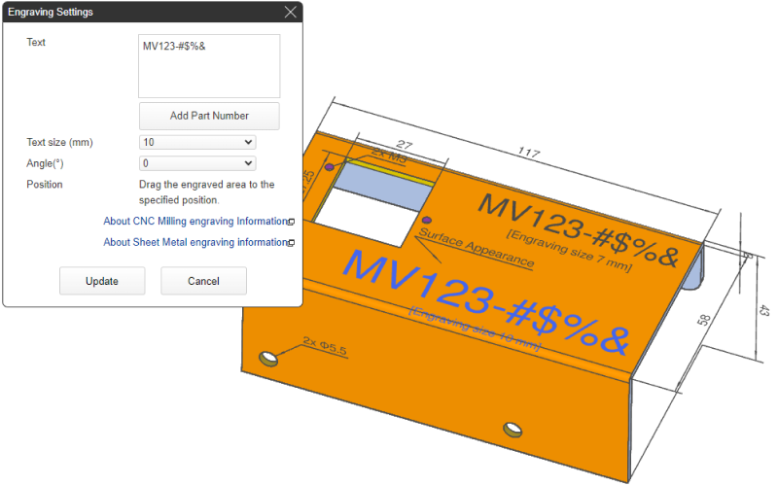＋

**Set engraving**

* For sheet metal engraving, content can be entered and positioned (angles and positions) in the 3D viewer only for the appearance surface.
* Multiple engravings on a single surface and engraving on multiple surfaces can also be ordered.

**Appearance of engraving**

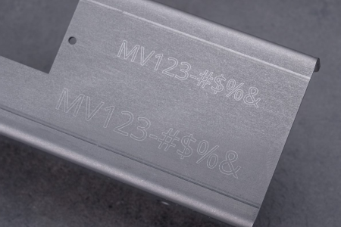

**Engraved letter finish**

* ・Engraving service for sheet metal is done with laser engraving.
* ・The letter width (approx. 0.1 mm), depth of engraving, and spacing between letters cannot be specified.
* ・Font size and angle are approximate values. We cannot guarantee accuracy.

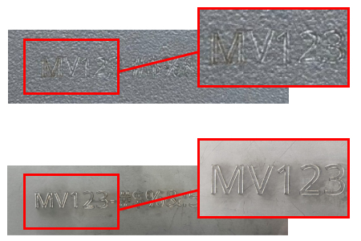

**important notice**

* ・Depending on the material and machine conditions, burn marks may occur around the letters.
* ・Depending on the material, the finish of the engraving may be softer.
* ・If the height of the engraving characters is small (3 to 5 mm) or the shape of the characters is complex, the characters may appear blurred.

## Clear Resin Specification

**General Tolerance Standards for Machining Dimensions**

The tolerance for external dimensions is ±1.0. See the table below for the tolerances used for other sections.

|  |  |  |  |  |
| --- | --- | --- | --- | --- |
| Standard Part | Tolerance Grade | | Dimension | Tolerance |
| Symbol | Description |
| Dimensional tolerances for length dimensions, excluding chamfered parts | m | Medium | 0.5 ≦ X ≦ 3 | ±0.1 |
| 3 < X ≦ 6 | ±0.1 |
| 6 < X ≦ 30 | ±0.2 |
| 30 < X ≦ 120 | ±0.3 |
| 120 < X ≦ 400 | ±0.5 |
| 400 < X ≦ 1,000 | ±0.8 |
| 1,000 < X ≦ 2,000 | ±1.2 |
| Dimensional tolerances for length dimensions of chamfered parts | c | Rough | 0.5 ≦ X ≦ 3 | ±0.4 |
| 3 < X ≦ 6 | ±1 |
| 6 < X | ±2 |

*General tolerances for JIS B 0405 cutting are used.

|  |  |
| --- | --- |
| Standard Value | Example |
| If the internal angles of the model are sharp corners or are less than R3, machining of around R3 will be applied. (If you would like the internal angle to be finished to a sharp corner or to less than R3, contact meviy support for an estimate.) | Example |

**Dimensional Changes for Clear Resin**

Unlike metal, resin is a material that easily deforms as a result of temperature and humidity and changes in dimensions. Accuracy is assured in the following way:

* Testing is conducted in a temperature- and humidity-controlled environment
* Accuracy assurance is based on the results of inspections performed immediately before shipment.

## Perforated Metal Machining Specifications

Standard ValueExample

There are no restrictions on the relationship between cut sections and hole positions. (Use caution when handling cut sections or the cutouts around holes as they are particularly sharp.)

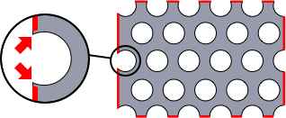

## Quality Control

### Quality Assurance Scope for External Appearances

|  |  |  |
| --- | --- | --- |
| Cut surface | | Marks from the hanging jig used during the application of the painting coat |
| Cut surface | Cut surface | Marks from the hanging jig used during the application of the painting coat |

**Surface**

· The external appearance surfaces must be free of blemishes caused by nails. For surfaces that are not considered external appearance surfaces, some processing/machining marks may be present.

|  |  |  |
| --- | --- | --- |
| Burring in the pulling direction | Damage caused by bending | Protrusion from bending |
| Burring in the pulling direction | Damage caused by bending | Protrusion from bending |

**Machined Sections (Punching, Bending)**

* · Any burrs that exceed 0.1 mm that occurred as a result of the machining/processing will be removed.
* *Does not include edge breaking or C-chamfering.
* · If chamfering or filleting is required on the external sections, include this in the modeling. However,  
  this does not apply to chamfers and fillets in the plate thickness direction.
* · Note that the appearance of the cut surface may vary depending on the processing/machining method.  
  (The processing/machining method cannot be specified.)
* · Marks may remain from the hanging jig used during the application of the painting coat.
* · Machining/processing marks from the die used during the bending process may remain.
* *For 304 Stainless Steel (Single-Sided #400-Grit Polished) and 304 Stainless Steel (Single-sided hairline finish), protective sheets are applied to external appearance surfaces to protect against the formation of defects.
* · Bulging/protrusions of about 15% of the plate thickness can occur on each side of the bent sections during the bending process.

### Notes on the product appearance

|  |  |
| --- | --- |
|  | 1018 Carbon Steel plate thickness 16㎜ |
| 304 Stainless Steel (No.1) plate thickness 12㎜ | ASTM A36 Steel plate thickness 16㎜ |

**Cutting surface**

· For thick plates (over 6.0 mm), burn marks from laser cutting may be noticeable.

|  |  |
| --- | --- |
|  | 1018 Carbon Steel plate thickness 16㎜ |
| Unevenness inside the hole | Hole shape distored on the back side |

**Hole machining**

* · Unevenness may occur inside the hole.
* Also, when viewed from the back side of the product, the shape of the hole may be slightly distorted.

### Inspection Item

|  |  |
| --- | --- |
| View of inspection (1) | View of inspection (2) |
| View of inspection (1) | View of inspection (2) |

**Inspection Details**

* · External appearance inspection: Defects, dents, unevenness, condition of painting coat, condition of surface treatment (visual)
* · Dimensional check: Viewer display dimensions (digital Vernier calipers, goniometers, etc.)
* · Inspection frequency: As part of each process and immediately prior to shipment

### Dimensional Tolerances for Sheet Metal & Thin Shim Plates

|  |  |  |  |  |  |
| --- | --- | --- | --- | --- | --- |
| No. | Standard Part | Classification of Standard Dimensions | Standard Values* | | |
| Normal Bending | | R-bend (FR bending) |
| Plate Thicness  ≦6.0mm | Plate Thicness  >6.0mm | Plate Thicness  ≦3.2mm |
| 1 | Section with no bending | 6 or less | ±0.1 | ±0.3 | ±0.1 |
| More than 6, equal to or less than 30 | ±0.2 | ±0.5 | ±0.2 |
| More than 30, equal to or less than 120 | ±0.3 | ±0.8 | ±0.3 |
| More than 120, equal to or less than 400 | ±0.5 | ±1.2 | ±0.5 |
| More than 400, equal to or less than 1,000 | ±0.8 | ±2.0 | ±0.8 |
| More than 1,000, equal to or less than 2,000 | ±1.2 | ±3.0 | ±1.2 |
| 2 | Section with bending | 6 or less | ±0.3 | ±0.5 | ±0.5 |
| More than 6, equal to or less than 30 | ±0.5 | ±1.0 | ±1.0 |
| More than 30, equal to or less than 120 | ±0.8 | ±1.5 | ±1.5 |
| More than 120, equal to or less than 400 | ±1.2 | ±2.5 | ±2.5 |
| More than 400, equal to or less than 1,000 | ±2.0 | ±4.0 | ±4.0 |
| More than 1,000, equal to or less than 2,000 | ±3.0 | ±6.0 | ±6.0 |

**General Tolerance: JIS B 0408 Grade B (Plate Thickness ≤6.0 mm), Grade C (Plate Thickness >6.0 mm)**

* · If painting/coating is specified, the standard value for material conditions is used.
* · The allowable dimensional tolerances are applicable only for dimensions for between holes on the same face and end-faces/perpendicular-faces that are adjacent as a result of the bending.
* *The tolerances are not applicable for hole-to-hole or hole-to-end face dimensions on non-adjacent faces (across multiple bent sections).
* See “Example of non-applicable dimensions” in the figure below.

|  |  |
| --- | --- |
| Example | Example of non-applicable dimensions |
|  |  |

### Dimensional Assurance Range for Clear Resin

|  |  |  |  |  |
| --- | --- | --- | --- | --- |
| Standard Part | Tolerance Grade | | Classification of Standard Dimensions | Tolerance |
| Symbol | Description |
| Dimensional tolerances for length dimensions, excluding chamfered parts | m | Medium | Equal to or greater than 0.5, equal to or less than 3 | ±0.1 |
| More than 3, equal to or less than 6 | ±0.1 |
| More than 6, equal to or less than 30 | ±0.2 |
| More than 30, equal to or less than 120 | ±0.3 |
| More than 120, equal to or less than 400 | ±0.5 |
| More than 400, equal to or less than 1,000 | ±0.8 |
| More than 1,000, equal to or less than 2,000 | ±1.2 |
| Dimensional tolerances for length dimensions of chamfered parts | c | Rough | Equal to or greater than 0.5, equal to or less than 3 | ±0.4 |
| More than 3, equal to or less than 6 | ±1 |
| More than 6 | ±2 |

*General tolerances for JIS B 0405 cutting are used.

**General Tolerance Standards for Machining Dimensions**

· The tolerance for the external dimensions is ±1.0. See the table to the left for the tolerances for other sections.

**Dimensional Changes for Clear Resin**

· For dimensional changes caused by temperature or humidity, accuracy is guaranteed based on the following conditions:  
– The inspection is performed in a temperature-controlled environment.  
– Accuracy assurance is based on the results of inspections performed immediately before shipment.

**Clear Resin R**

· If the internal angles of the model are sharp corners or are less than R3, machining of around R3 will be applied.  
See “Clear resin internal angle (R)” in the figure below  
· If you would like the internal angles to be finished to a sharp corner or to less than R3, contact meviy support for an estimate.

|  |
| --- |
| Clear resin internal angle (R) |
| Clear resin internal angle (R) |

## Quality Control of Nut Mounted Products

### Regarding the appearance of nut mounted products

|  |  |  |
| --- | --- | --- |
|  |  |  |
|  |  |  |

**Product with press-fit nut**

* Low Carbon Steel (Cold Rolled) with Electrolytic Zinc Plating, Hot Zinc Plating, 5052 AL Alloy Pre-Finish, Clear Anodize and 5052 AL Alloy Pre-Finish, Black Anodize may have some plating peeling due to nut mounting.
* Installation of nuts near the edge of the plate may cause the edge to swell.

|  |  |
| --- | --- |
|  |  |
|  |  |
|  |  |

**Product with weld (spot) nut**

* For products with spot-welded nuts on steel materials,remove burns by using a file or similar tool. Scratch marks may appear due to the filing.
* Low Carbon Steel (Cold Rolled) with Electrolytic Zinc Plating and Hot Zinc Plating may have some plating peeling due to nut mounting.

Finish marks may remain.

Also, polishing to remove burns is not performed because it causes plating to peel off.

Spot-welded nuts on stainless steel will be removed the burn marks by electrolytic polishing.

* The projection part of weld nut may be eluted, but the following items are inspected to confirm that there is no problem with tightness.
  + pass through.
  + projection part is not convex more than the material thickness.

**Regarding the Strength Warranty for Nut mounted Products**

**Product with press-fit nut**

* We do not guarantee the strength of products with press-fit nuts, but we will ship them after confirming that there are no problems with fastening.

**Product with weld (spot) nut**

* We do not guarantee the strength of products with weld (spot) nuts, but we will ship them after confirming that there are no problems with fastening.In addition, periodic evaluations are conducted in accordance with JIS B1196.